Helena Wang
Integrative Seminar: Memory
Vignettes: Flushing
Maya Samat
10/30/15

Basketball Court

Confucius once said,
“When true knowledge is achieved, then the will becomes sincere; when the will is sincere, then the heart is set right; when the heart is set right, then the personal life is cultivated; when the personal life is cultivated, then the family life is regulated; when the family life is regulated, then the national life is orderly; and when the national life is orderly, then there is peace in this world.”

Throughout Chinese history, the emphasis of academic intelligence and knowledge as a direct link to success and comfortable living has been passed down to generations of Chinese immigrants, including those who immigrated to Flushing, often called the Chinatown of Queens, New York. Immigrant-parents instill a common “American Dream” upon their children: to receive the best education, hit the highest marks, and go off to the best colleges.
In this worn-down, yet popular basketball court located just a few minutes away from Main Street, Flushing, teenagers can be seen laughing, shooting balls with friends, and having intimate conversations about their futures. Above them, countless pairs of sneakers dangle from the overhead power lines (Nikes, Addidas, Sketchers, you name it). These sneakers aren’t just randomly there; they embody the stories of young adults who left Flushing to further achieve their –and their parents’ – “American Dream.” Every year, it is a tradition for high-school graduates accepted into college to throw their shoes, tied together by the laces, onto these power lines, leaving their mark on the basketball court before they leave Flushing. These shoes not only represent years of pressure that these children of immigrant families have to face, but they also epitomize the happiness and reward that comes from hard work. The presence of these shoes – hanging high above heads – are positioned to motivate and to serve as a reminder for current teens to work hard and accomplish the same goal of getting into the best possible college. Hoping to be in the same shoes as these alumni, those currently spending their teenage years in this basketball court can physically and metaphorically look up to the graduates who have already accomplished a major part of the Chinese “American Dream.”
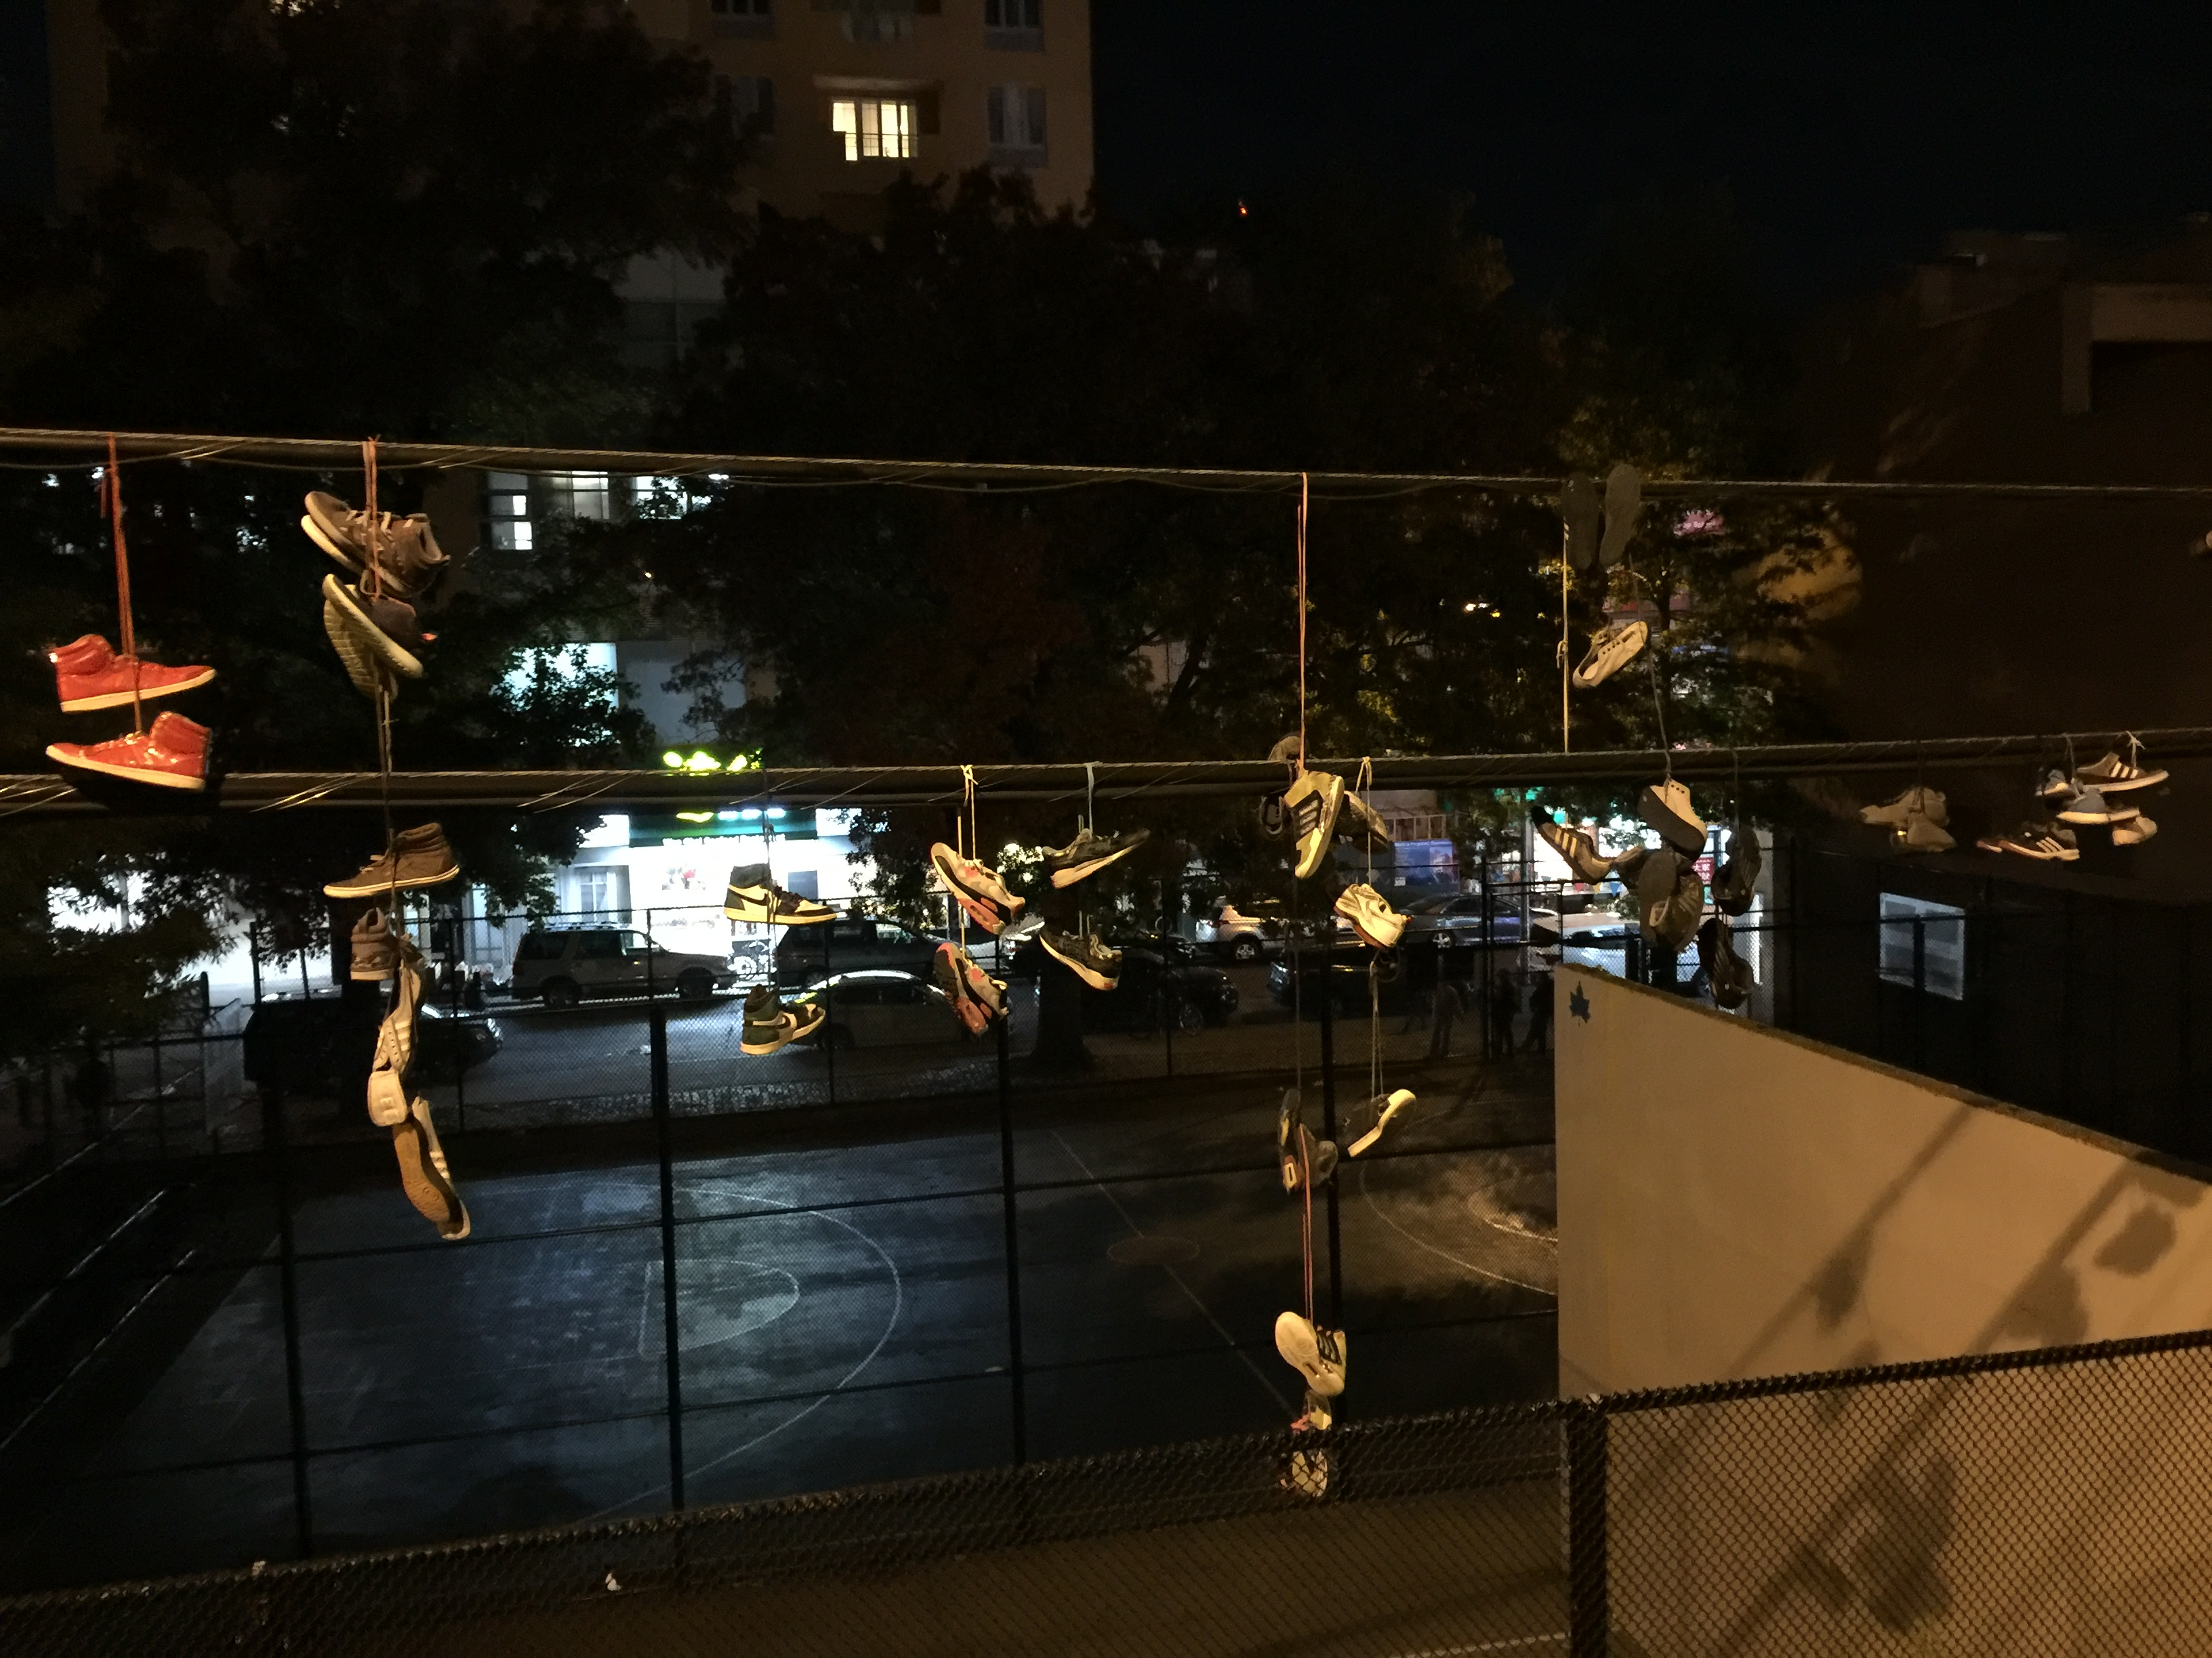

Like They Never Left
Flushing is a denser version of the streets of China. Repeatedly, dumpling Restaurants line after Chinese pharmacies, bamboo-plant shops, karaoke businesses, Buddhist associations, and stores with clothing directly imported from Korea and China. On the streets, in Chinese, people say, “Wow! Is this America? It feels like I’m in a small town in China.” Although Flushing is home to various ethnicities, such as those of Hispanic, Middle Eastern, European, and African American decent, the Asian population dominates the area. You don’t have to know English at all to get around Flushing. In fact, it’s better if you don’t speak English. Speaking and knowing Chinese gets you the best deals in bargains, the secret menu in restaurants, and allows you to read most of the neon signs on the streets. This is why the majority of the Chinese-immigrant population, which surpassed the immigrant population of Manhattan’s Chinatown, can’t speak English even after being in America for years. They come to a new country, arrive at JFK, and travel all the way to Flushing, to arrive at a neighborhood exactly the same as those in China. Supermarkets have the same spices, snacks, and delicacies, and pharmacies have the same comforting herbs. It’s like they never left. But they have come to a land with more freedoms, and less pollution, without the feeling that they have left home.
Students from China who come to New York for high school and college also dominate the area. Whether through the subway or the Long Island Railroad, many come to Flushing for an experience of home. Through these authentic restaurants and other businesses owned by the immigrants themselves, anyone can take a trip back to the streets of China.

Plant Shop

There are Four Noble Plants in Chinese Culture: plum blossoms, orchids, bamboo, and chrysanthemums. Compared to the Confucian “jun zi” (gentlemen), each of these plants embodies a different human virtue. For example, because plum trees resist the cold winter and exert a type of beauty and elegance without being too striking, they represent humbleness and inner beauty during unfavorable conditions. The orchid, graceful and fragile in form, symbolizes humility and nobility. The bamboo, which has a hallow stalk, represents open-mindedness and tolerance. The strength and flexibility of the bamboo also symbolizes human cultivation and integrity. The chrysanthemum, which thrives in the autumn, anticipating winter, symbolizes the virtue to withstand hardships.
This is why there are an abundant amount of plant shops in Flushing. In one of these plant shops, a forest of plum blossoms, orchids, bamboo, and chrysanthemums reigns over the small space. It is a cultural experience to walk through the aisles and be surrounded by the noble plants. In the middle of the store, turtles, which represent longevity and are divine animals in Chinese culture, peacefully swim in a large glass bowl. The presence of the shop shows how Chinese immigrants continue to live on with the same virtues they were raised with despite moving to a new country. The shop emits an aura of good fortune, and with the help of the powers of these noble plants, the shop thrives in business. Customers also bring the plants that possess good fortune home. A beautiful mutualistic relationship dominates the business.
