Immersive Attention Report
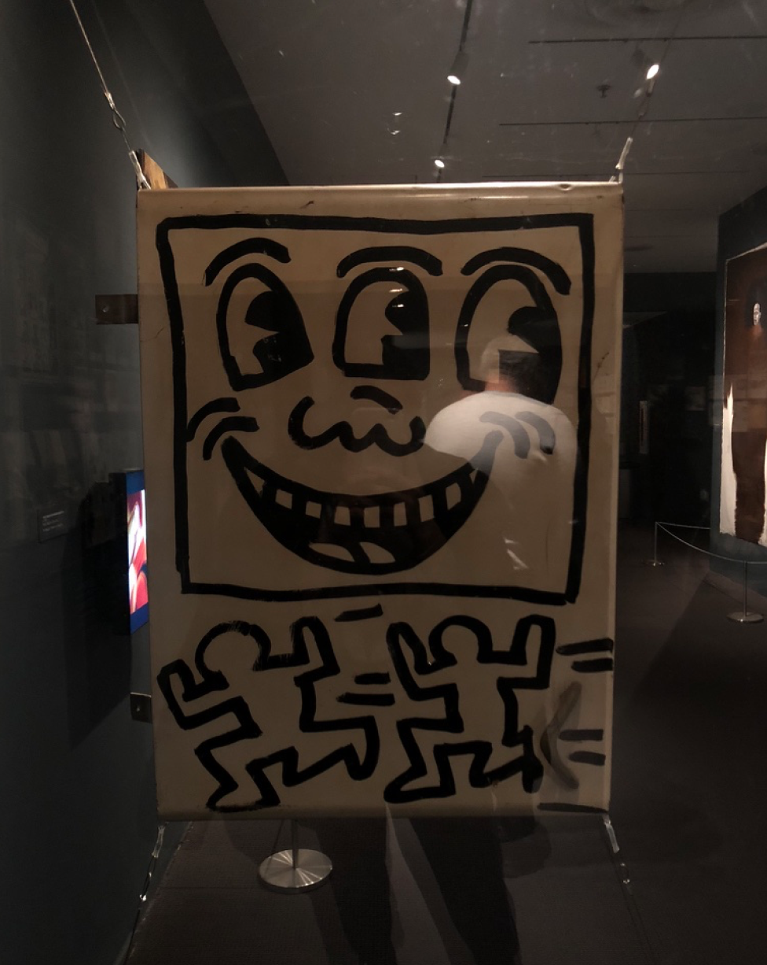
This past week for seminar class we went to MOMA’s exhibition called Club 57: Film, Performance, and Art in the East Village, 1978–1983. Club 57 was taking place in a basement where artists were free to experiment different kinds of art. When I was exploring around the exhibition, I was amazed how artists we studied though years were using this venue to showcase and create art. Especially Club 57’s active member Keith Haring’s one particular piece that was exhibited in this exhibition caught my most attention. Keith piece “Untitled” done in 1980 was an acrylic painting on a cabinet door art made for Joey Arias. Back then, Joey Arias was known to be a drag/performance around New York City especially in Club 57.
Before we visited Club 57, I would always admire Keith Haring’s Neo-Expressionist and Graffiti works. With the little background information, I knew about Keith and his work of art, this “Untitled” piece made me very intrigued to stare at a long time, specifically, around 20 minutes. While looking at this work I felt very joyful and childlike and because of the illustrations reminded me the childhood animations we would watch on TV or cartoon comics we would read for entertainment. I enjoyed Keith’s very simple drawing technique which shows the figures very clear. The bold lines he used makes the viewer observe easier.
After time was passing by, I realized that Keith’s works are also known for creating imagery and gives a certain message, this made me understand that his piece was far away from childlike, happy moments. Unlike, all the nice things, this piece critiques about how gender and sexuality is a problem and a serious issue for the religion and political view of people. At first, I didn’t realize this piece was double-sided. But when I saw the human figure holding the cross, I immediately realize the message. In Christianity, being gay or any other beliefs related are considered as a sin. This sexist idea is mockingly shown though Keith’s work, which makes sense for Joey Arias to keep it because the things he does are considered as a sin because he is a gay drag-queen. Also the “xxx” on the top left corner also a symbol for pornographic content.
On the front side of the piece, there is a smiling face that also has three eyes which can be considered as a god. By the looks, the potential “god” is giving a message saying “I am watching your every move,” like if you make a wrong move you will get punished. So, at the other side, the human figure is punishing someone by stabbing with the cross because they have different sexual preferences that are considered wrong in religion.
Overall this piece made me think through so many different ideas. However, the details of this piece remain as a mystery together with other information, which made me question many things. How was this political piece got reacted by other viewers? Where was it made? There was no description of this piece which led the viewer to create a story about this piece, which caught my attention the most.

