Sustainable Systems
Brandon Chu
Journal 2

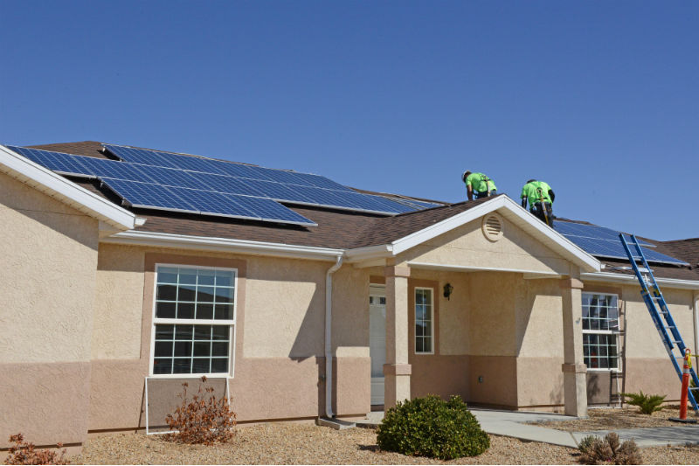
There are a lot of ways that solar energy could be improved. Luckily for us, the draught men lots of sun (no water but lots of sun); however, in other areas, this would be more temperamental with the weather and even season. There are places closer to the poles that stay dark for months at a time, which means no HBO during the daytime. Having been a huge supporter of green energy. I know that panels are struggling to reach 23% and I strongly believe that if more research went into it than research for great deep fakes or more unnecessary topics then we could make improvements faster. Also, it bothers me that I am going into a useless field to help the environment. We are the pinacol of selfishness being artists. Therefore, I feel it so necessary that artists coalesce with philanthropy. I also want to look into integrating science into fashion which leads me to my second idea of improvements to solar and global energy: green energy is available, but it is so expensive and uncommercialized. We are all lazy but outcome of a society who needs to work hard. We have no time to try and spend more money on another energy and starve. Therefore, if we make sustainable systems more commercialized like recycling we can make a huge contribution. Integrating sustainability into every day fashion would mean billions of people making contributions without even trying and still working on their own lives.
We have solar power energy on our house which may not be the main source of energy, but it provides enough energy for us that we save a couple thousands of dollars per year.

