How the Evolution of Glass Brings Light to Contemporary Architecture

Glass as a material has taken many different shapes and strengths over time as the ability to manufacture it evolved. This has impacted greatly on the history of architecture. The evolution of glass manufacturing allowed the enhanced use of light as a foundational element in contemporary architecture. Glass has been used to dematerialize architecture and thus create sections apparently free of physical substance. Light becomes part of our enclosed spaces through the use of cut-outs like windows and doors which often utilize glass.

Glass and its use has evolved throughout the history of architecture through the progression of technology and science. In Roman times, windows made of glass were created by blowing a long balloon of glass, cutting off the ends and flattening the cylinder on an iron plate. This method is called broad sheet glass and the windows created using it were not strong and were often translucent. Over time, iron or other forms of metal were used to hold the pieces of glass together and increase strength. This can be seen in stained glass windows like the 1345 rose windows at the Notre Dame Cathedral in Paris.

In the 17th century, crown glass was introduced and became the popular form of glass production, it was made by “blowing a sphere of molten glass, opening the end opposite the blowpipe while still molten and spinning it out into a circular sheet.” These circular discs of glass had a “bulls-eye” in the center from the rod used to spin it. Crown glass was stronger than broad sheet but also required many panes, due to its circular nature. You can still see this form of glass today as a design feature in some windows. By the 17th century there had been improvements in the material, but it wasn’t completely clear or sturdy.

In the late 18th century, polished plate glass entered the market which was created by “casting a sheet of glass onto a table and then grinding and polishing it by hand superseded at the beginning of the 19th century by steam powered machine-grinding and polishing.” By then the quality and size of glass panes was much improved but was very expensive due to the new processes. A process similar to broad sheet and crown glass was introduced in 1834 in Germany. Due to technological advancements, it could produce larger sheets of glass with better quality and became the main process used into the early 20th century. In 1845, the duty on glass was removed which made the material cheaper and more accessible. However, in this time glass was still somewhat weak, windows were still smaller than modern day and had many panes. However, it was now being incorporated into architecture as a design element. An illustration of this use is the Red House designed by William Morris and Philip Webb in 1859.

In the 19th century the next manufacturing process improvements were rolled plate obscure glass which was then replaced by machine rolled obscure glass and subsequently wired cast glass. The impact of this process improvement can be seen in the design of the Glasgow School of Art which was built in 1897 by Charles Rennie MacIntosh. The size of the windows was much larger, but there was still the need for many windowpanes made of smaller squares of glass to ensure structural strength of the window. In 1903, laminated glass was developed “by incorporating a thin plastic film between two sheets of glass,” this “increased the safety and security of much larger windows which could be glazed undivided by glazing bars.” An example its use is the Vienna Post Office Savings Bank by Otto Wagner in 1904. Throughout the 20th century glass manufacturing continually improved with new, cheaper, mass-production techniques. The quality, strength and clarity of glass improved immensely from the broad sheet glass of Roman times to the 20th century where whole walls are made of glass as an architectural element seen in structures like the Farnsworth House completed by Mies van der Rohe between in 1951. Most glazing today is made with the “float process in which molten glass is allowed to float on a bed of molten tin while the upper surface is polished using pressurized nitrogen.” Windows today employ techniques like double-glazing which increase the efficiency of energy used by employing airspace between the panes as insulation. These advanced production techniques have allowed modern architecture to employ light as a foundational element without the restrictions that existed in earlier times.

The use of glass in architecture can be characterized as the use of light due to its transparent nature. Light is “often the experiential quality that most directly and forcefully conditions the spatial atmosphere and our mood.” It has the ability to connect spaces to the surrounding environment and atmosphere. “The interplay of light and shadow connects architectural spaces with the dynamics of the physical and natural world, the seasons, and hours of the day.” When humans are outside in the environment they are able to see and feel the impact of natural light and how it’s changes impact their visual experience. Clouds and trees are two natural partitions that create areas of light and shade that are constantly changing. In Le Corbusier’s Villa Savoye, the long glass windows that span the length of the walls allow light to impact the interior environment as it does the exterior environment. Paul Scheerbart wrote a piece called “Glass Architecture” about the importance of including glass in design. It was originally published in 1914, two months before the opening of the Cologne Werkbund Exhibition which included Bruno Taut’s Glass Pavilion. He said “if we want our culture to rise to a higher level, we are obliged, for better or for worse, to change our architecture. And this only becomes possible if we take away the closed character from the rooms in which we live. We can only do that by introducing glass architecture, which lets in the light of the sun, the moon, and the stars.”The advances in glass production made it possible for architects to embrace this vision in a manner that was not previously possible.

As society embraces sustainability and a better appreciation for our natural environment, contemporary architecture has led the way. People want less walls and more glass to make their environment as bright and open as possible. The modernist architects “dreamed of a light and airy sense of space, no longer tied down to traditional heavy materials, ruled instead by the new morality of the clear and transparent.” Through the many modernist buildings created, as well as much of contemporary architecture, we can see that this dream has been accomplished. Light “has a deep effect on our activeness and energy level in addition to conditioning our mood.”

Modernist architects like Philip Johnson started “breaking away and floating free from the heaviness of traditional context.” Johnson did this through designing and building structures like the Glass House which used the material as “a substitute for nothingness.” Glass allowed him to bring a weightlessness into the space unlike past building materials such as iron and concrete which feel and look substantial. Glass allowed architects to enclose spaces and keep them safe from the elements while giving the illusion of openness. “Visual connection is exactly what clear glass allows, and provides, yet ambiguity results because of the physical, hard barrier, transparency aside.” Glass allows designers to play with the concepts of public and private space through variety in the material due to new technologies. The entire back wall of Maison de Verre by Pierre Chareau in Paris is made of glass bricks. The bricks are slightly translucent and double layered which allows light and shadows to be projected on the wall from inside and outside. Glass bricks turn what would usually be a private space inside the home into a more public space because people from neighbouring buildings have more visual access. The evolution of the use of glass and the technology behind it has created the contemporary architecture we see today. Glass facade buildings like the One World Trade Centre by David Childs evolved from architecture like the Seagram Building, by Ludwig Mies van der Rohe and Philip Johnson. The Seagram Building and its facade was built from steel and glass. It was part of the International Style movement which paved the way for the utilization of glass in skyscrapers.

The evolution of light as an element of design has considerably impacted architecture and interior architecture. This evolution would not be possible without the progression of glass production. It has allowed the modernist architecture that we love to incorporate light as a critical design aspect. As glass has become stronger, the possibility of light incorporation has grown. Glass allows sections and walls to be opened while keeping the interior safe from the outside elements. Contemporary architecture has been greatly enhanced due to the progression of this material as a key design element.

Examples of Glass in Architecture Through History

Bruno Taut’s Glass Pavilion
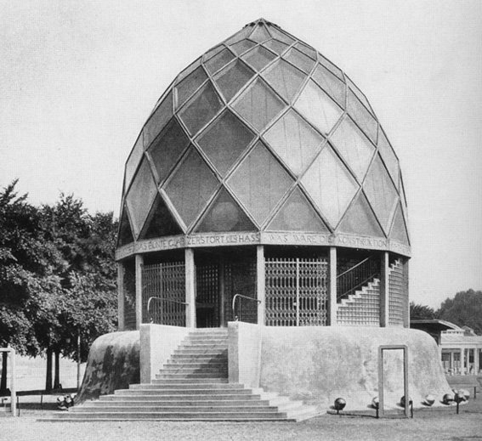

Philip Johnson’s Glass House
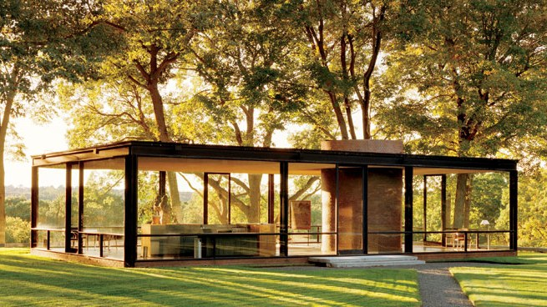

Pierre Chareau’s Maison de Verre
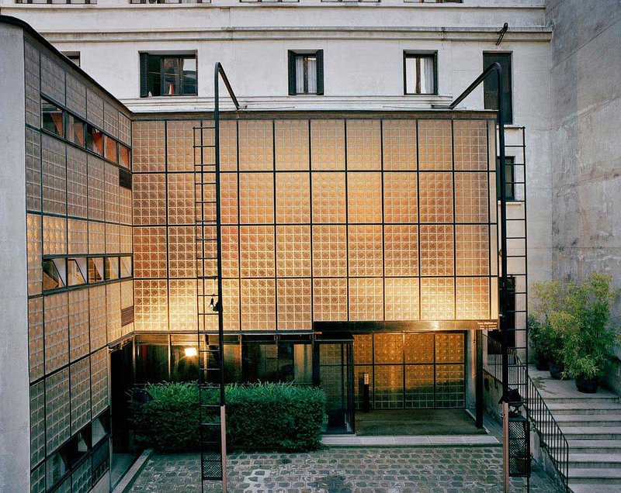

Ludwig Mies van der Rohe and Philip Johnson’s Seagram Building
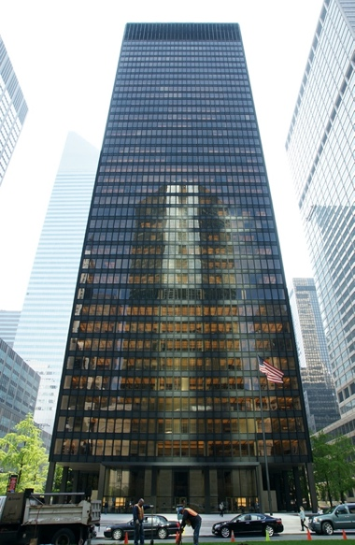

David Childs’ One World Trade Center
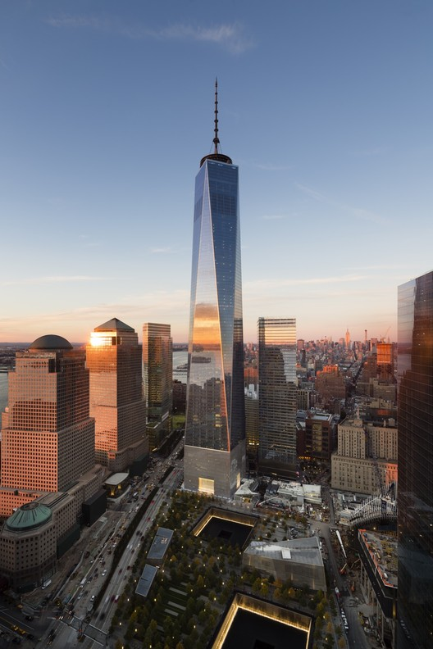

William Morris and Philip Webb’s Red House
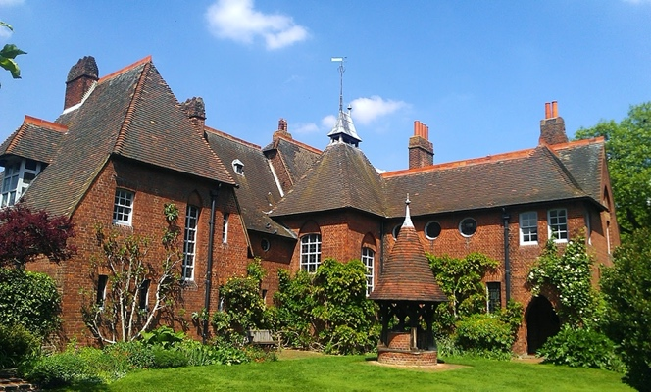

Charles Rennie MacIntosh’s Glasgow School of Art
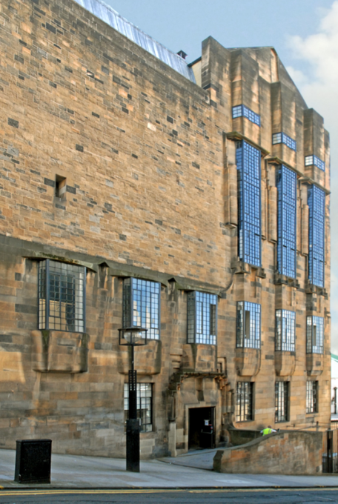

Otto Wagner’s Vienna Post Office Savings Bank
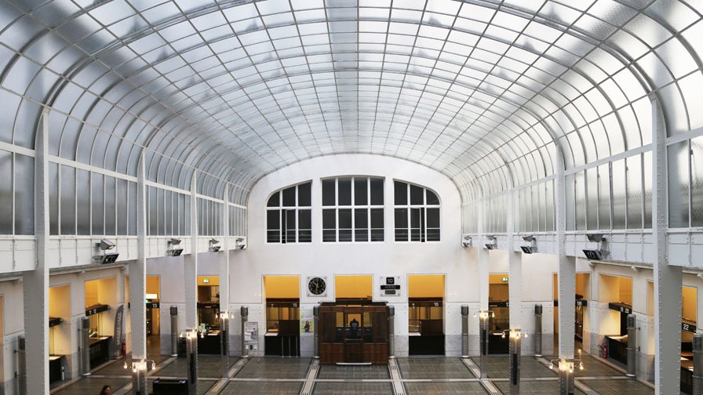

Le Corbusier’s Villa Savoye
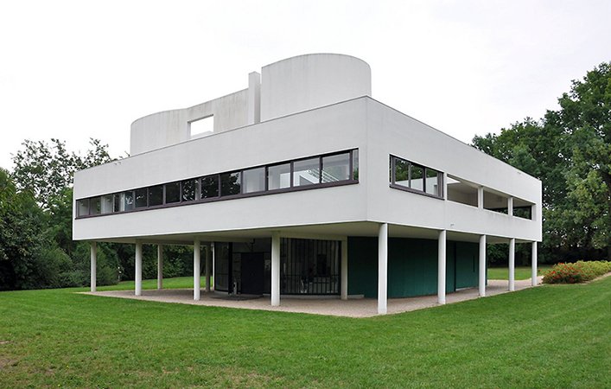

Mies van der Rohe’s Farnsworth House
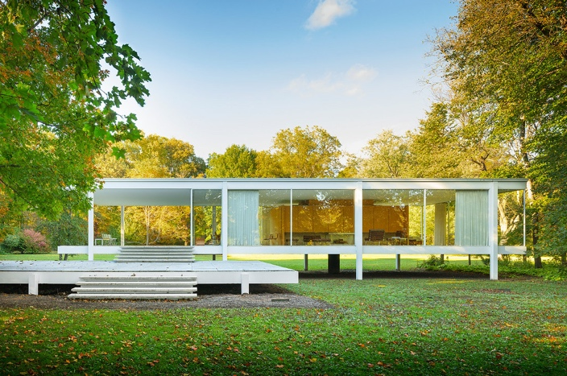

Jean-Baptiste-Antoine Lassus’ Notre-Dame Cathedral
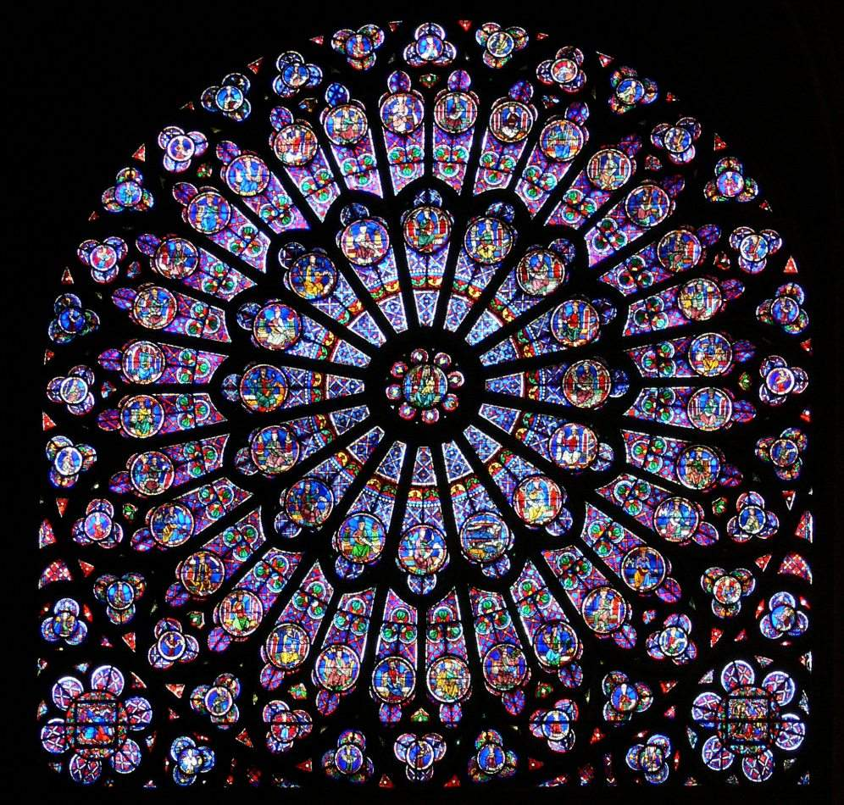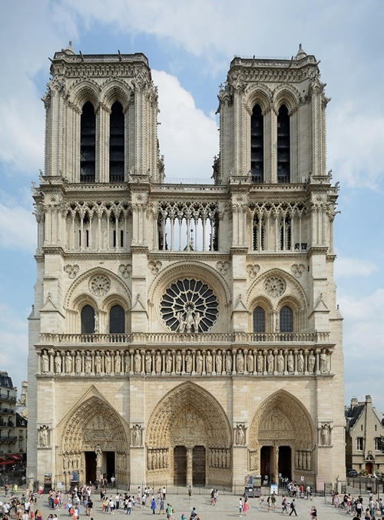

“The History of Window Glass Manufacture,” History of Glass Manufacture, Sash Windows London, accessed November 27, 2019, http://www.sashwindowslondon.org.uk/info/history-of-glass-manufacture.html.
Sash Windows London, “The History of Window Glass Manufacture.”
Sash Windows London, “The History of Window Glass Manufacture.”
Sash Windows London, “The History of Window Glass Manufacture.”
Sash Windows London, “The History of Window Glass Manufacture.”
Sash Windows London, “The History of Window Glass Manufacture.”
Sash Windows London, “The History of Window Glass Manufacture.”
Sash Windows London, “The History of Window Glass Manufacture.”
Sash Windows London, “The History of Window Glass Manufacture.”
Sash Windows London, “The History of Window Glass Manufacture.”
Juhani Pallasmaa, "Light, Silence, and Spirituality in Architecture and Art," in Transcending Architecture, ed. Julio Bermudez (Washington, D.C.: Catholic University of America Press, 2015), 19-32, doi:10.2307/j.ctt130h9f6.7.
Pallasmaa, “Light,” 23.
Paul Scheerbart and Bruno Taut, “Glass Architecture,” in Glass Architecture and Alpine Architecture, (New York: Praeger Publishers, 1972), 41-74.
John Rajchman, "Light Matters," ANY: Architecture New York, no. 5 (1994): 28-29, www.jstor.org/stable/41845636.
Pallasmaa, “Light,” 23.
Rajchman, John.
Ziff, Matthew. “The Role of Glass in Interior Architecture: Aesthetics, Community, and Privacy.” Journal of Aesthetic Education 38, no. 4 (2004): 10-21. doi:10.2307/3527372
Ziff, Matthew.

