Powerful art is created when an artist does not work within the bounds of what is expected by society at large, or even by other artists working within the same community. For a piece of art to truly connect with a viewer it should work with the concepts and techniques of the past, the present, and the future. This blending is what Giorgio De Chirico was able to accomplish with his painting, The Enigma of a Day, from 1914. De Chirico represents a combination of classicism, modernism, and surrealism to create a calming piece that still provokes thought and emotion. De Chirico’s harmonization of different movements can be seen in his classical architecture, perspective, and figurative representation, and his modernist and surrealist color palette, composition, brush stroke, and conceptual significance.
De Chirico’s classical architecture and perspective creates a world that a modern viewer can think of in a realistic framework. The purpose of the space is questionable, but creating a perspectival space that includes elements of modern life can make the viewer understand the three dimensional world as a stage for a bigger concept. The use of continuous arches emblematic of the roman/greek world that many classical artists chose to represent in their idealistic scenes. Lastly the figure represented as a statue follows classical ideals, not only for the representation of stone that was important to classical sculpture, but because of its proportionate and realistic rendering. Incorporating these classical elements allowed De Chirico the ability to express and experiment more visually with modernist and surrealist elements.
The mixing of classicism and modernism can first be witnessed in the most eye catching component of the piece: the white structure to the left. De Chirico used perspective in this piece, which is uncommon for other modernist painters, but he exaggerates and distorts the perspective of the structure to create an unnatural, surrealist structure. Because of this exaggeration, the rest of the proportions are slightly skewed, as seen in the yellow floor, the yellow box in the middle right, and even the structure that the statue stands on. The color pallete derives from modernism as it is mostly muted, almost dirty, colors that would generally be striking next to one another in their original state. The muted tone of the colors allows for a palette that has a calm tone, almost like a state of purgatory, that is neither happy nor sad. The composition at first glance can be quite off putting, as it is not obviously symmetrical, but with further examination, directs the viewer's eyes to the two small black figures in the middle of the painting. The right side of the painting has a chaotic amount of objects and colors, while the left side has the brightness and scale of the white structure to counter it. This balance of objects allows for the two figures to have an area of blankness that adds to the vastness of the imagined space. This scene is almost a glimpse into a daily happening, unlike the compositions of classical paintings that represented in the moment occurrences but in a theatrical or stage like composition.
Seeing De Chirico’s brushstrokes not only represent modernist ideas of the artist’s impression on the work, but also opposes classical ideals of perfection that were staple to representing figures and eliminating the artist from the work. De Chirico’s brushstrokes are contained but messy within their respective spaces. The viewer can see where colors meet and the intentional mixes of colors on canvas. His brushstrokes are most notably seen around the red smoke stacks in the back of the painting, where you can see that he was trying not to mix the blues of the sky with the reds of the structure. Hidden in the bottom right corner is a line drawing -possibly done in charcoal- of a rectangle, not colored in and nearly unnoticeable. These elements of brushstrokes and unfinished objects represent a non-idyllic, but personal scene that makes the viewer dissect the concept of the piece.
This piece is most likely a commentary on industrialism and World War I, which started the same year the painting was created. The statue at the forefront of the painting seems like an overbearing and omniscient force, highlighted by its size and strong contrast. The statue could be a comment on military powers and/or governmental figures that were sometimes hated or admired by different countries. The two black figures towards the back also make the viewer question what they are discussing. Because of the muted colors, dramatic architecture, and perspective, an ominous tone is created around their relationship. The industrial nature of the piece, seen in the smoke stacks and straight geometry, poses questions about modern technology and its effects on society. It also brings into question the war, as World War I was one of the first technological wars, with the creation of tanks, machines guns, and dangerous gases.
De Chirico’s use of classical architecture, perspective, and figurative representation was able to create a structure for the painting that could then be altered and used as a stage for personal impressions, modernist and surrealist ideals, and thought provoking representations of De Chirico’s world. De Chirico’s classical elements were less prominent than his modernist or surrealist ones, but were still important to the coherency and tone of the piece. With the classical elements present, De Chirico had the ability to distort such elements, and use them to his personal and conceptual benefits. The Enigma of a Day shows the benefits of not working with restrictions, as a deeper connection can be made with the viewer, and the artist’s message can be more clearly and creatively demonstrated. 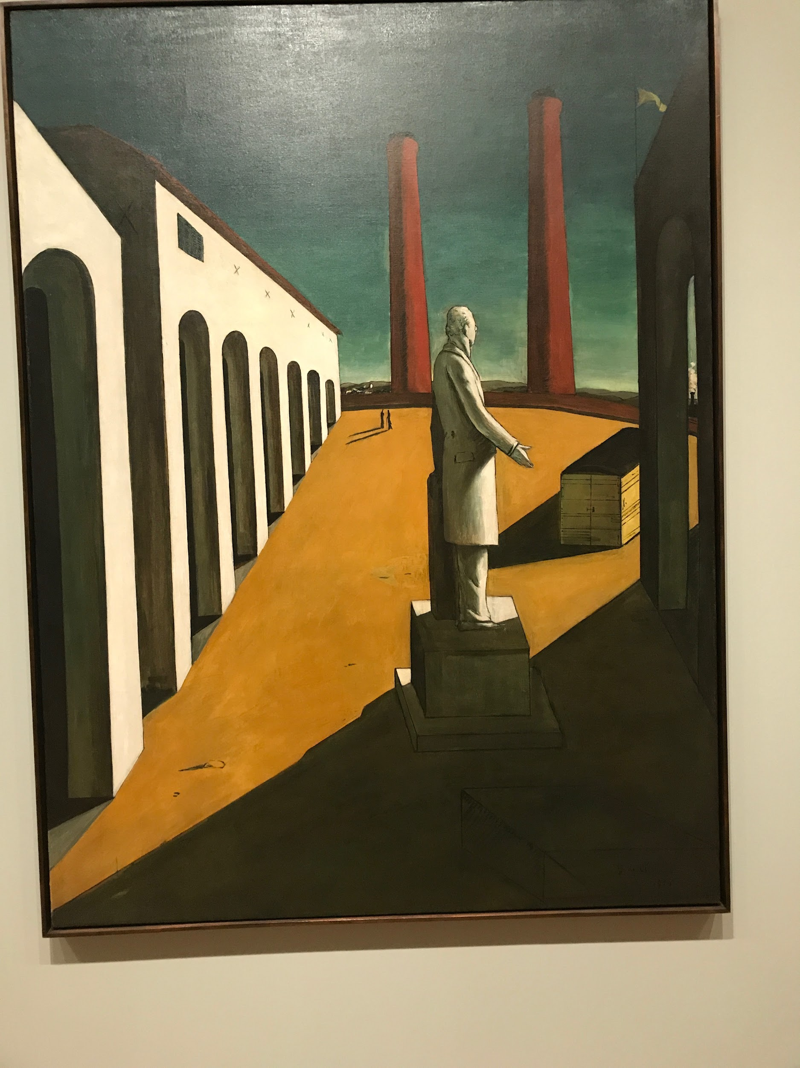
Giorgio de Chirico
The Enigma of a Day
1914
Oil on Canvas

