Artists Journal Entry

Hedi Cui
Integrative Studio: Fashion
Prof. Stacy Seiler
January 30, 2018

I’m Frank Holiday. Before I become a New Yorker, I was in Greensboro, North Carolina, where I was borned in 1957. I still remember how I used to escape to my grandmother’s place. She encouraged me to be what I want; I loved spending time with her.
As I grew older, I moved to the San Francisco to study painting. I first started at San Francisco Art Institute, then I came to New York Studio School, and ended up in the School of Visual Arts to receive my BFA in 1979. I became famous in New York in the 1970s and 1980s. That was wild and fun time of my life. I was being part of the East Village, which was very different at that time.
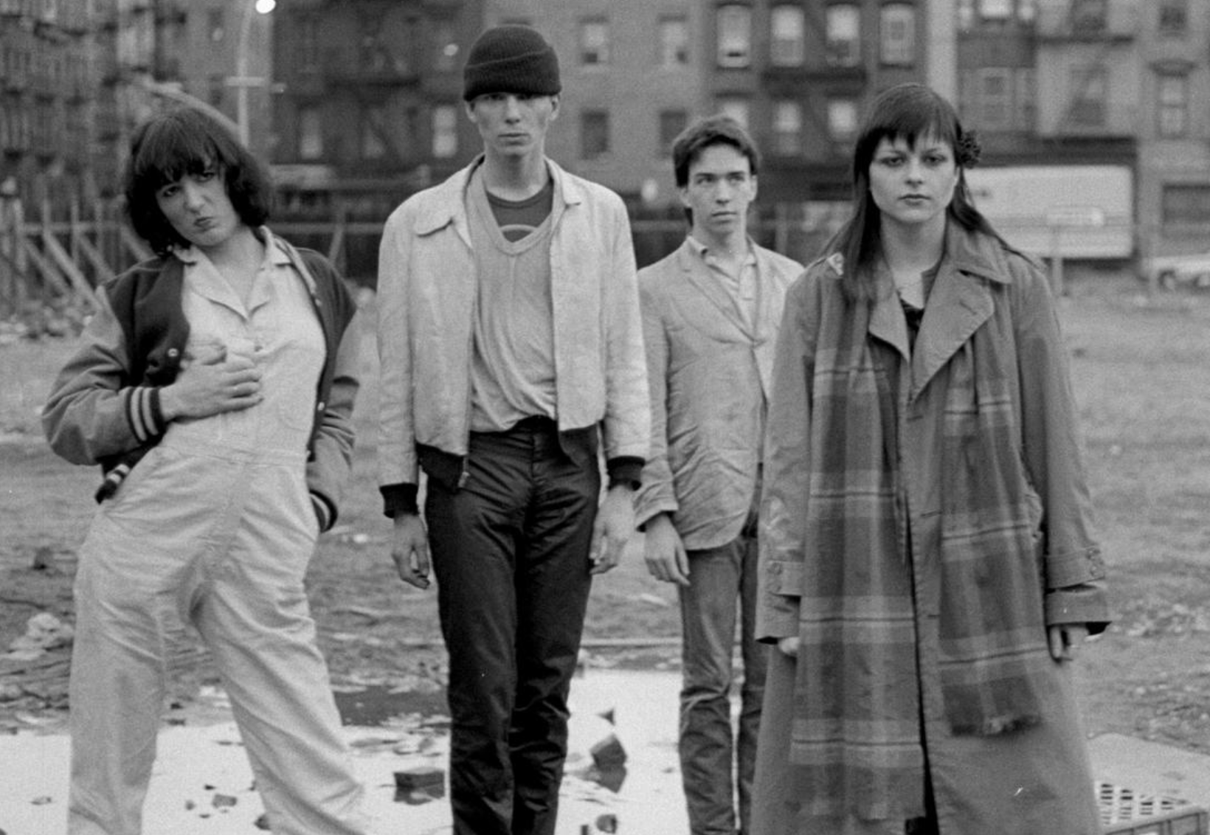
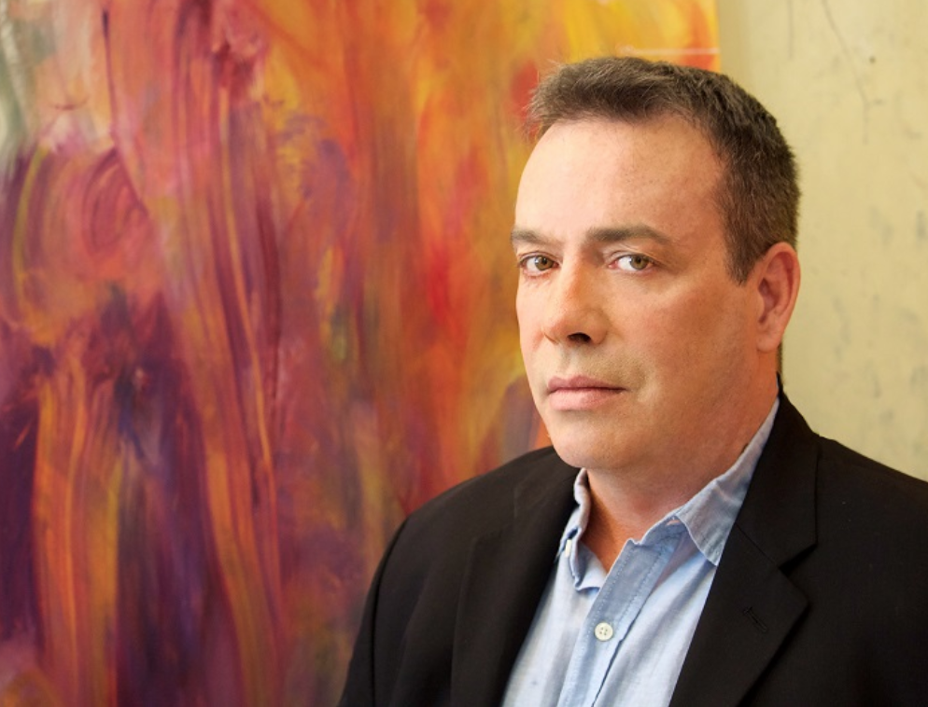
I was the original member in Club 57- a place of performance, theatre, and art shows only for our cultural generation. My friends and I created this wonderful place since we were not welcomed in the other crew. It located in a Polish church basement in East Village. I remember going down with Susan Hannaford, Tom Scully, Anne Magnuson, Andy Rees, and Dave Shapiro. It was so dusty. At that time I was doing black, so I told them paint the wall black. Club 57 was opened in 1978 and quickly became so popular. Many people had the desire to experiment the non-mainstream form of art, performance, fashion, music, and exhibition. Involving in this counterculture art scene, we were just being who we are and presenting whatever we want. I made many friends there. Keith Haring, Andy Warhol, Klaus Nomi, Jean-Michel Basquiat, and other friends were all there. Unfortunately, a lot of them are dead. All of the friendships are incredible but it can only stay in my heart.
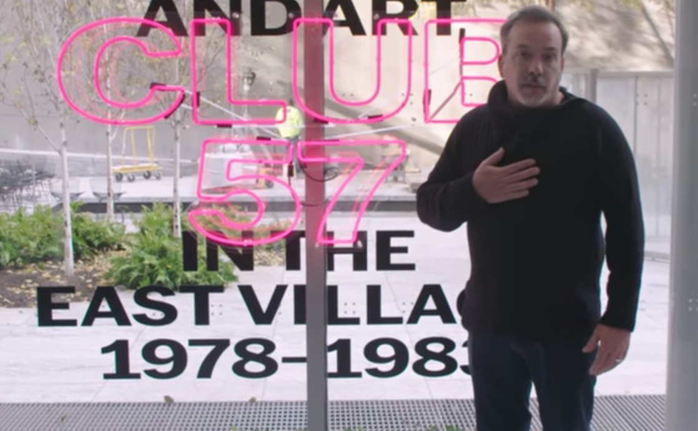
My art firstly became known in the New York art world in the seventies and eighties. I am considered as a Neo-Abstract Expressionist painter. I want to evoke viewer’s emotional moments, enabling them to realize the importance of cherish lives. My art is not typical realistic painting. I prefer to use the techniques such as pour, drip, splatter, smear, and brush to create undefined areas, unclear figures, and cloudy colors, oversetting the normal sense of art. Beside being an artist, I am also a professor in Parsons. I often share tales of my passed-away artist friends with my friend. It is bittersweet. I am in my sixties now, and live with my partner Rafael and my dog Lulu. I am also having a show at MoMa about Club 57. I welcome everyone to stop by and get a feeling of what it was like back then.

Bibliography

Holliday, Frank. "Frank Holliday Studio." Biography. Accessed January 27, 2018. http://frankholliday.net/tablet/biography.html.

Luxuo Staff Writer. "Interview: Painter Frank Holiday." LUXUO. April 18, 2016. Accessed January 27, 2018. http://www.luxuo.com/culture/art/interview-painter-frank-holiday.html.

"Oral history interview with Frank Holliday, 2017 January 24- 26." Archives of American Art. Accessed January 29, 2018. https://www.aaa.si.edu/collections/interviews/oral-history-interview-frank-holliday-17439.

Saenz, Thomas. "The Rise Of The East Village Counterculture Movement: Club 57 At The MoMA." Bwog. November 08, 2017. Accessed January 29, 2018. http://bwog.com/2017/11/08/the-rise-of-the-east-village-counterculture-movement-club-57-at-the-moma/.

Wheeler, André-Naquian. "An oral history of club 57, the legendary 80s underground art club." I-d. November 02, 2017. Accessed January 27, 2018. https://i-d.vice.com/en_au/article/evbbgw/an-oral-history-of-club-57-new-yorks-legendary-underground-art-club

YouTube. December 07, 2017. Accessed January 27, 2018. https://www.youtube.com/watch?v=fl6TBQSncuE.

André-Naquian Wheeler, "An oral history of club 57, the legendary 80s underground art club," I-d, November 02, 2017, , accessed January 27, 2018,https://i-d.vice.com/en_au/article/evbbgw/an-oral-history-of-club-57-new-yorks-legendary-underground-art-club.
Frank Holliday, "Frank Holliday Studio," Biography, , accessed January 27, 2018, http://frankholliday.net/tablet/biography.html.
"Oral history interview with Frank Holliday, 2017 January 24- 26," Archives of American Art, , accessed January 29, 2018, https://www.aaa.si.edu/collections/interviews/oral-history-interview-frank-holliday-17439.
Luxuo Staff Writer, "Interview: Painter Frank Holiday," LUXUO, April 18, 2016, , accessed January 27, 2018, http://www.luxuo.com/culture/art/interview-painter-frank-holiday.html.
Thomas Saenz, "The Rise Of The East Village Counterculture Movement: Club 57 At The MoMA," Bwog, November 08, 2017, , accessed January 29, 2018, http://bwog.com/2017/11/08/the-rise-of-the-east-village-counterculture-movement-club-57-at-the-moma/.
YouTube.
YouTube, December 07, 2017, , accessed January 27, 2018, https://www.youtube.com/watch?v=fl6TBQSncuE.
Luxuo Staff Writer.

