Jackson Heights In a Nut Shell.

Jackson Heights in Queens, New York was the largest community ever built under one developer’s control in New York City. The architecture originally created there was influenced by several movements, for example; like the urban housing innovation in Europe generally. If you go there today a lot of these old-style building will still be there and are still lived in still. In 1917 to 1940 the style of architecture was building what they called Green Co-ops or Garden Co-ops. What those types of buildings are they use the whole block of land but only used the interior surrounding land of the block to build the building for apartments or town houses and left the middle open for a green space to garden in the middle. They did this for people in the building living next to each other to feel like more of a community and to be able to interact with each other to be friendly.
Then came the 1950’s with the demand of higher density housing where it prevailed over building Garden Co-op’s. Jackson Heights architecture was going in a new direction where buildings needed to be built for the high demand for housing needed. So taller building was built there, making more available space for new comers. This is when Jackson Heights really attracted Immigrants from around the world making this one place a very diverse place to live in. In the 1970’s, there was a major economic crisis causing a huge halt in improving the housing there. Finally, the economics improved and talk of rentals, condos and possibly co-ops again came about. In the 2000’s, Jackson Heights really got re-newed attraction and attention for its quality of life and diversity in the community and also the unique architectural building still there.
Jackson Heights is 4 blocks tall and 25 blocks wide and has over 167 languages spoken in the neighborhood. A lot of people call New York City the melting pot of culture and diversity but people in Jackson Heights don’t using the term melting pot they like the term Mosaic instead. They use the term Mosaic instead because they like to think each culture stands for itself but also stick together to form a community.
A staple piece of Jackson Heights is it’s large Roosevelt Avenue elevated subway train station, built in 1917, connecting Jackson Heights to Grand Central Station and many other locations, making it a hub of transportation. It also has LaGuardia Airport near by, many bus routes and stops, many people walking the streets, A major subway station and many roads used for truck routes. The one thing I noticed while in Jackson Heights is missing bike lanes and congestion of traffic mainly on Roosevelt Avenue. I did notice a lot of bikes there but all chained to lighting lamps and only a few bike racks to lock to.
The problem I would like to fix or find a solution to is the congestion on Roosevelt Avenue by adding a bike lane and also making it shared with a bus lane during designated hours of the day. A major problem I read about and also noticed by being in Jackson heights is there is a lot of bikers and they either have to share the main road with cars and busses or use the sidewalk and be in the way of people on the street. I think by creating more bike lanes and placing citi bikes could prompt more people to use bikes to get around the neighborhood and not wait in traffic.
Another problem in the neighborhood is with feeling like a community and not separated by the different cultures and races. Residents in Jackson Heights talked about the need for more public spaces like parks, so the community can hang out together and plan events to gather and meet new people. If there were more parks built in the area, there could be more public space for people in the community to go to and also, we could place bike lanes or trails to have a more scenic route to see.
The questions I would like to know more about is how people feel about all the transportation that is available in Jackson Heights and what could be improved. I want to interview people that take the public transportation on a daily basis and also interview people I see parking bikes or using them. I would want to ask if putting bike lanes on Roosevelt Avenue would be helpful to them or not. I also think interviewing bikers that are for example Uber Eats bikers who deliver on bikes and have to navigate routes to get to people houses, or apartments would be useful and helpful to my research.
The stakeholders in Jackson Heights that I can think of and see is the New York City Department of Transportation, any other type of transportation department, elected officials, private owners, and the community. I would like to interview the New York City Department of Transportation for sure because they will hopefully give me the most information about the current transportation in Jackson Heights and if they have any plans in the works to solve problems I have noticed. Also want to interview people in the community and ask if adding a bike lane would be useful to them or not and if it would encourage them to use biking as a form of transportation more if there were lanes placed in the streets.
I plan to add to my knowledge in the week few weeks about what it takes to add in bike lanes in a major road, how can you get citi bikes in Jackson Heights, how adding bike lanes could help the environment by adding another way of transportation. I would also like to know the process of getting this approved as if it was to actually going to happen in the neighborhood.
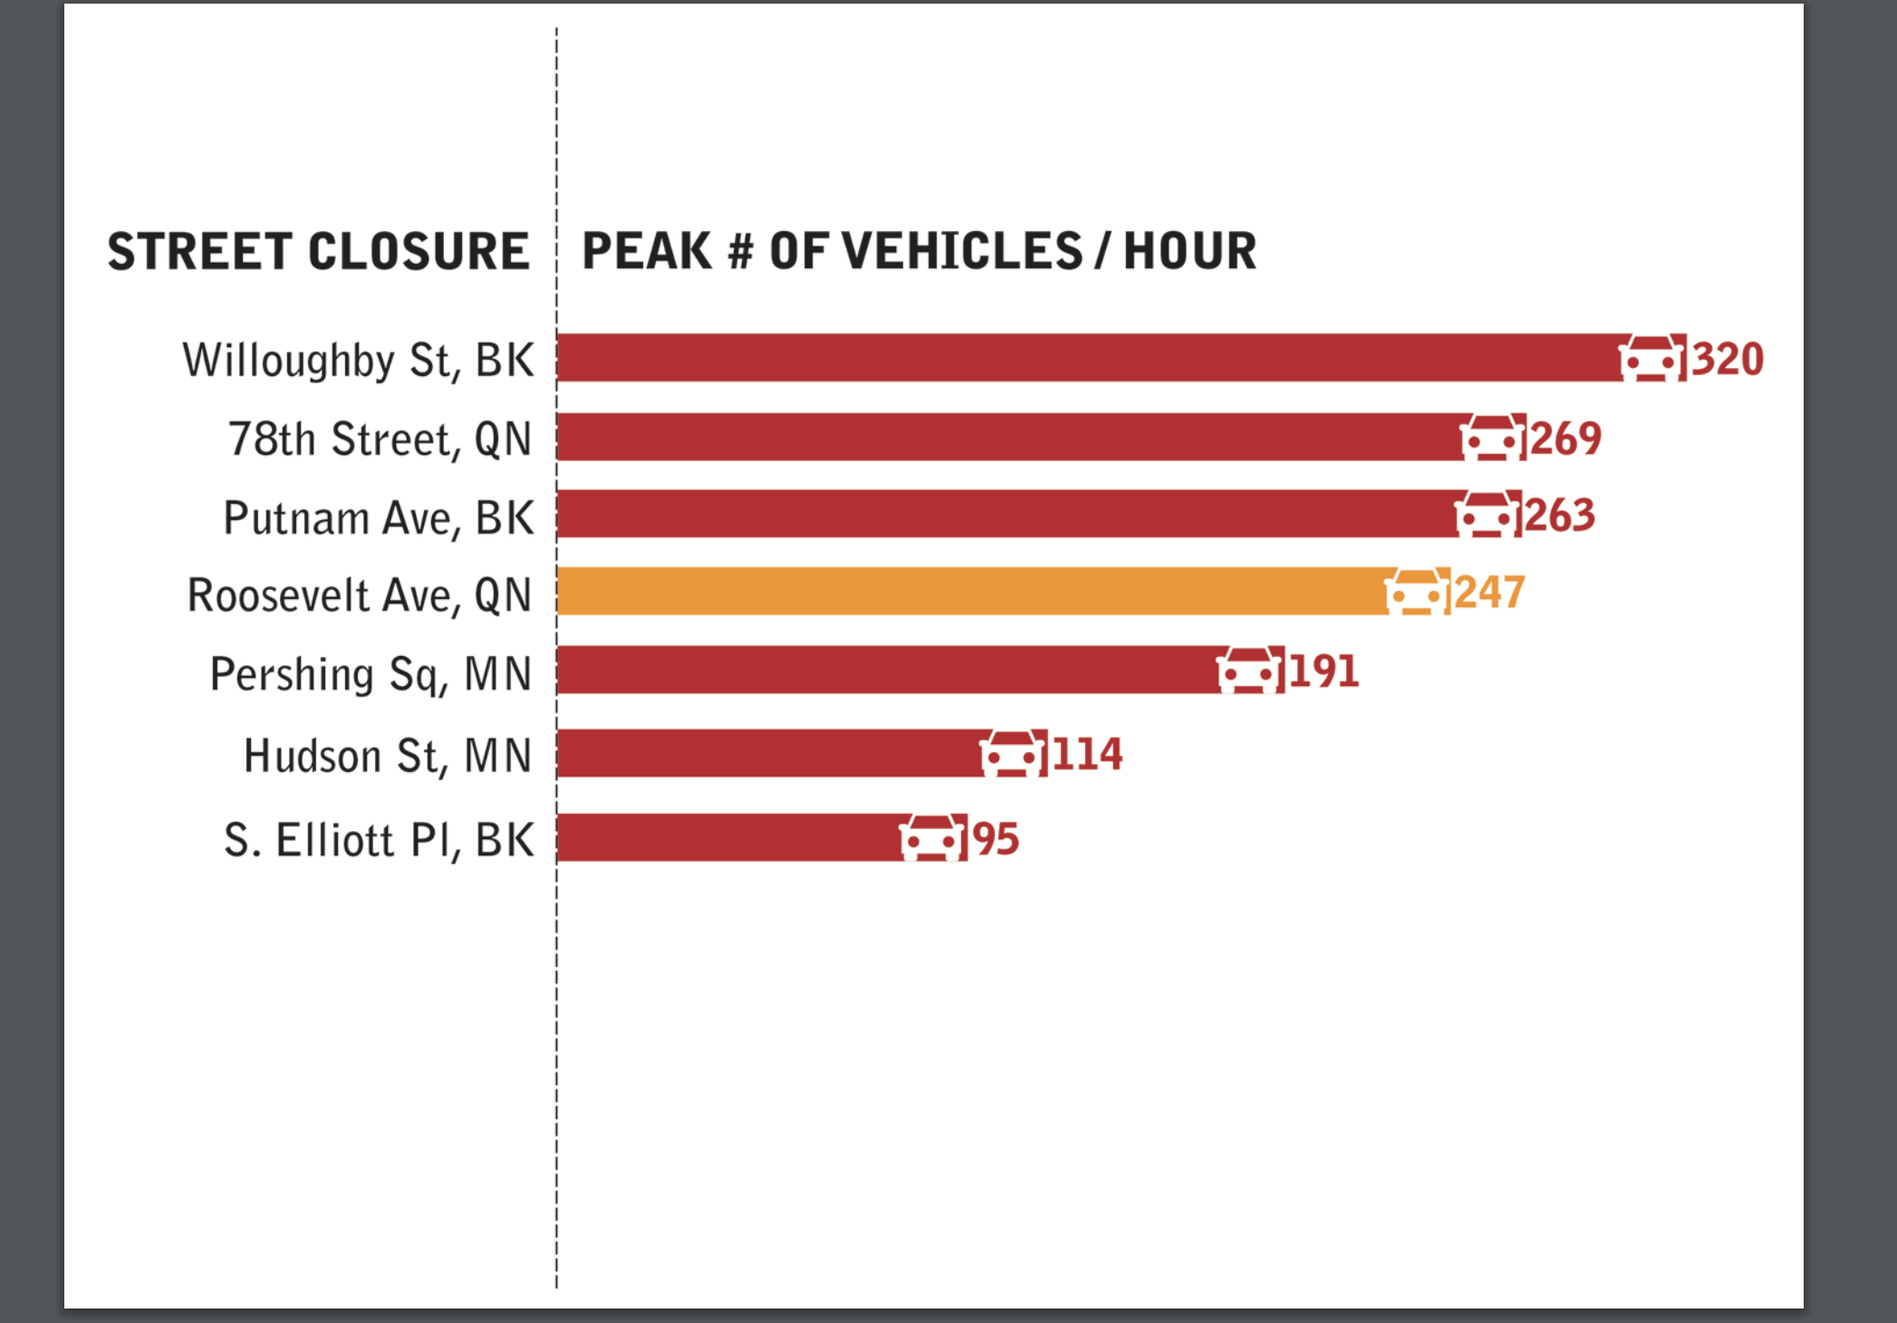

This Graph was useful to understand and compare how congested Roosevelt Avenue was compared to areas surrounding it and how there is a problem with traffic.
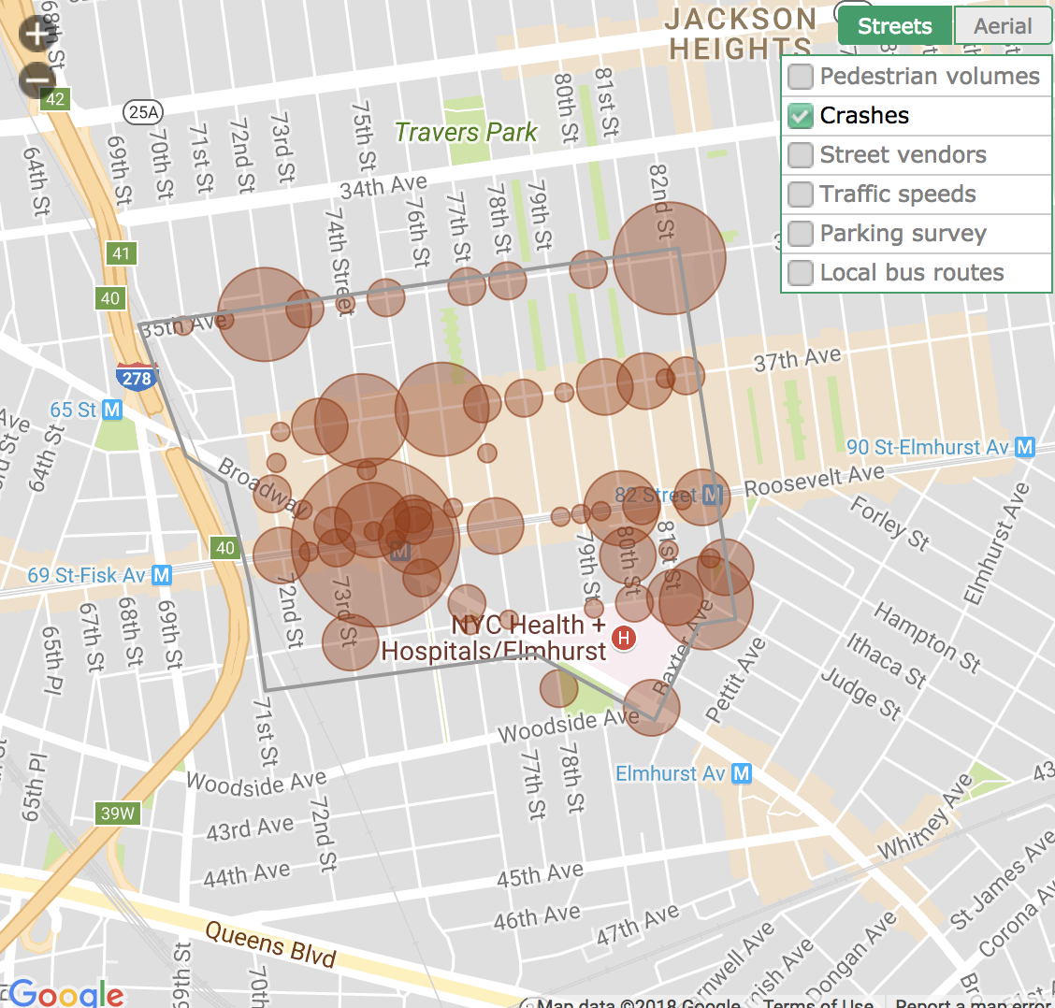

This Chart shows crashes by cars caused by pedestrians and bikes. This helped conformed the need for a solution to congested streets.

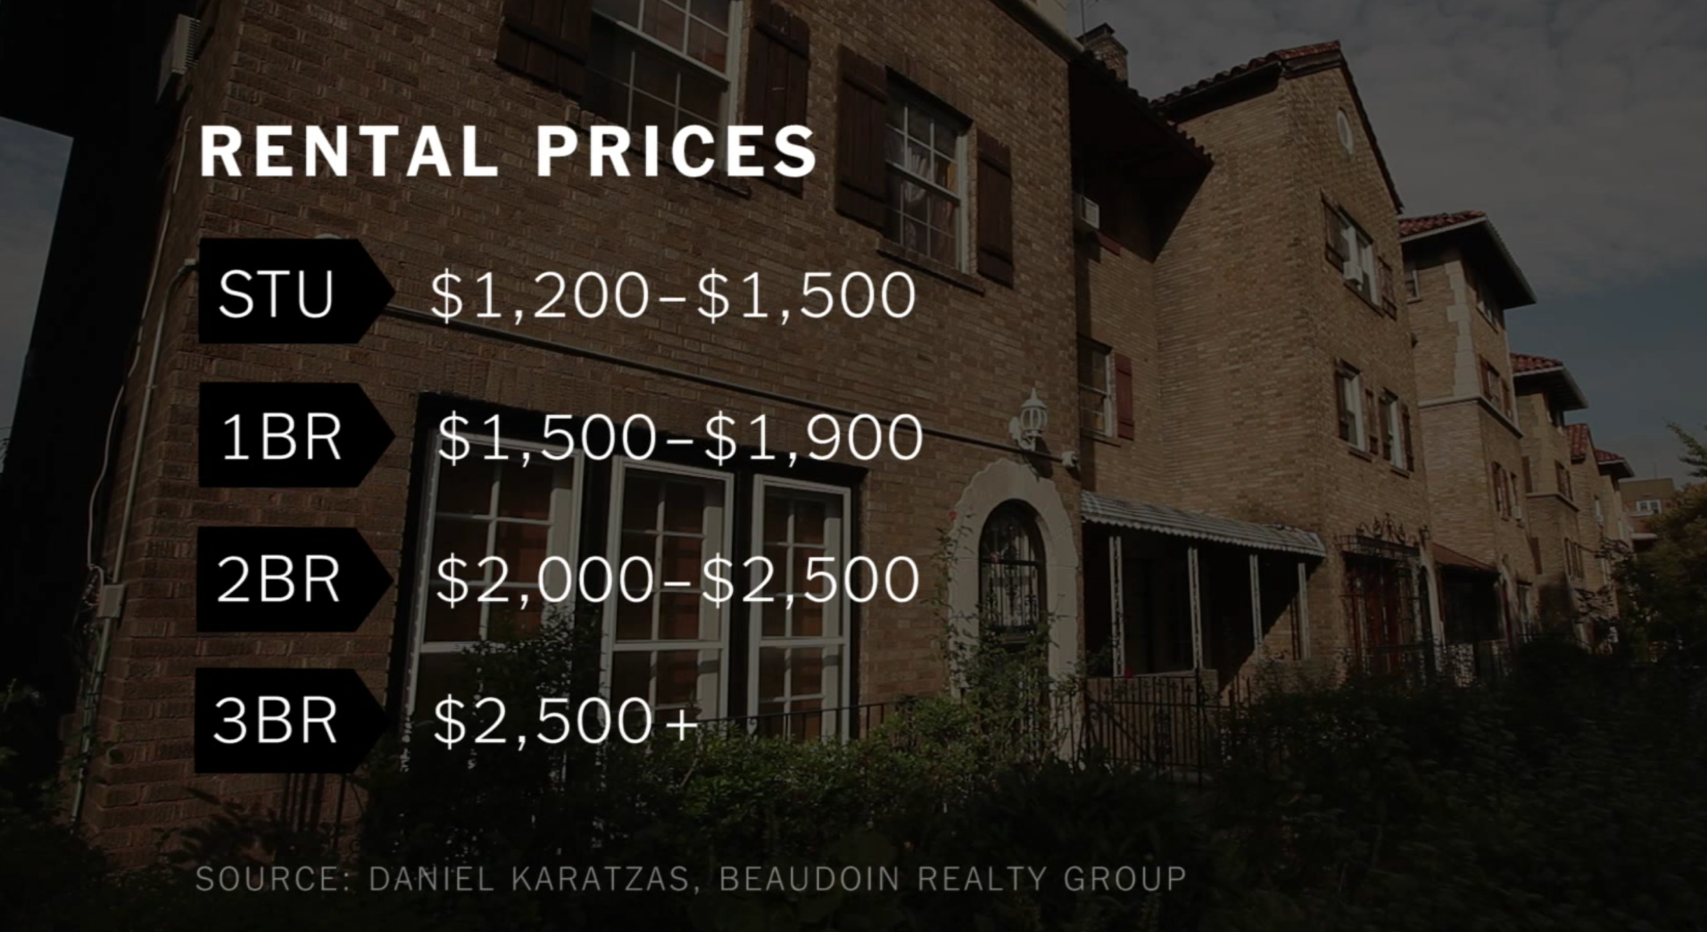
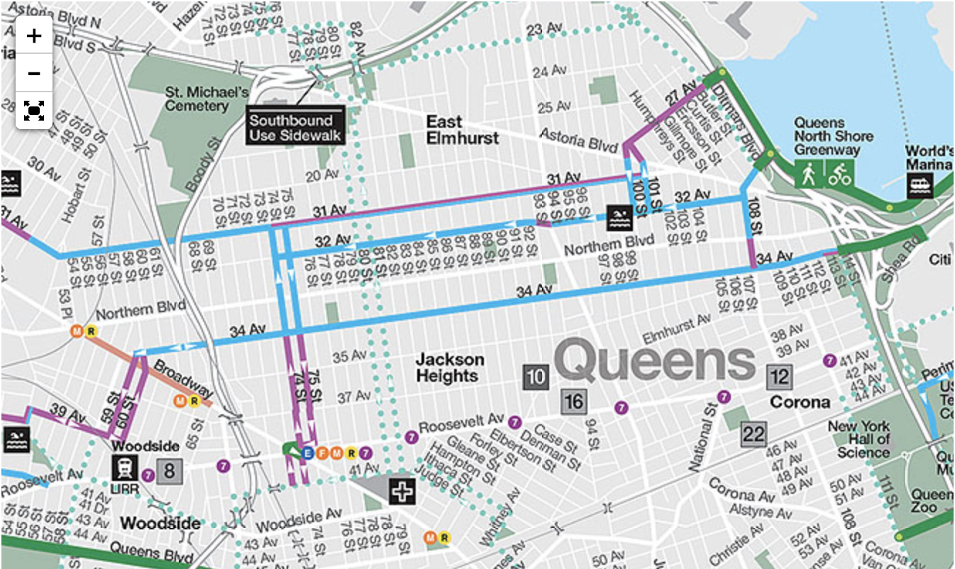
This map is of the current bike lanes in Jackson Heights. It shows how there is only 3 lanes and none on Roosevelt Avenue where there is a real need for some.

This info helps understand the pricing in the area compared to how much it used to be and helped me understand the history.

Work Cited

- https://www.youtube.com/watch?v=rdDwqg8ujWY

This video is from the new York times and gives information about Jackson heights through interviews with people in the community and talks about main topics of the neighborhood.

- http://www.govtech.com/fs/perspectives/In-a-New-York-City-Neighborhood-the-Challenges--and-Potential--for-Americas-Urban-Future.html
An article about challenges in Jackson Heights and Talks about problems that have accrued and how the community handles it. Also talks about the future of the neighborhood and how changes could hurt the economics there.

- https://member.citibikenyc.com/map/
This is the link to the citi bike website that shows where there is places to rent bikes. This helps show that there is no bike stations in Jackson heights to use.
- https://www.nycgovparks.org/facilities/bikeways
This link gives information about parks and public spaces in NYC. Also gives info about the bike locates and just basic info about the bikes.

- http://www.nyc.gov/html/dot/html/bicyclists/bikemaps.shtml
Very helpful link that talks about NYC bikes and gives a map of all the bike lanes in NYC right now and gives all information about safety and requesting for a bike lane.
- http://www.nyc.gov/html/dot/html/about/current-projects.shtml#plaza-program
This link is about areas that have public plazas for their communities. It show that Jackson Heights has requested one and show a mice power point of points to when they need a plaza in the neighborhood.
- http://a841-tfpweb.nyc.gov/jackson-heights/map/?zoom=16&lat=40.74826&lon=-73.889&layers=B0FFFTFFTTT
This link is the most helpful to my data collection. This was a webpage about a study of transportation in Jackson heights and gives useful facts to problems in the neighborhood with their transportation.
- http://a841-tfpweb.nyc.gov/jackson-heights/files/2010/11/qn_cb4_06_1_10.pdf
This PowerPoint is about all the issue with the transportation in the neighborhood. And possible ways of fixing the problem in the future.

- http://maps.nyc.gov/census/
Gives data and statics of Neighborhoods in nyc.

