Sustainable Systems Natural Dyeing PH experiment Worksheet
Water and Collection Experience and Analysis (EA): The Natural Dyeing Exercise

A Record of Your Scientific Method
Date: 13 September 2019 Season:Summer

Gowanus Canal
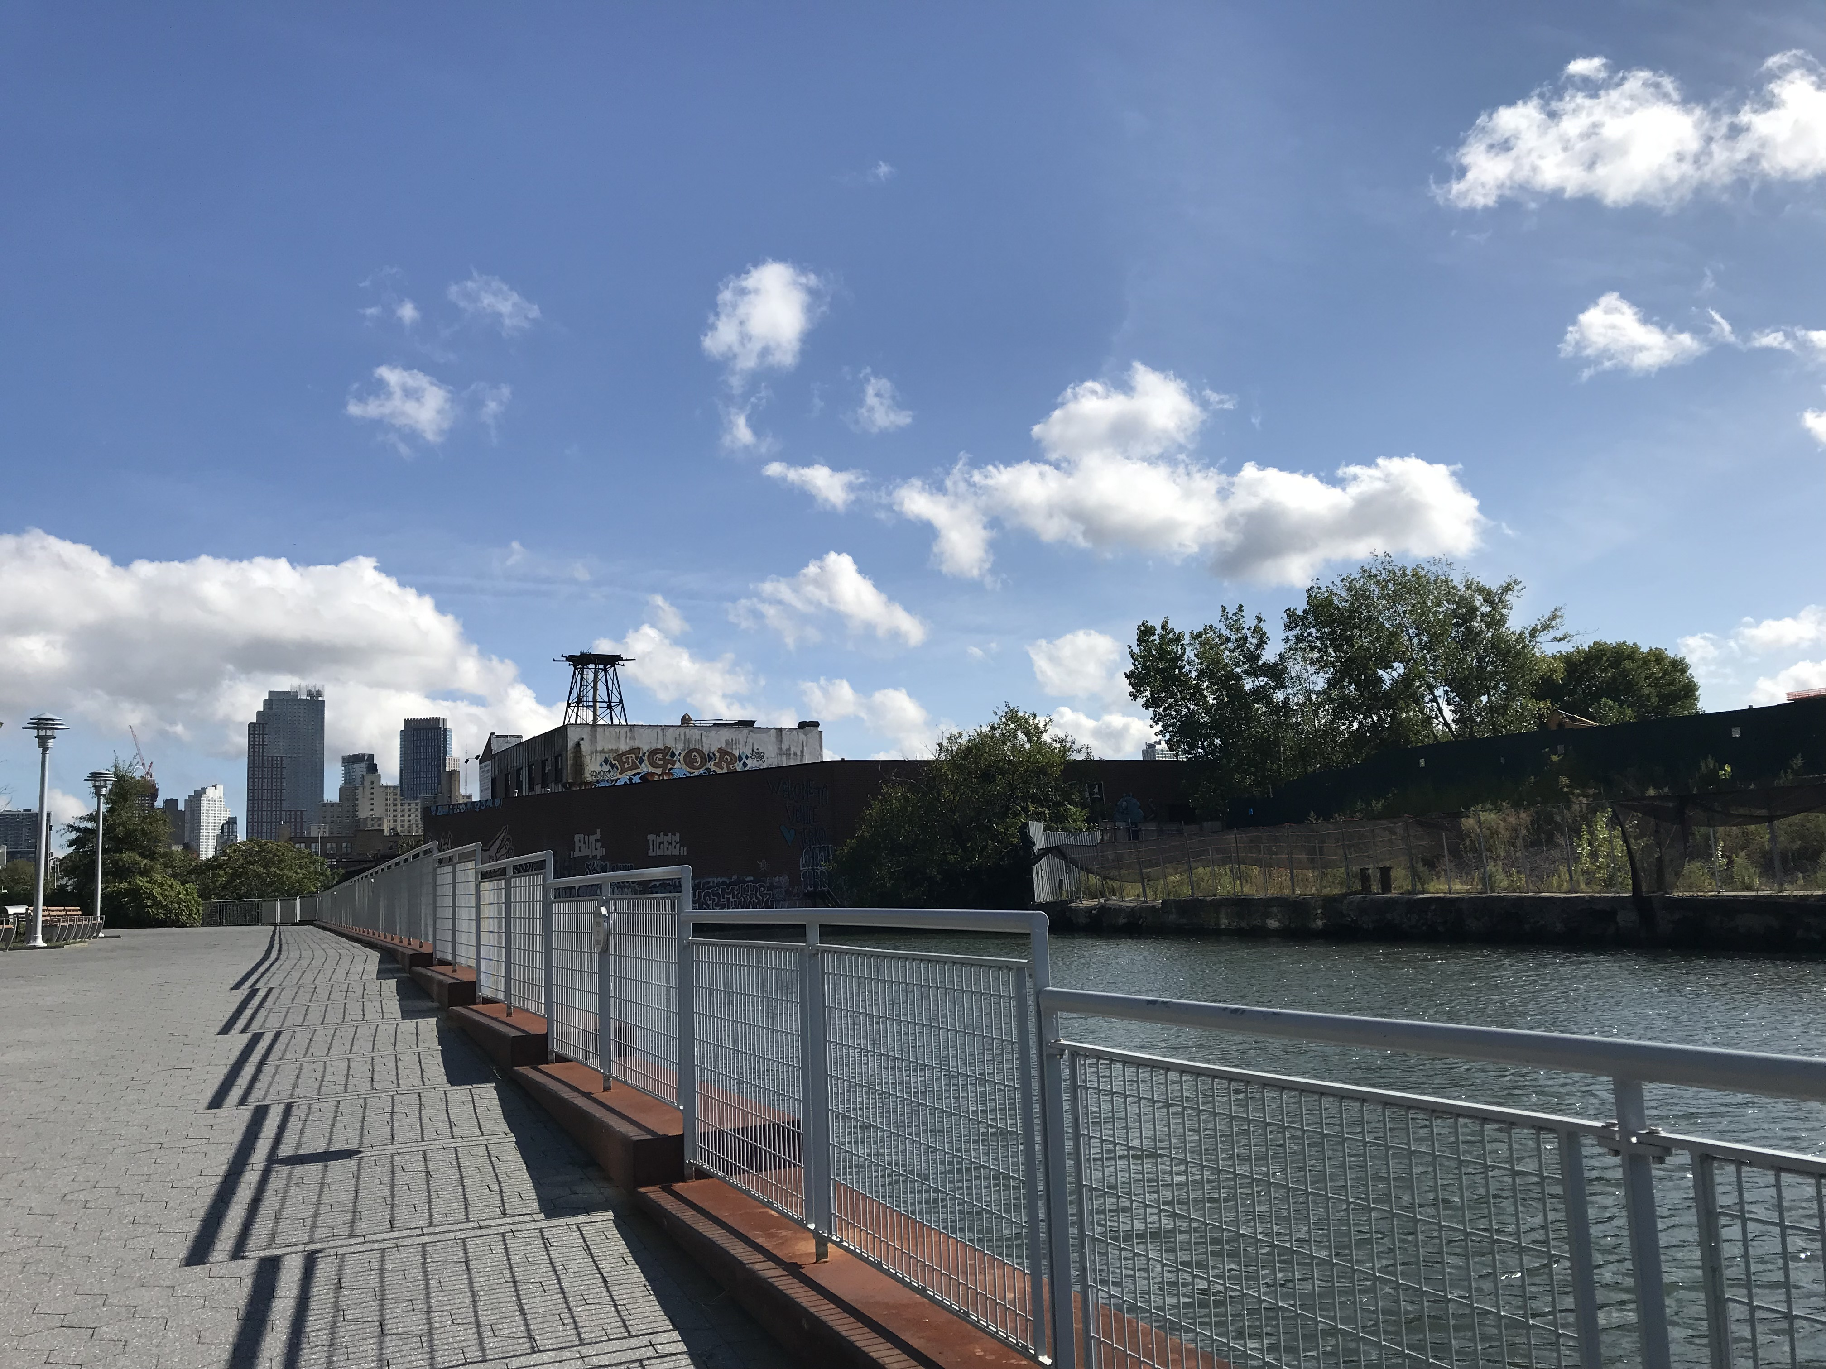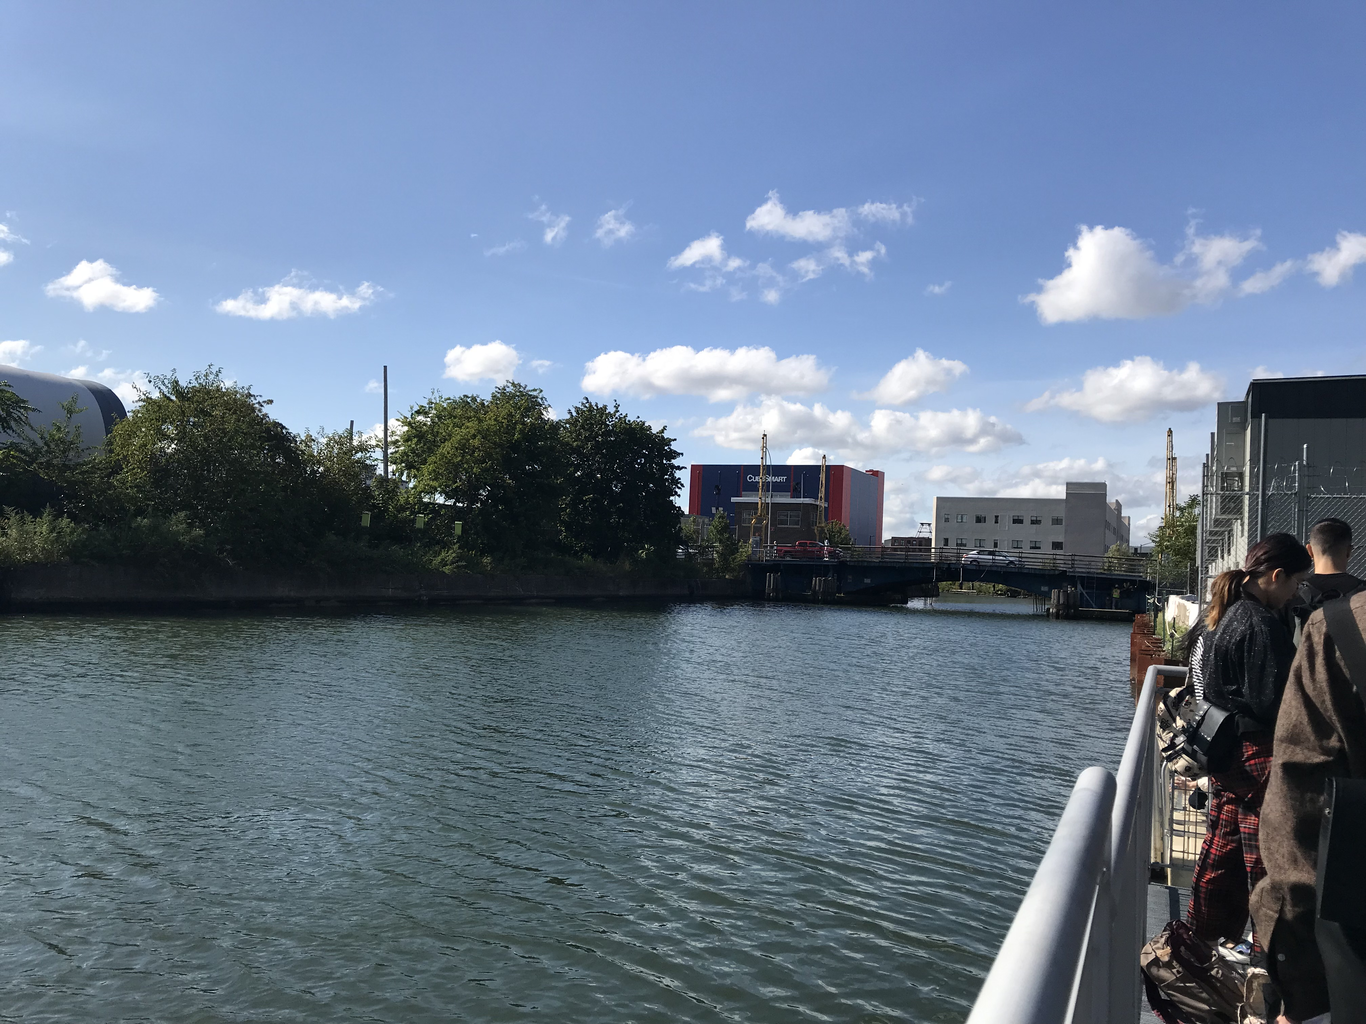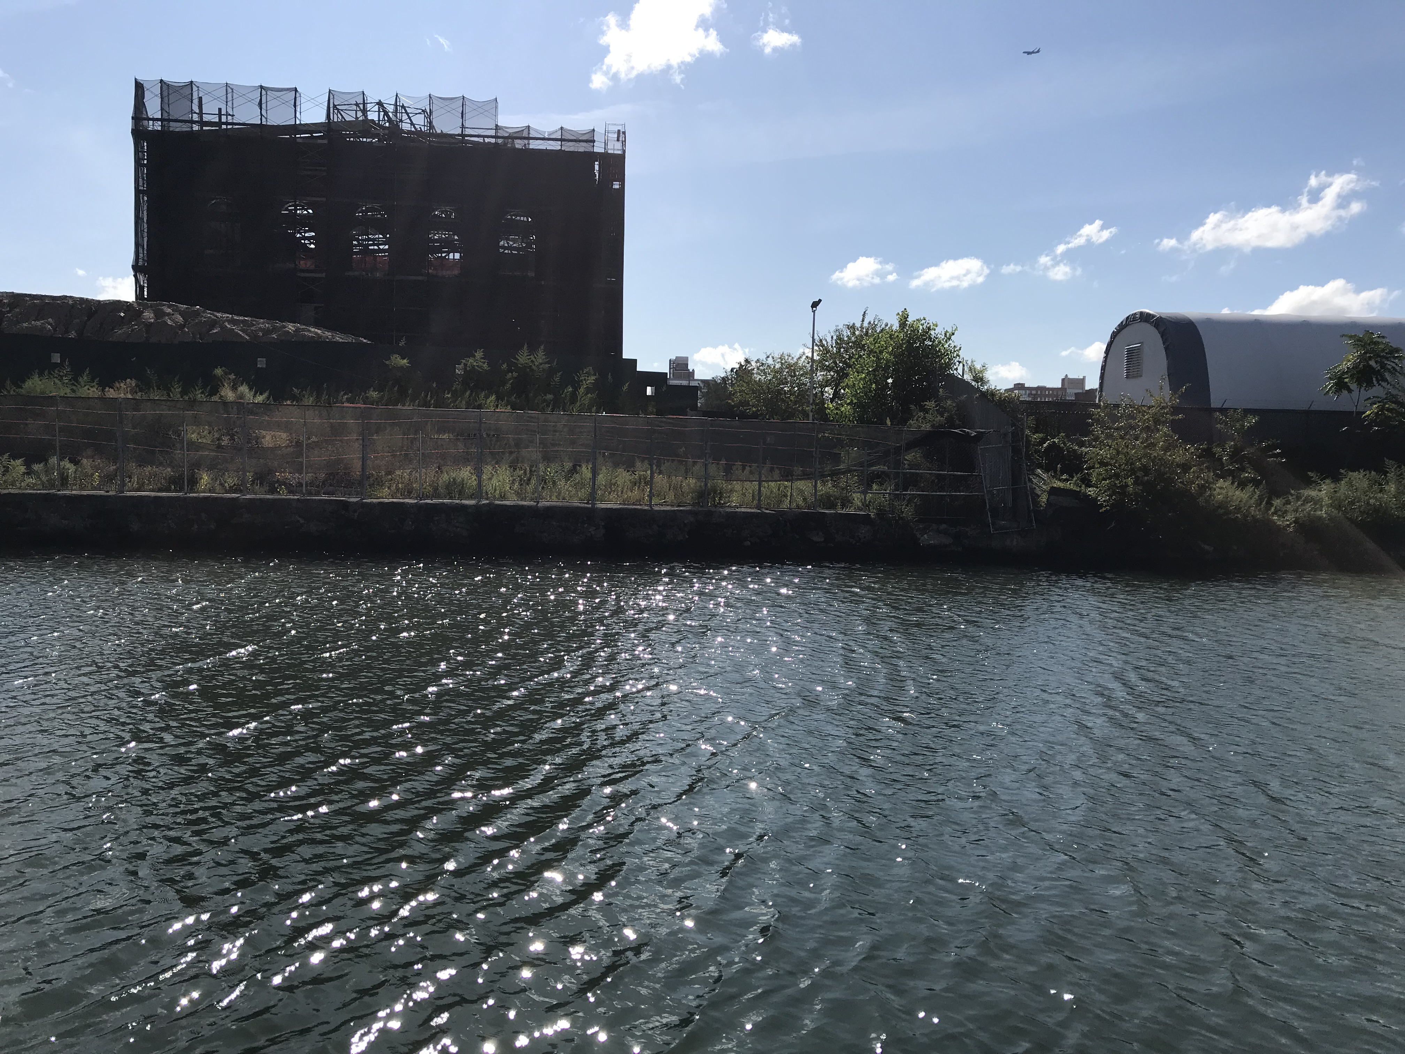

Make a brief observation of surroundings and state of water:
The canal is surrounded by apartments, insustrial buildings, office buildings. The water looks clean from afar because blue with not a lot of trash.
Water PH: 9

Which Protocol you are using? Describe your protocol/Dye Recipe:

Fabric: Cotton (143g)

Dye/volume:260g

Mordant/amount (measure given amount using measuring spoons):Alum- 21.45g
Assistant : Iron – 2.86g

I used 15% of the fabric weight for the mordant and 2% of the weight of the fabric for the assistant.

What do you predict will be the outcome based on your observations?
I predicted that the water would be the most polluted out of the other water samples because it is surrounded by industries and apartments that produces polluted waste water that is thrown to the canal, therefore the canal’s water would be affected.

Extraction process notes (include reflections on what happens in the process of your analysis):
In analyzing, I measured the ph. level and also the color of the fabric. The ph. turned out to be 9 and the color of the fabric was the darkest out of the 4 water sample.

Reflections about the pollution results and PH of water conclusion:
The ph level is 9, therefore it is really high on alkaline. This ph is the highest out of the 4 samples and the color of the end fabric is the darkest too. This means the water is the most polliuted out of all the 4 samples. Having the ph level 9 means that the water has a high concentration of alkaline because industries and apartment buildings produces sewage water that contains high level of alkaline. The water is thrown to the canal, therefore making the canal high in alkaline.

Attach a piece of the dyed textile


