Sustainable Systems Natural Dyeing PH experiment Worksheet
Water and Collection Experience and Analysis (EA): The Natural Dyeing Exercise

A Record of Your Scientific Method
Date: 19 September 2019 Season:Summer

Location of water collection: Prospect Park

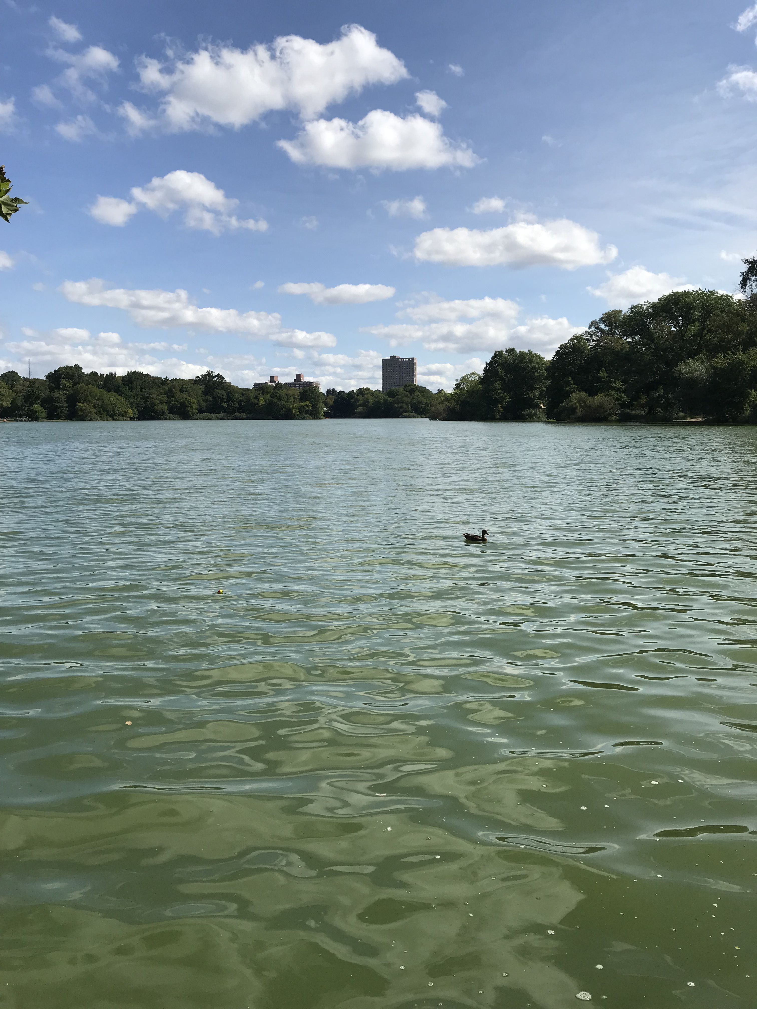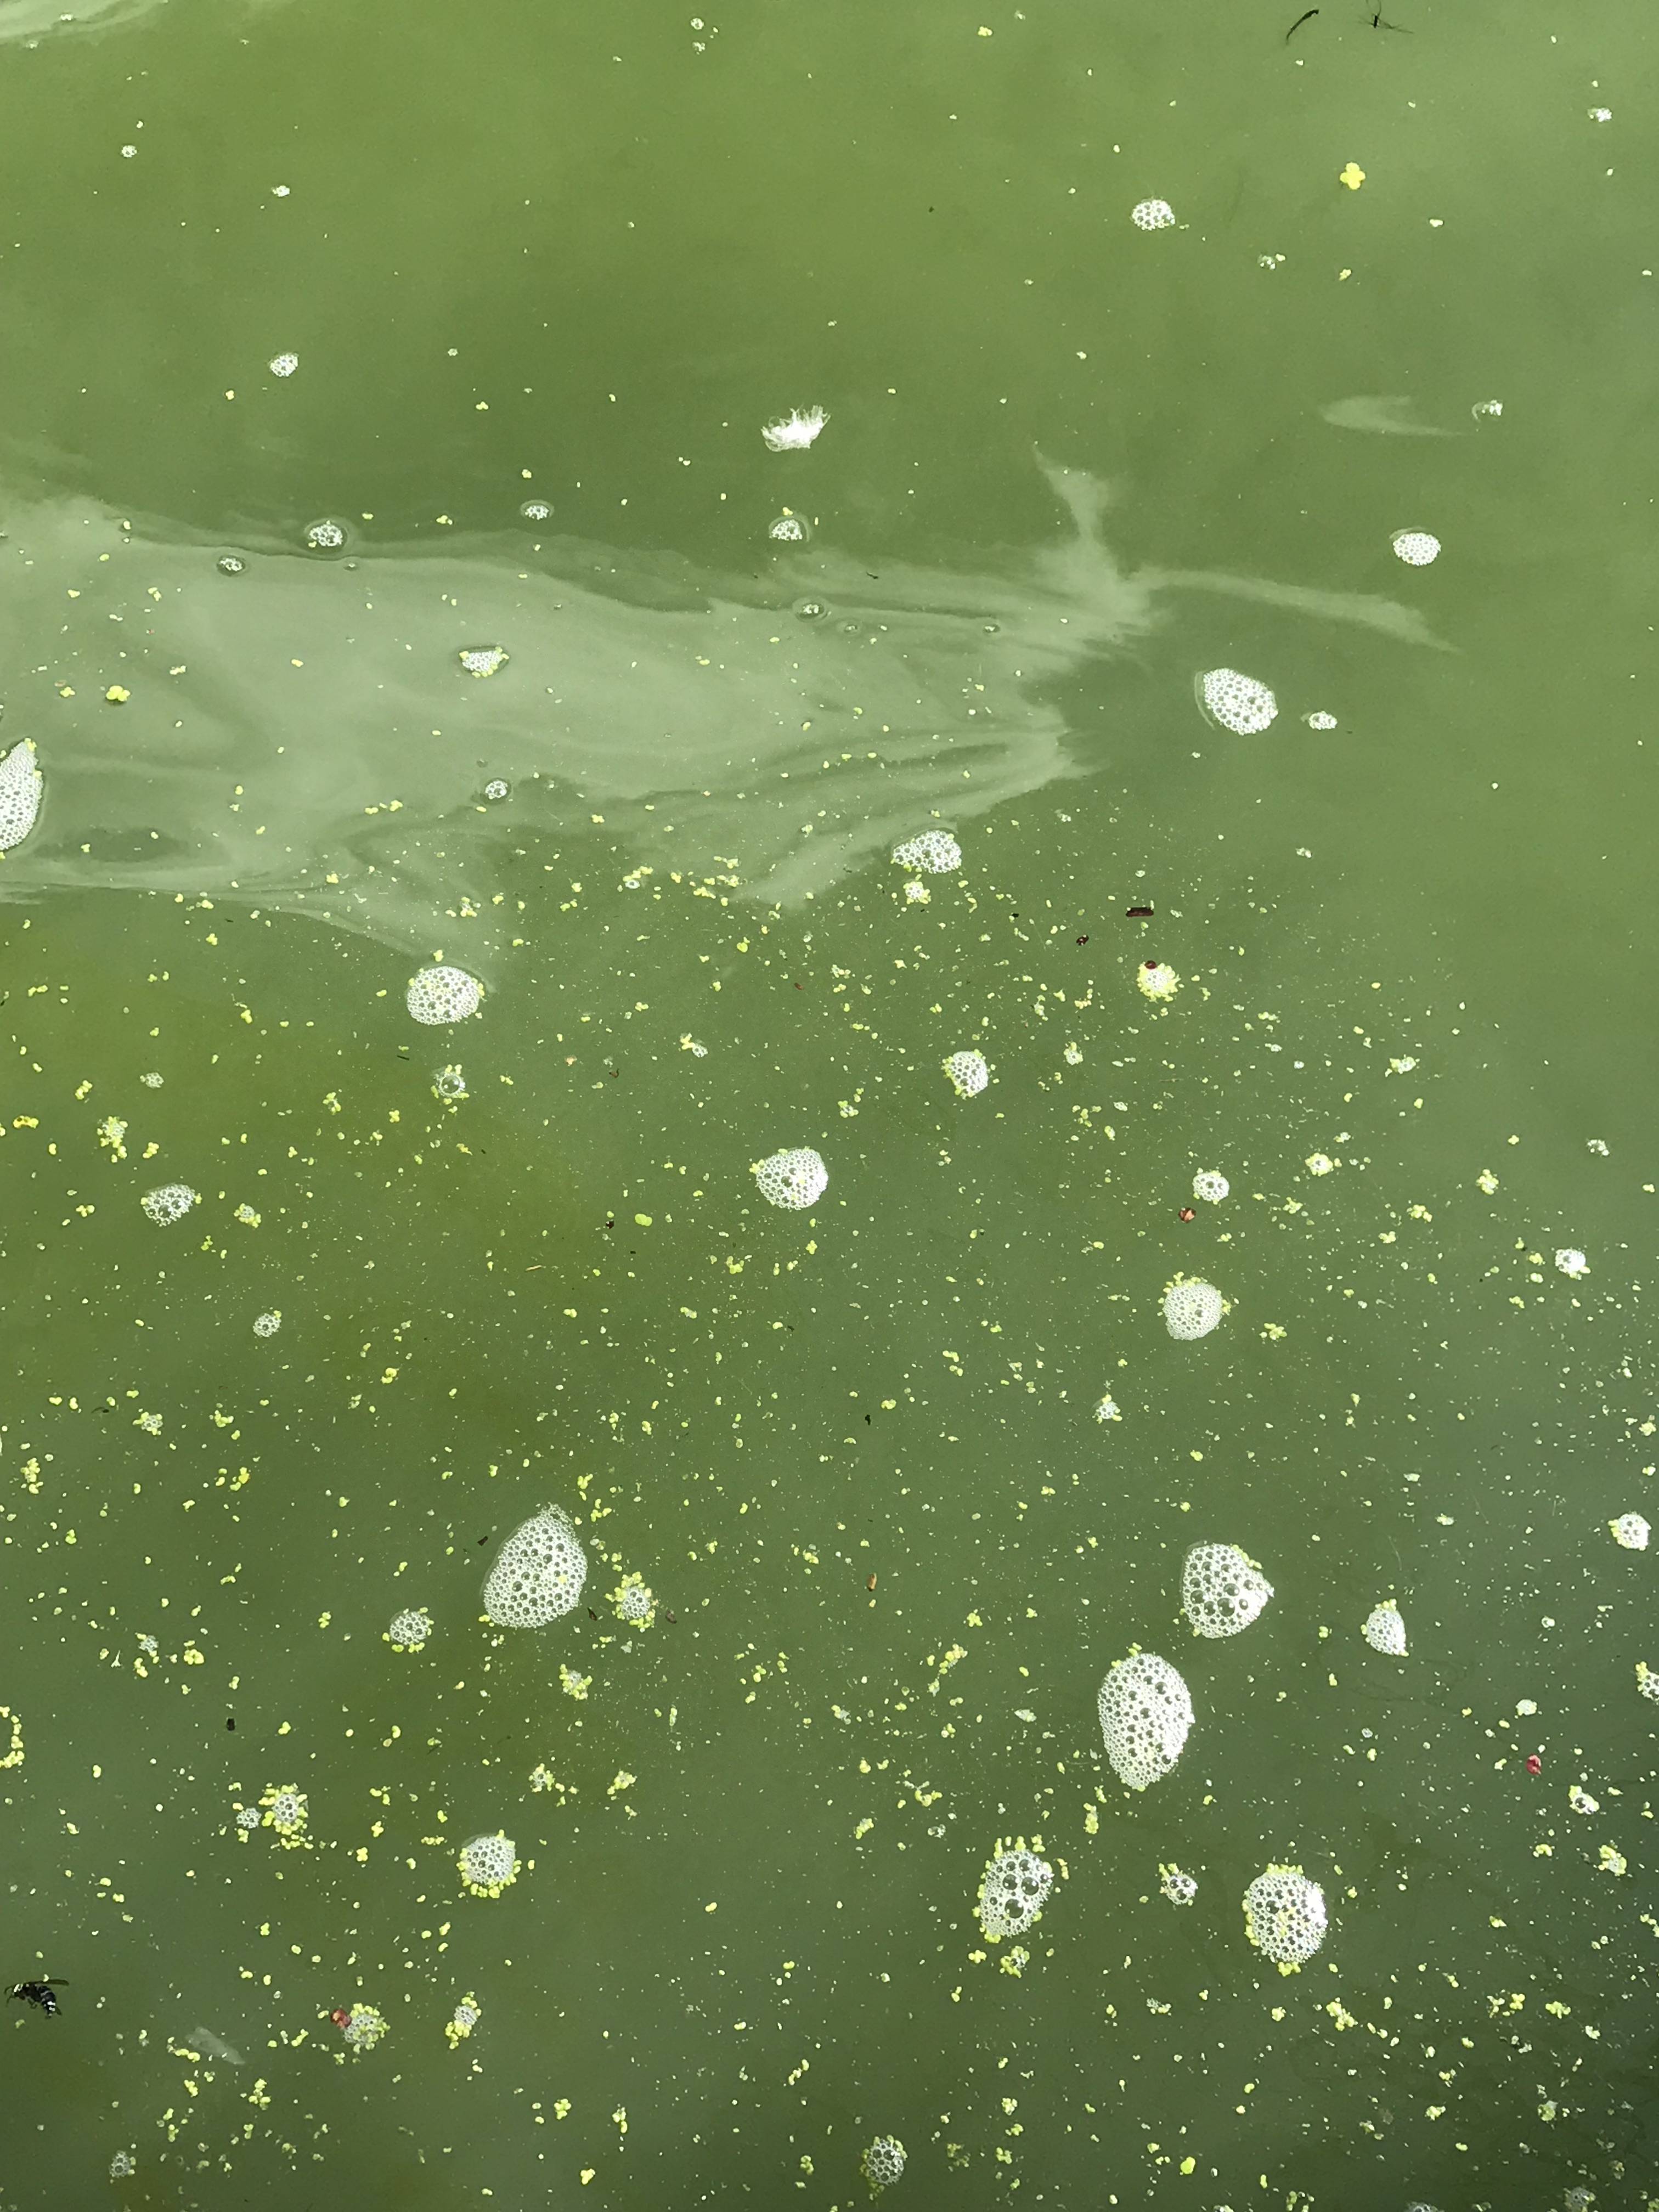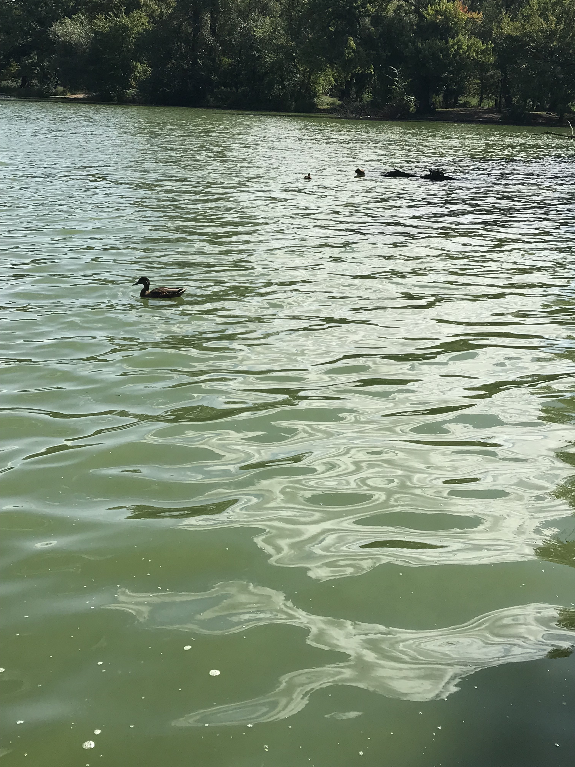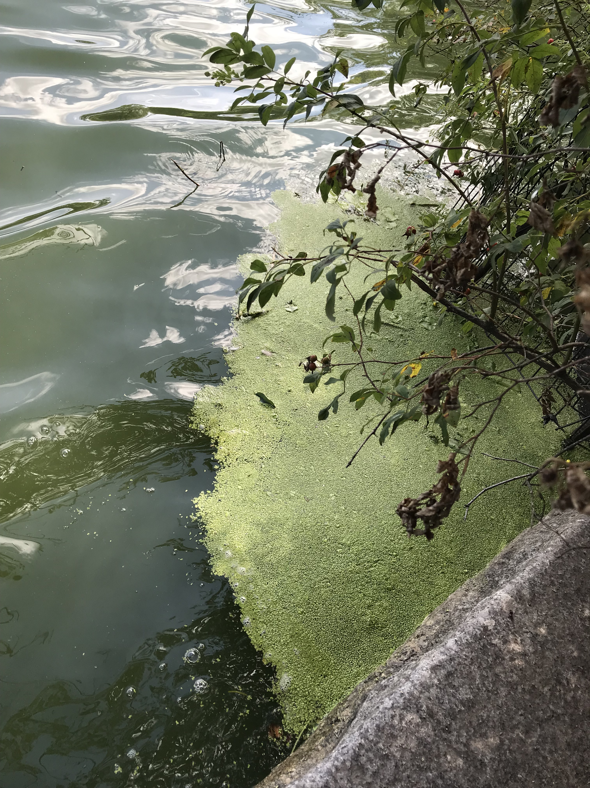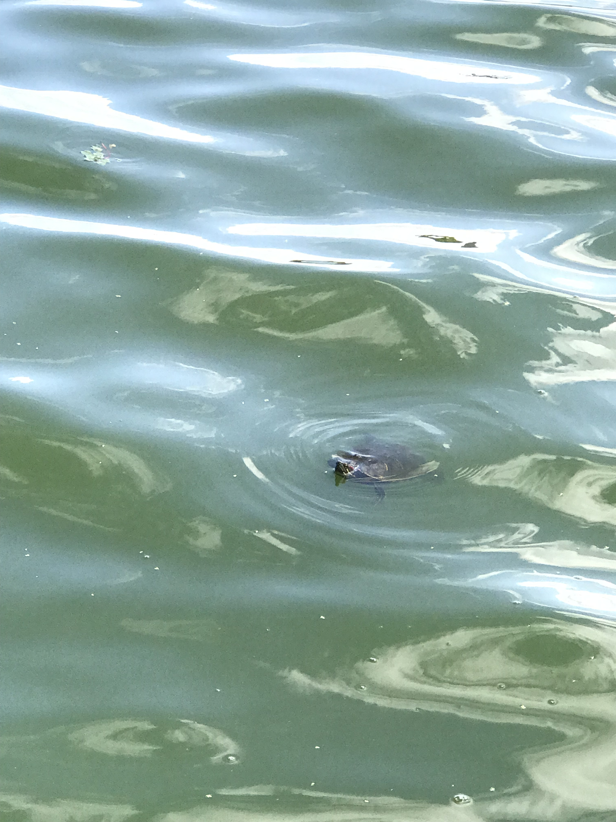

Make a brief observation of surroundings and state of water:
The water has a lot of algae in it and is green in color. There are lots of animals in the lake. The water is not clear and there may be signs of eutrophication because of the color of the lake.
Water PH: 8

Which Protocol you are using? Describe your protocol/Dye Recipe:

Fabric: Cotton (143g)

Dye/volume:260g

Mordant/amount (measure given amount using measuring spoons):Alum- 21.45g
Assistant : Iron – 2.86g

Further Recipe Notes: I used 15% of the fabric weight for the mordant and 2% of the weight of the fabric for the assistant.

What do you predict will be the outcome based on your observations?
I predicted that the water would just be a little polluted because there are animals living in the lake as a sign that the water is in good condition.

Extraction process notes (include reflections on what happens in the process of your analysis):
I measured the ph and it turned out to be 8. The color of the fabric was dark but not as dark as the gowanus canal.

Reflections about the pollution results and PH of water conclusion:

The ph level shows that the water has a little bit of alkaline concentration. This is probably the result of the minerals from the algae and plants around the lake. Also, since sewage water that is high on alkaline goes to the lake, becomes contaminated with alkaline. However, the water is not that polluted compared to the water in the gowanus canal.

Attach a piece of the dyed textile


