Gabriel Ozorco’s Eco-Art
Liz Burghart

Professor Bergman
Sustainable Systems
4 September 2018

Gabriel Orozco’s Astroturf Constellation is a collection of found objects gathered from a playing field. This piece was created for the Deutsche Guggenheim, Berlin in 2012. It is comprised of an array of 1,188 coins, glass, sneakers, soccer balls, metal, candy wrappers, chewing gum, thread balls, paper, and many more pieces of debris collected from Pier 40 in New York City near his home. These objects are arranged by material, color, size, and other criteria, as well as matched with 12 grids of photographs of the objects printed on a larger than life scale, and a 13th grid to document the landscape from which the items were found.
While playing on this pier, he began to notice all the garbage being left behind and felt inspired to create this piece. This provocative and uniquely inspired work is visually appealing yet equally effective. Throughout all of Orozco’s work, his main theme is the relationship of human beings to everyday objects. Sandstars is another large-scale piece of his created by found objects in a similar manner to Astroturf Constellation. The site of Sandstars was a nature preserve in Mexico, near where the artist is originally from, where whales go to mate and later to die. He and a group collected nearly 1,200 objects since the beach is not regularly cleaned. Objects include glass bottles, light bulbs, tennis balls, paper rolls, and so much more.
At first glance, both parts of these creative pieces, the viewer clearly sees how large of an issue littering and waste management is. Orozco’s work can do the planet and the human race a favor by bringing attention to an often-overlooked issue and promote a more conscious way of living. To keep this interesting, the artist has provided little information regarding his inspiration or reason for creating the art yet leaves it up the viewer to decide what they think the purpose of the piece is. Personally, I think these pieces are a bold statement of how the little things can add up and be so destructive right under our noses. Most don’t notice until the problem is right in front of our faces, which is what Orozco does with the larger-than life photographs against a very minimal white background.

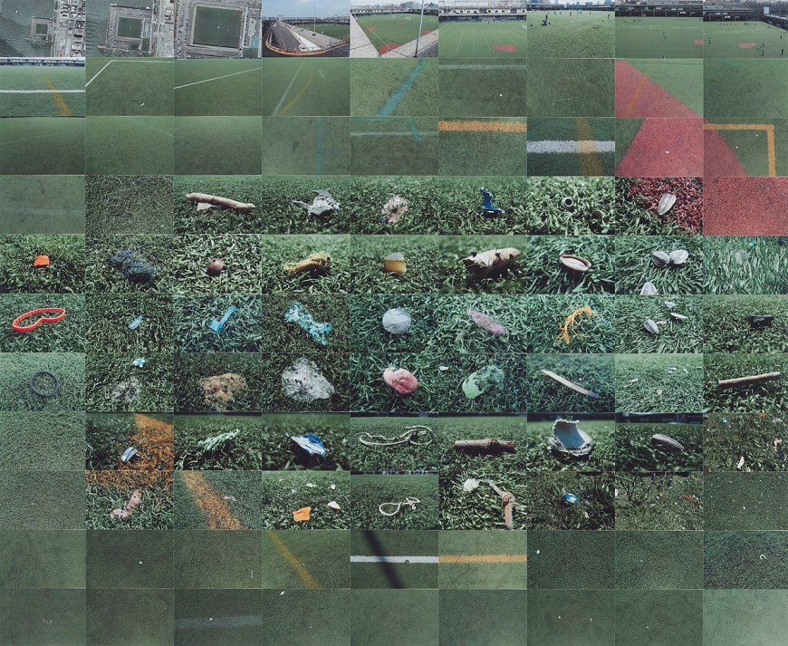
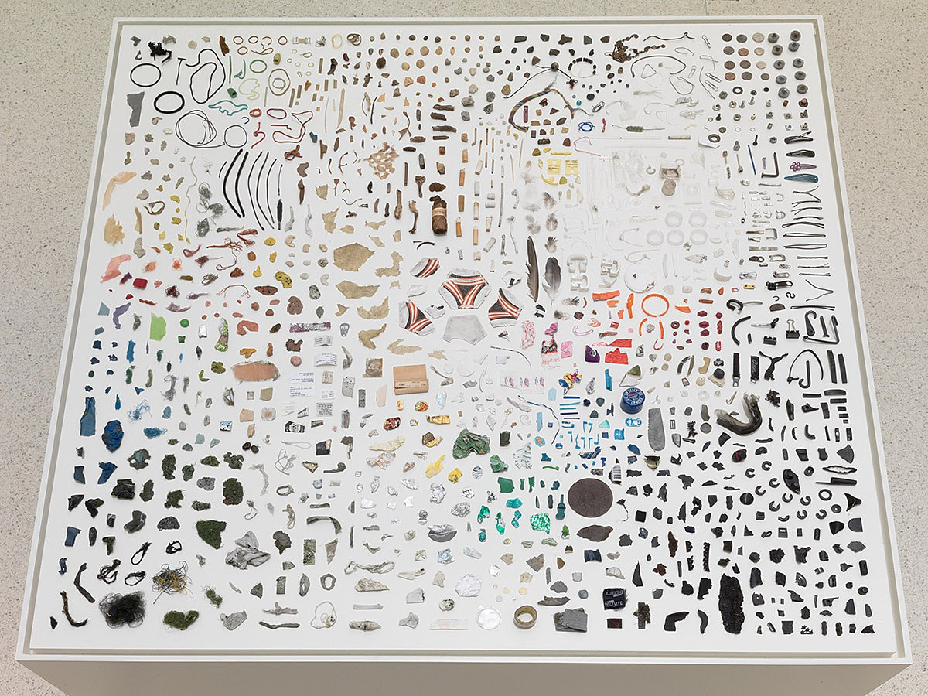
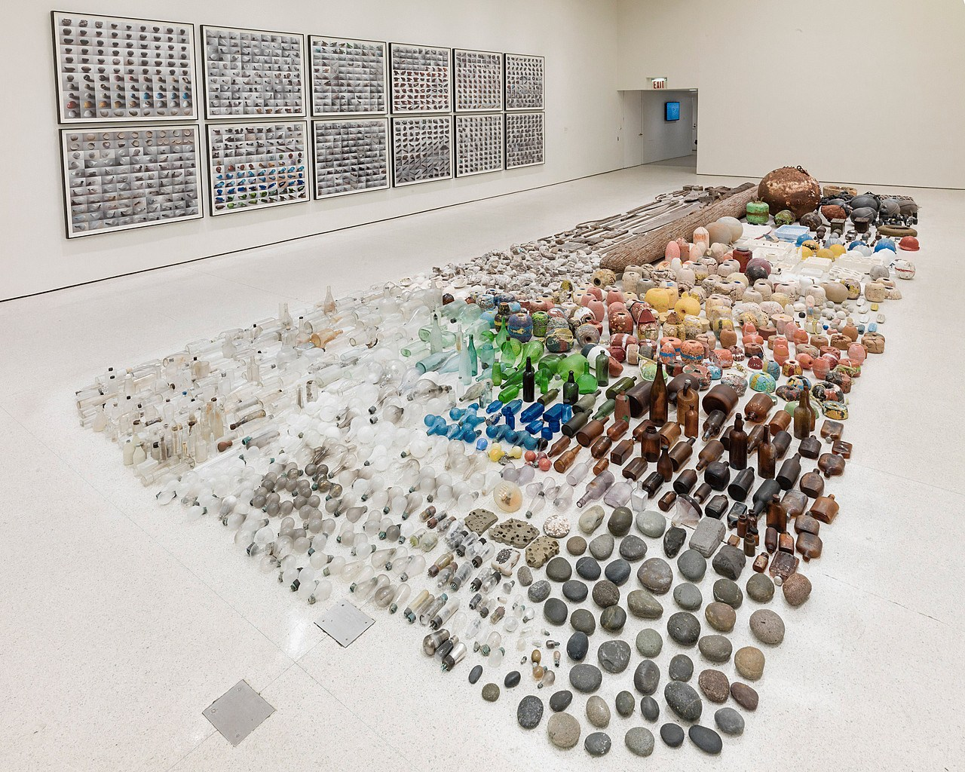

Sources

https://www.guggenheim.org/audio/track/gabriel-orozco-astroturf-constellation-2012

http://exhibitions.guggenheim.org/storylines/gabriel-orozco?index=2

https://www.nytimes.com/2012/11/16/arts/design/gabriel-orozco-asterisms-at-the-guggenheim.html

https://www.guggenheim.org/artwork/30591

https://www.guggenheim.org/artwork/31365

