Contemporary
Hunters
Thrifting
By Maegan Sundlie

Tips /guidebook to sustainable shopping- following images of teens who thrift instead of indulging in fast fashion.

Context
This flipbook of images message is a guide for student readers. I want to share the knowledge that there are ways to be fashionable that don’t involve fast fashion and other waste. Thrifting is in and here to stay. Not only does secondhand shopping make your style unique, but it also is a form of recycling. I want my book to inspire oth- ers to get comfortable with the dos and don’ts of thrifting and to see the benefits with which it will reward them and their wardrobe in the future. As a New School stu- dent, I would encourage other students to branch out of their comfort zones and switch to the thrifting lifestyle.

In Manhattan it’s easy to find a thrift shop, but the key is to find the hidden gems where things are cheaper. To find bargains, try traveling outside the city to areas in Jersey.

In addition to amping up your style, thrift shopping is an adventure in itself. You never know what you might find or discover.

For me, thrifting defines personal style and allows me to incorporate the past with the present for a modern twist. Here is a list of tips.

Thrifting enables me to have and wear something that no one else has.

When you nab a high-quality find, it can last for years.

Don’t be afraid to invest in a piece. If it doesn’t fit perfect- ly, know that you can have it altered and tailored at a later time.

Take the opportunity to stock up on accessories—they don’t show much wear and tear. It’s easy to dress up a cheap accessory and make the outfit more unique.

If you are familiar with a thrift shop, figure out their re- stock days—and discount days—for better finds.

Make sure you wash your garments correctly before wearing.

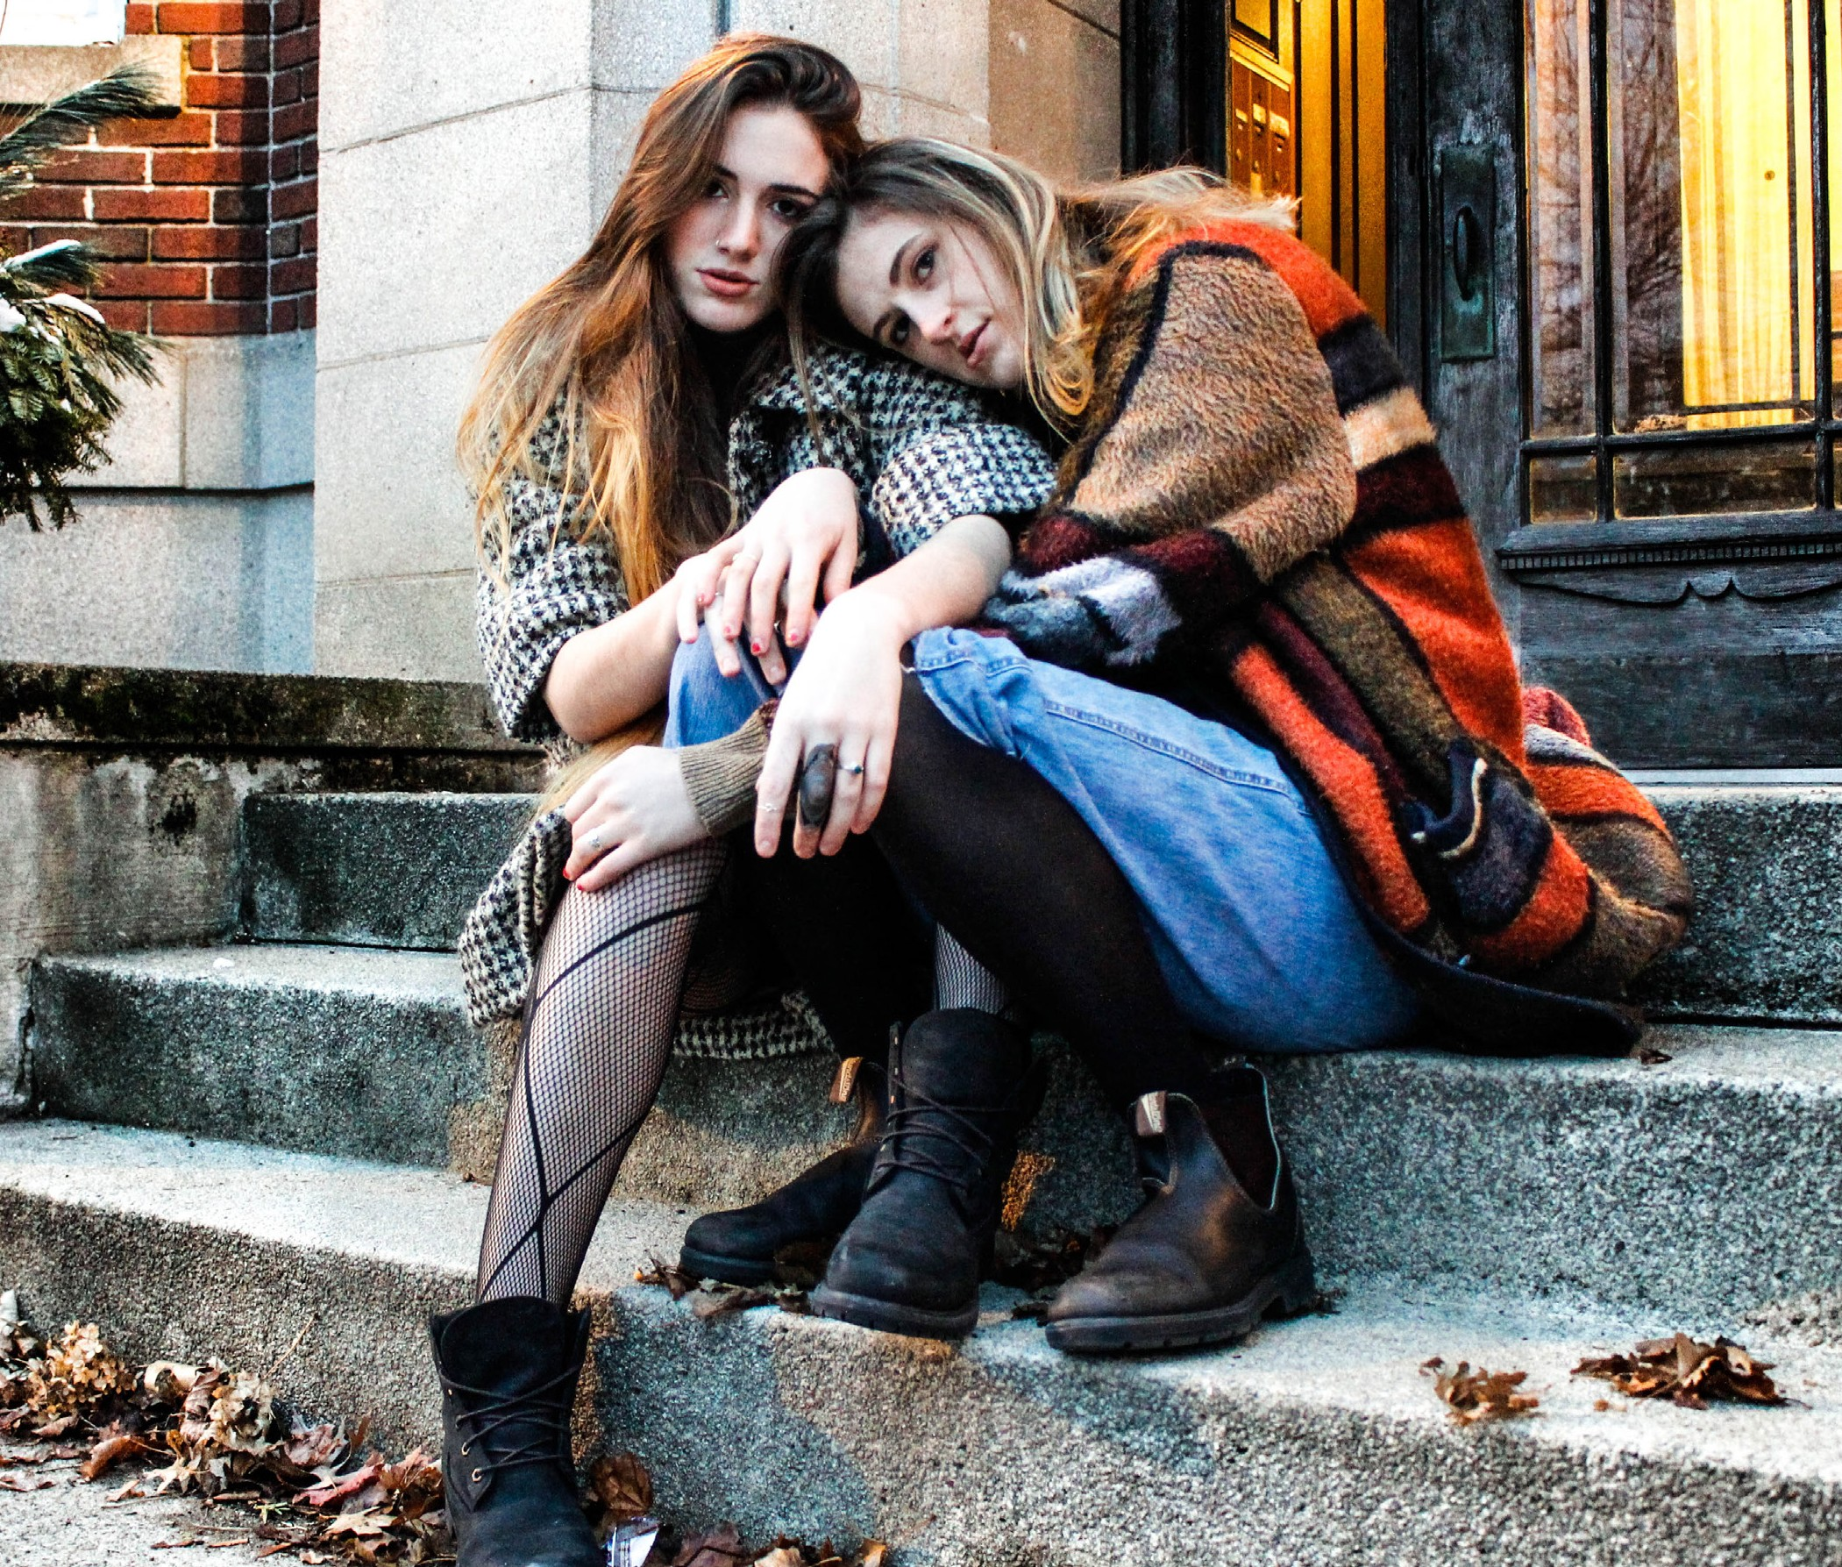

Don’t let clothes sit around in plastic; let the garments breathe.

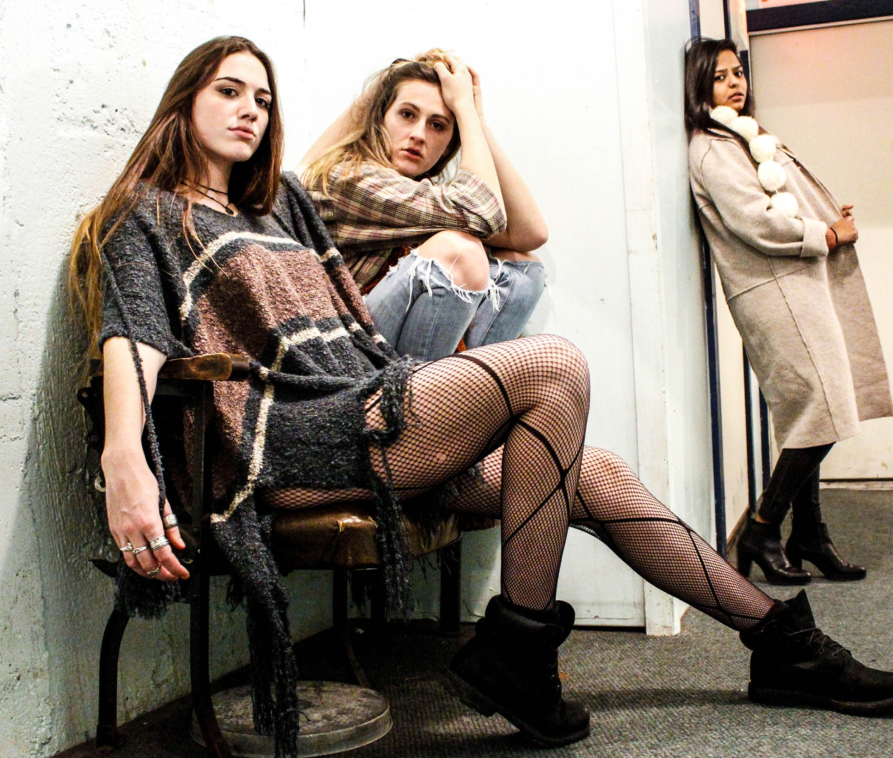

If there is no mirror in the shop, make sure you bring a friend along for advice.

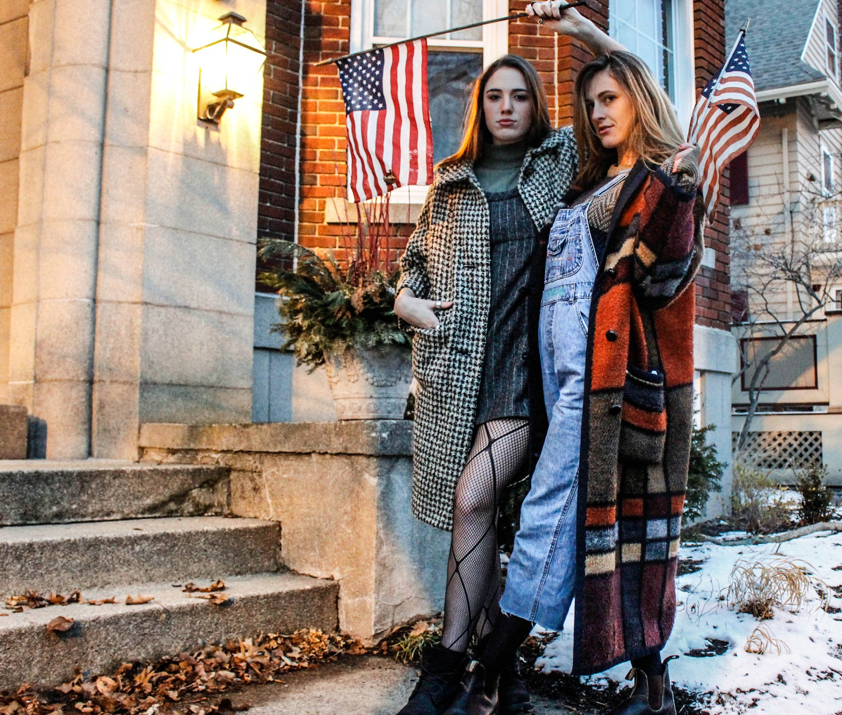

Narrow your shopping to specific sections to avoid being overwhelmed.

Bring your own eco-friendly shopping bag.

Go with your gut. Your initial reaction was most likely the right decision.

Keep your eyes peeled. Sometimes the thrift shops in the worst areas have the best stuff.

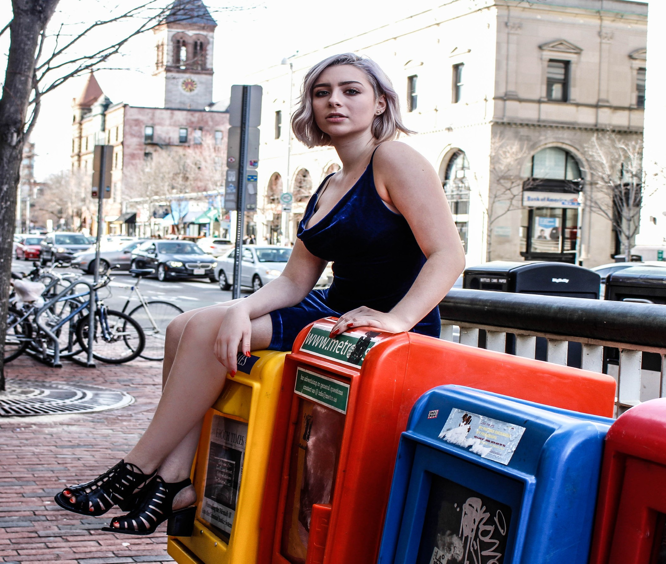
Research the trends. If you come in with an idea in mind, it will be easier to find what you’re looking for.

Dress in something comfortable and versatile for trying on clothes in or even outside the fitting rooms.

Remember that you can repurpose your items. Get cre- ative and make something else out of it.

Don’t get carried away because the clothes are cheap.

Clean out your closet and bring your donations to the shop. In some stores you can even get money in return or store credit for giving clothes.

Don’t be afraid to bargain if you feel the garment calls for it.

You can now even do some thrift-shopping online from the comfort of your home.

Take your time. Thrift shops are free of hovering sales people.

Do good by shopping. Many thrift shops support the community.

Know all the specials. Getting discounts on discounted clothes—you can’t go wrong with that.

Don’t be afraid to leave empty-handed.

Remember each era has distinct silhouette.

As a student it can be hard to keep up as well as afford clothes. I can tell you from firsthand experience: you can still be cool, if not cooler, by trying the secondhand.

