Audio Documentary

Visual
- White background
- White sheets
- Bed
- Red Lights

REFERENCE PHOTOS
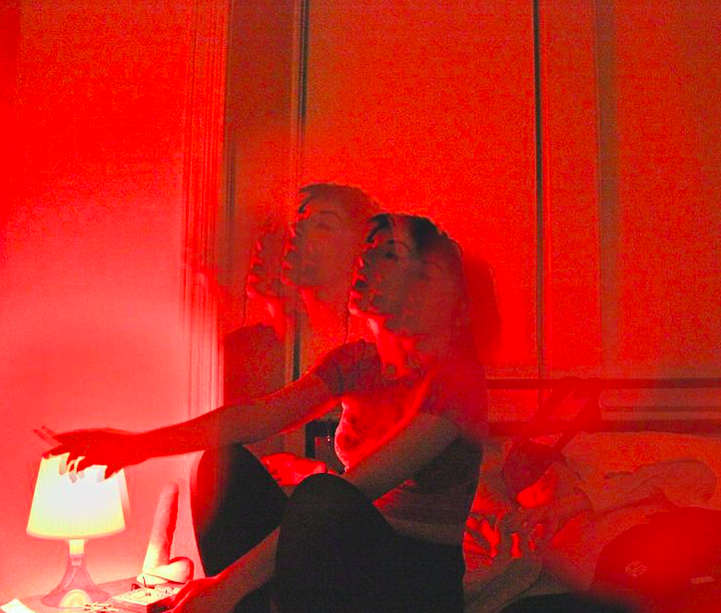

Irene Moray Brian M. Ferguson

OUR CONCEPT
The red lights and hue in the room in tandem with a figure in a bed represents how the color red, although it can be interpreted as anger, it can also represent love, warmth, family and conviviality. The idea of having someone sleeping represents how we are all reminiscing and thinking of our past experiences associated with the color red. Although reminiscence plays a minor role in our pieces, our previous memories are used more to ponder and remember these memories. We are trying to express how we are remembering our past but also are embracing the changes in our lives all in a new city. The consistency of the color red is in a juxtaposition with the differences of our memories, including different national holidays, cultures, traditions and languages.

OUR VISUAL
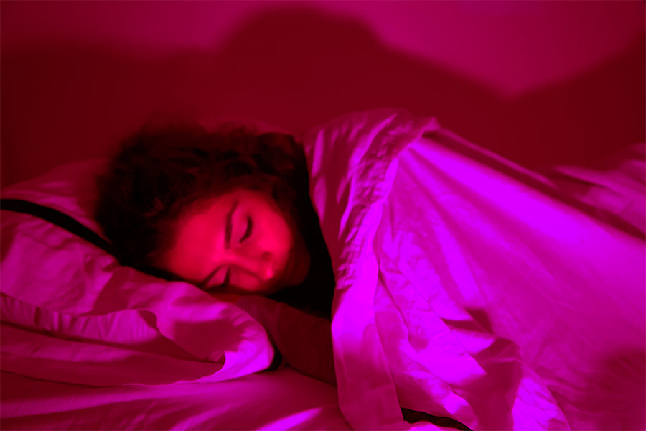

Audio
Using the color red, as a group we decided to express the emotions of happiness, love & the themes of conviviality & family. Each individual has created a soundtrack related to a happy and convivial moment that they tie with the color red. To bind each of these memories, the use of music and laughter combines the visual imagery we have when thinking of the color red and the sounds of the actual memories themselves.

Base Sounds/ Link
- Laughter
- Voiceovers
- Music

We decided to use laughter as a linking sound effect (fx) as it is a globally known sound for happiness in all languages and doesn’t need any sort of translation.

Music is used as a linking sound as it is also another type of melody/ sound that everyone can relate to and in many cases it can still be enjoyed without understanding the language.

The use of voiceovers is also a key part of our project as we wanted to explain our memories to allow for a further understanding. However, it is also used to indicate and further emphasize on our differences in cultures, traditions, languages and holidays. These dissimilar memories all come together to form an entity exuding memories of love, happiness and conviviality.

Link
- Different music merging to link the different memories
- Creating a holistic idea of all the memories to represent conviviality.

HEDDA
Narration: English & Swedish
Sound Effects: Family Speaking, Laughing
Music: Christmas Song

KELLY
Memory: Collective family eating together, the table cloth being red reminded Kelly of these memories and the theme of conviviality.

Narration: Crowd Talking in Mandarin
Sound Effects: Dishes clattering
Music: Chinese String Music

MARIE
Memory: Sitting in a café in Paris. The red of the décor of traditional Parisian cafés and the color of wine. Wine being a symbol of the importance of the national activity of gastronomy in France.
Narration: French Chatter
Sound Effects: Wine Pouring, Cigarette Lighting
Music: La Vie en Rose Interlude – Louis Armstrong

ISABELLE
Memory: Going to a family members house for the 4th of July. Cousins setting off fireworks, triggering the memory of the color red. This symbolizes the idea of happiness, family and conviviality & culture of growing up and the traditions in the US.
Narration: Description – 4th of July
Sound Effects: fireworks
Music: Patriotic Music

CARLYANN
Memory: Memory of an important person and their love for cherries, triggering the color red. The specific moment and drink that reminds Carlyann of togetherness, happiness and love. The cherries symbolize good memories & a specific individual.
Narration: English (short)
Sound Effects: Opening soda, jar opening, sipping, eating
Music: Jazz Music

