Anthropocene Journal Entry #1 07.09.2017

Readings
“The Anthropocene is functionally and stratigraphically distinct from the Holocene”–sciencemag.org
“Enter the Anthropocene – Age of Man” – Elizabeth Kolbert

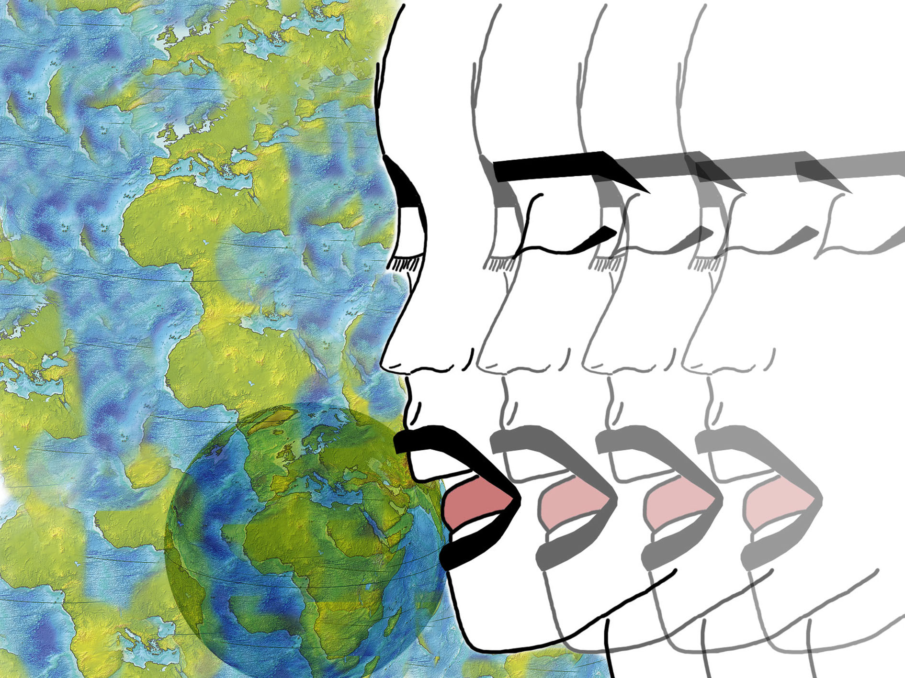

The Anthropocene is a newly coined phenomenon regarding the epoch where human activity has had a holistic and significant impact on the Earth including its stratigraphic, geology, climate and ecosystems. Humans have undoubtedly impacted the earth, whether it is transient or enduring has not yet been fully determined. Humans have altered the earth’s balance by overproducing and over using the earth’s resources. For instance, the burning of fossil fuels has invisibly changed the overall composition of the earth’s atmosphere, creating further visible problems such as the extinction of species at rates higher than ever seen before. Deforestation and pollution furthers adds to this species extinction, creating one of the earths largest mass extinctions since the Ordovician. Human impact has been relatively prevalent since the industrial revolution however the controversial name for this time period remains. Geologists and Stratigraphers started using the word after Paul Crutzen first used it around a decade ago. Crutzen said “We are no longer in the Holocene; we are in the Anthropocene” at a scientific conference, which marked our transforming mindset when regarding our current era. Nonetheless, the reliability of the name, Anthropocene, is still widely criticized, many say that even though the human race’s influence will change the structure of our atmosphere and sedimentary rock, including the appearance and disappearance of certain fossils, such as techno fossils and loss of species, since it has not yet occurred, many criticize the names relevance in our era. Humanity will further alter the earths general configuration, and these widespread changes will become even more established, however its prevalence now is nevertheless significant and unavoidable.

Anthropocene Journal Entry #1 14.09.2017

Readings: “Imagination Will Help Find Solutions to Climate Change” – Sheree Renée Thomas, “How 2016 Became Earth’s Hottest Year on Record” – Jugal K. Patel

Movie: Disruption

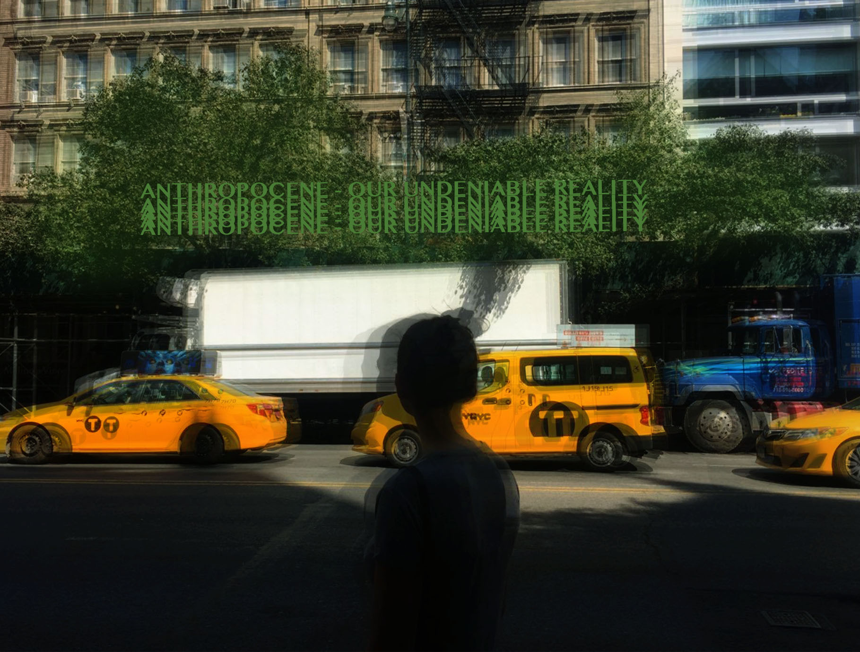

The Anthropocene is the new reality, whether the term is accepted or not, human existence is impacting so many systems of the earth that allow for life to exist. Humans are currently overusing, overproducing, and taking advantage of all the resources that we can exploit. This is leading to an overall transformation of the earths composition, including the climate (perfectly demonstrated as 2016 is the Earth’s hottest year), the sedimentation, the atmosphere and more, all of which directly affect human existence and creates monumental problems such as natural disasters and social unrest. In the documentary, Disruption, a number of environmental activists and speakers were involved to express their opinions on the environmental situation. Naomi Klein and Bill McKibben were the two most capturing speakers in my opinion and I focused on them and their works.

Naomi Klein: Who is she?

Klein is an environmental journalist, activist and filmmaker, who advocates to exposes the causes of climate change, transforming ideas on environmental change into processes and supports our worldwide transition off of fossil fuels onto more sustainable uses of energy.

Klein has written many award winning novels regarding climate change including “This Changes Everything: Capitalism vs The Climate” and “No Logo”. She also has been nominated for many awards for her inspirational bestsellers. She is contributing to changing the climate change situation and impacting the world on a large scale by educating the masses through her novels and films and being a member of the board of director for the climate-action group.

Bill McKibben: Who is he?

Bill McKibben is an environmental author and activist who wrote over a dozen novels including “The End of nature” one of the first novels regarding climate change for the general audience. He has further been awarded prizes for his literary works and is the founder of 350.org a website dedicated to the worldwide climate change movement. He has impacted the world by organizing this global climate change movement and has been responsible for thousands of environmental rallies globally which helped resist the fossil fuel industry development and movement.

In the documentary, when regarding Copenhagen, during the environmental conference there were social outbreaks and complete social disruption. This conflict reflects on the paradoxical mindsets and opinions when regarding the environmental crisis of the time. “Nothing happened [Copenhagen] because the fossil fuel industry was still strong enough to scare nations into avoiding the issue” –McKibben. This reflection of the issues with the Copenhagen conference shows our understanding of the problematic priorities we have when regarding our energy choices and how little power society and our leaders have in comparison to the large multinational industries. This is further proven by what Naomi Klein stated “No leader was coming to save us [Copenhagen]. When regarding the current climate change and the temperature rise, both McKibben and Klein believes the need for a change and express their affliction towards the lack of effort shown by society. “It is not that we need to save the earth, we need to save the systems that make the earth compatible with human existence and the existence of other life forms” –Klein. Klein expresses the nature of the change we need to adopt whereas McKibben was more enthusiastic in expressing his displeasure with the current situation by stating “Scientists had said that this is the worst thing that is happening right now” and “It would be crazy to find out what two degrees will do” – McKibben. This further specifies the opinions that these two renowned environment activists have regarding this era and how human impact may be the deadliest of all. Whether the Anthropocene is a term that can be widely used is still controversial, however it’s effects are undoubtedly a reality in the 21st century, and will continue to to negatively impact the earth if no action is taken.

Sources:
http://www.naomiklein.org/meet-naomi
http://www.billmckibben.com/bio.html
https://www.nytimes.com/interactive/2017/01/18/science/earth/2016-hottest-year-on-record.html?_r=0
https://www.nytimes.com/roomfordebate/2014/07/29/will-fiction-influence-how-we-react-to-climate-change/imagination-will-help-find-solutions-to-climate-change?mcubz=1

In 2016:
NYC: 1.2 degrees above normal
HK: 1.5 degrees above normal
Paris: 0.5 degrees above normal

