Anthropocene Journal #4: Installations

Part 1: Ai Wei Wei “Good fences, Make Good Neighbours”

An art installation can act as a form of self-expressionism but can equally be a form of political outcry, protest or piece of admiration. Ai Wei Wei uses his installations around New York to comment and express his personal afflictions with the issues regarding border control, immigration and the increasing segregation among our societies. I visited two of Ai Wei Wei’s installations including; Arch in Washington Square Park, and Gilded Cage in Central Park. However, the one that really captivated me was Arch. Its meticulous location is cleverly chosen, personally it symbolizes the obstruction of our political and social mentalities to those outside of our society. The cage like features and the human shapes encompassed by the fence suggests how there is a barrier around us. Since it is situated directly beneath the arch already present in Washington square park it also criticizes the current political situation facing against immigration and segregation between America and other countries, due to the existing governmental stances. The use of reflective metal and the inclusion of the two silhouettes intelligently suggests that collectiveness is essential to proceed civilly in the future. The piece seemed to be inspired by Marcel Duchamp’s, French artist in the early 90s, which is an ambitious way to integrate different cultures into this installation clearly condemning the present day mindsets against migration and other cultures.

“We are witnessing a rise in nationalism, an increase in the closure of borders, and an exclusionary attitude towards migrants and refugees, the victims of war and the casualties of globalization.” – Ai Wei Wei

Part 2: Design an Installation

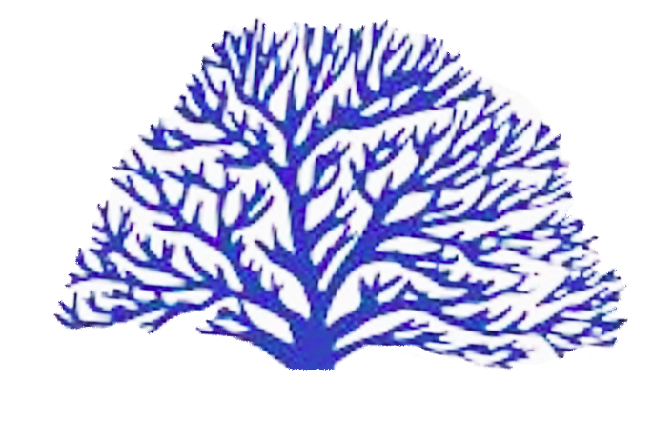

Dynamics
3.5 meters tall
Dark Blue Colour – Thermochromic Dye
Metals + Leuco Dye
When touched it turns red/ orange

Thermochromic materials are now readily used in household objects, art pieces and for scientific purposes to easily detect and reflect the changes in temperature of its surroundings. By using thermochromic ink or materials for my installation I can not only explore the creative aspect of the piece which can be used to criticize the issues of climate change to marine life but also show explicitly the changes in temperatures.

I also wanted the piece to be interactive, to express how we are not only affecting climate change but how it affects us. It is to show the close and symbiotic relationship we have to climate change.

Thermochroic ink/dyes/ materials: Changes due to temperature changes

