Field Experience Trip Circle Line: 22 September 2017

- Draw a map of our route

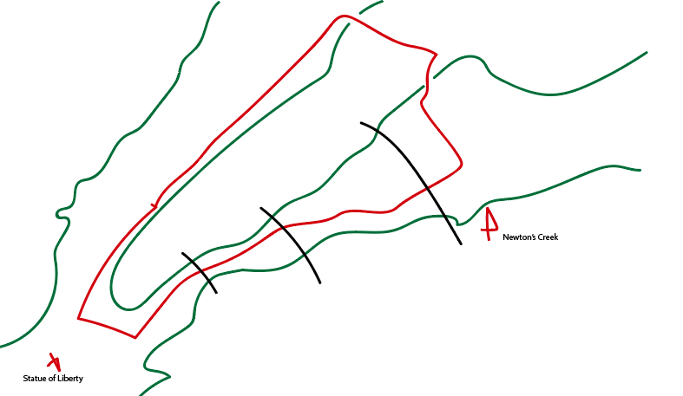

In the above drawing, I drew a quick sketch indicating our route on the city line tour, including our route, the statue of liberty, newton’s creek and indicated the basic location of the bridges that we passed.

- Observe the systems & infrastructure

These are some of the locations viewed, taken around 11:40am. This shows the views from the boat from our departure. While observing these surroundings, it is clear that the water is quite murky and green and not clear.
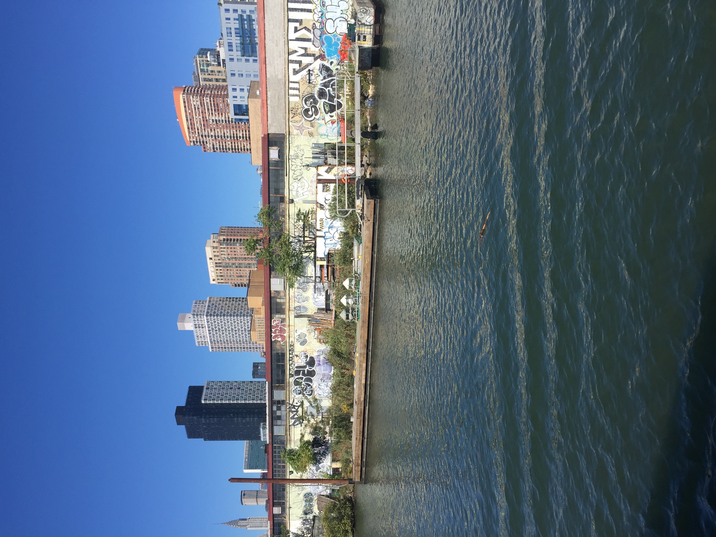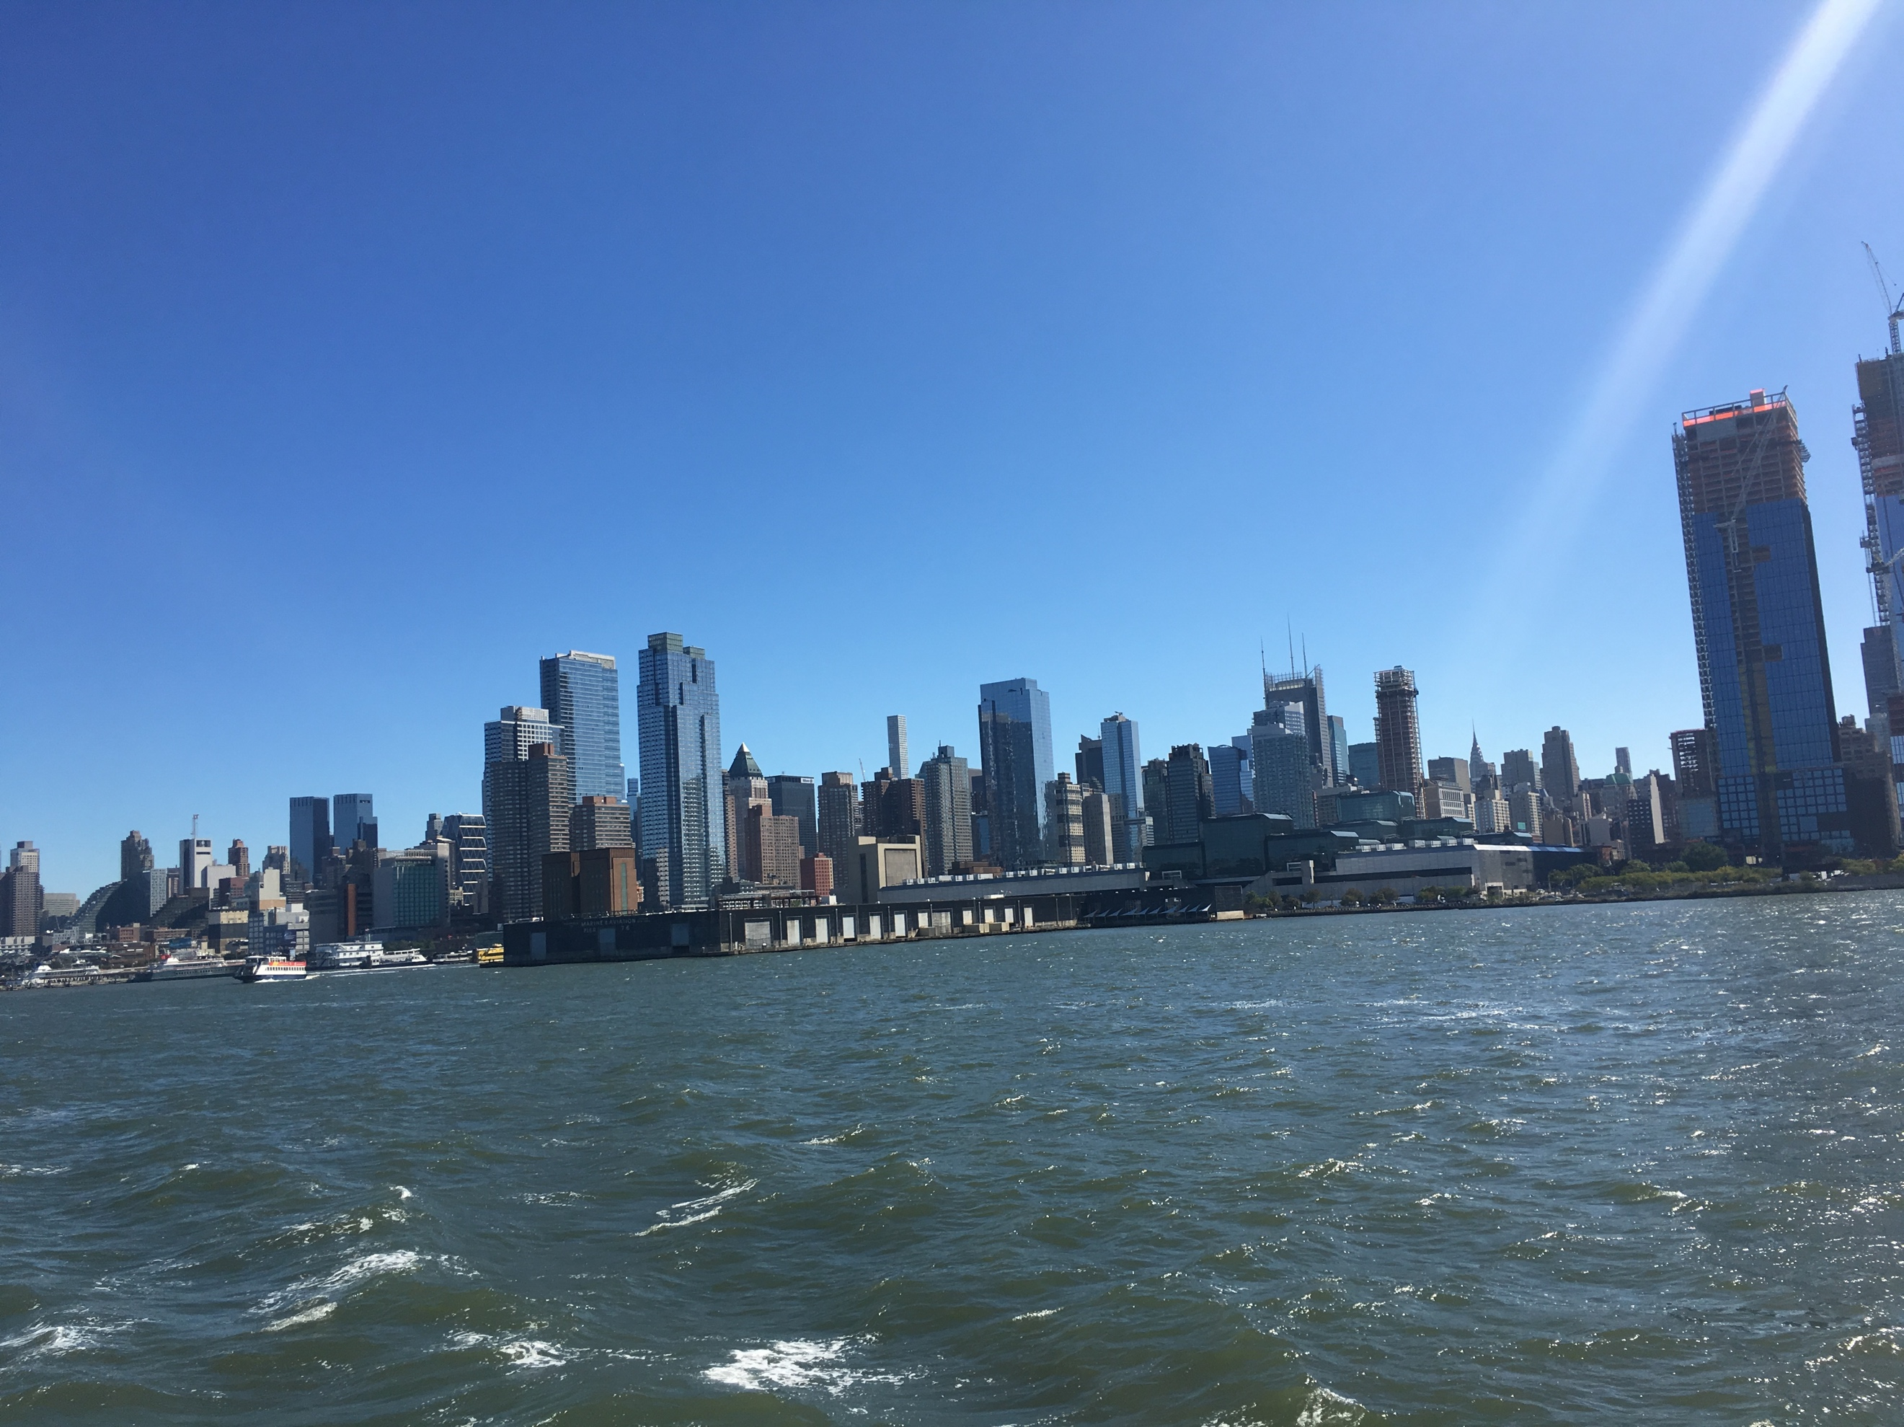
The photos below are some of the locations that we passed around 12:11pm. Where we passed Newtown creek. Although it is a waste dump, the water surrounding was relatively clear and it was very noticeable how high the water was in comparison to the edges of the treatment plant. The waste pile was large and very significant. It showed how much waste needed to be processed and treated.
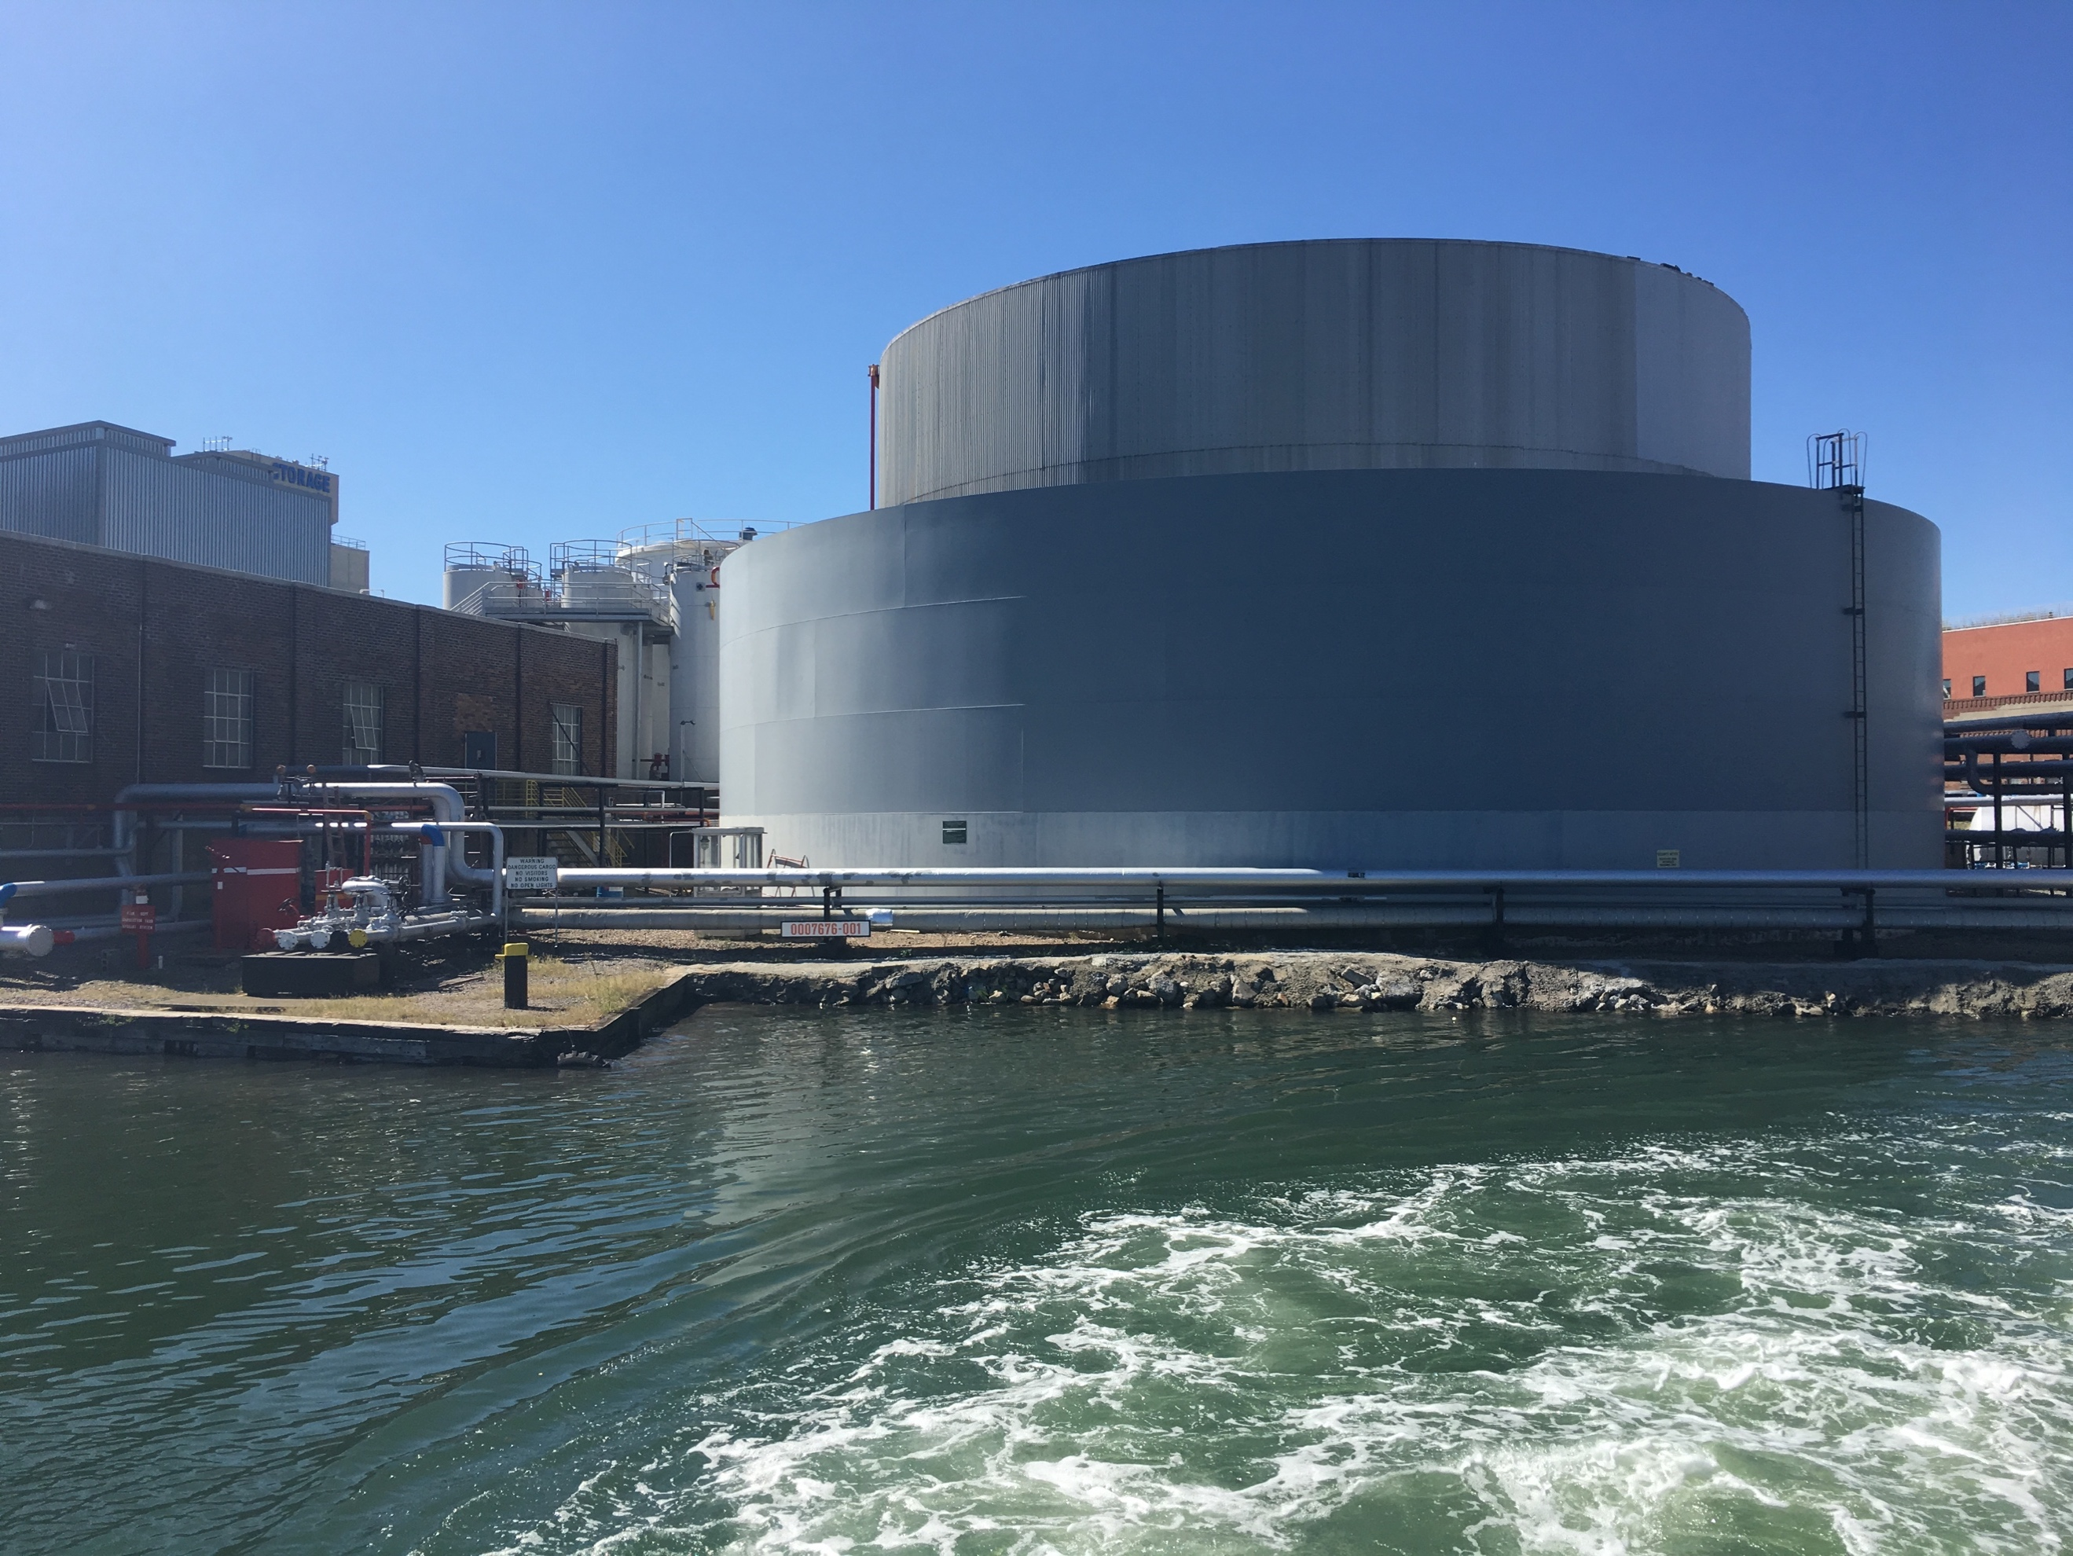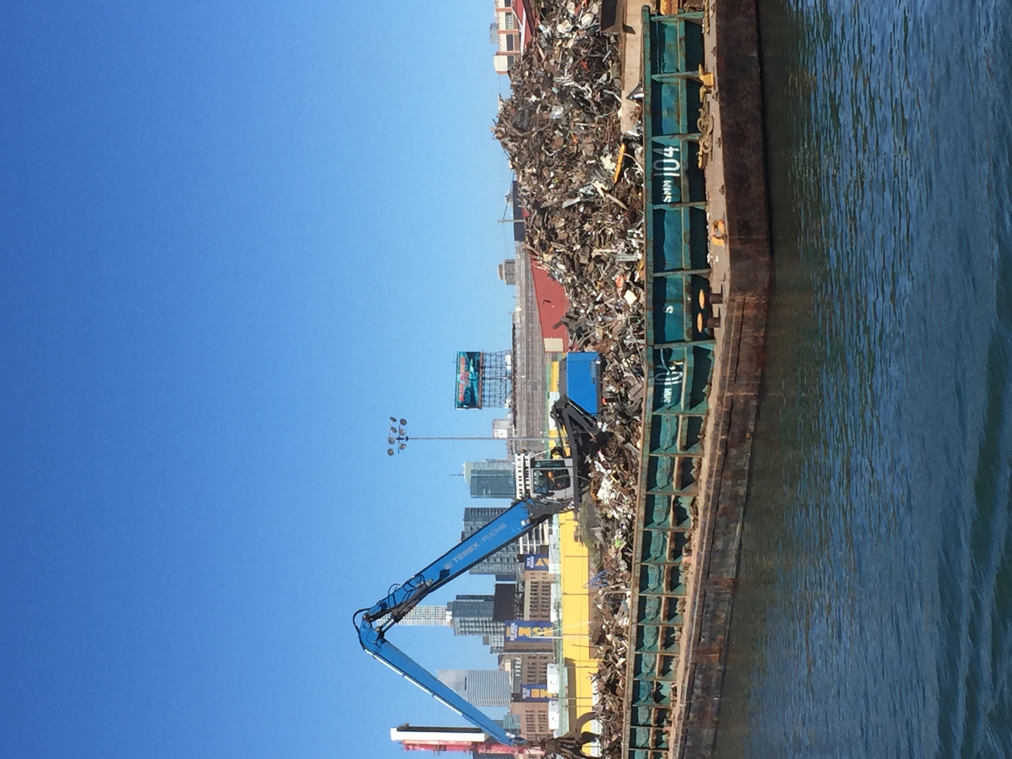

These photos are taken around 12:28pm, on our way back after the treatment plant, the water returned towards its murky state. The bridges look sturdy and able to withstand many natural disasters. Along the shoreline, there were visible green areas and small walls built, obviously made to withstand any flooding or storms.
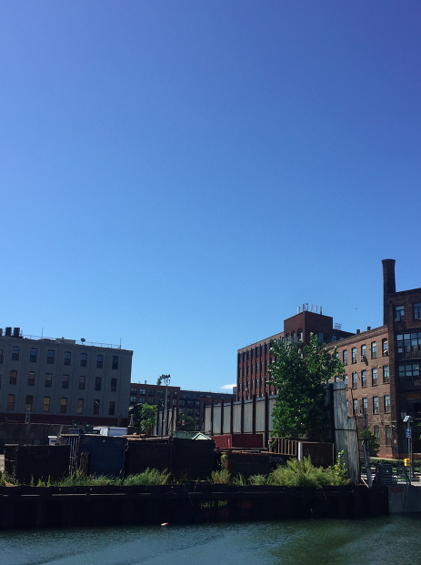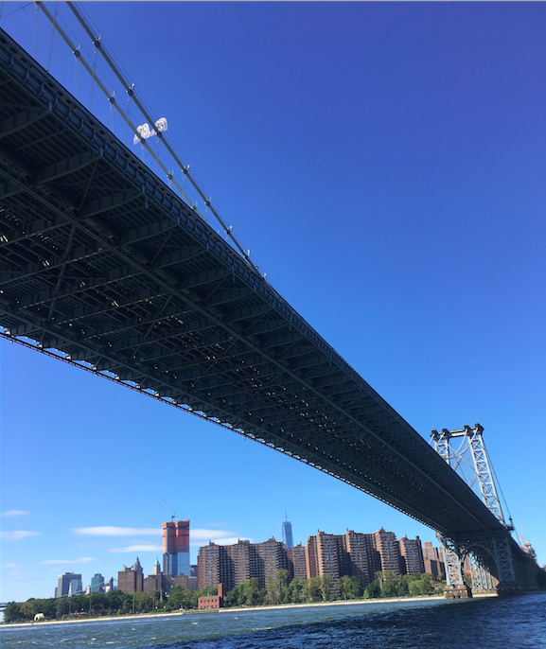

The water meets in city in various different scenarios. For instance, the shoreline where there are walls or green spaces. It also meets the water by the landfill islands and extensions built in and around New York City. The various bridges also are a way that the city meets the city.

- Some areas that are along the coast, especially the ports, and boat docking areas seem un-prepared for large storms. Certain residential areas or building areas have little to no resistance towards rising water or large amounts of rain.

- I was personally unable to tell whether certain areas were built on landfill or not. However, due to prior knowledge I knew that Ellis island is built on landfill and I took notice when we passed it on our tour. Personally, I could not tell that it was built on landfill, which was shocking and suggests how good technology and our progress has become. This shows that many areas could be built on landfill, and no one would take obvious notice.

- Some buildings and areas of the coastline have green spaces, which can be used for absorbing water in case of a major storm. On many areas of the cost there are small walls built or in some cases flood walls used to protect the shoreline and the buildings bordering the waterways from major effects of storms. The walls are used as reinforcements in case of storms, floods or other natural causes from floods and large amounts of precipitation. (examples shown below)
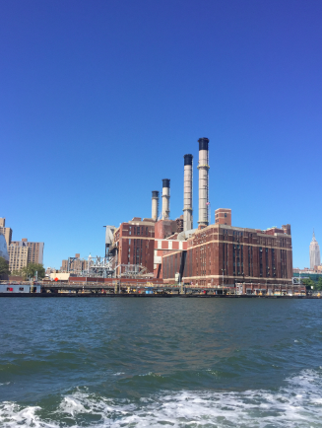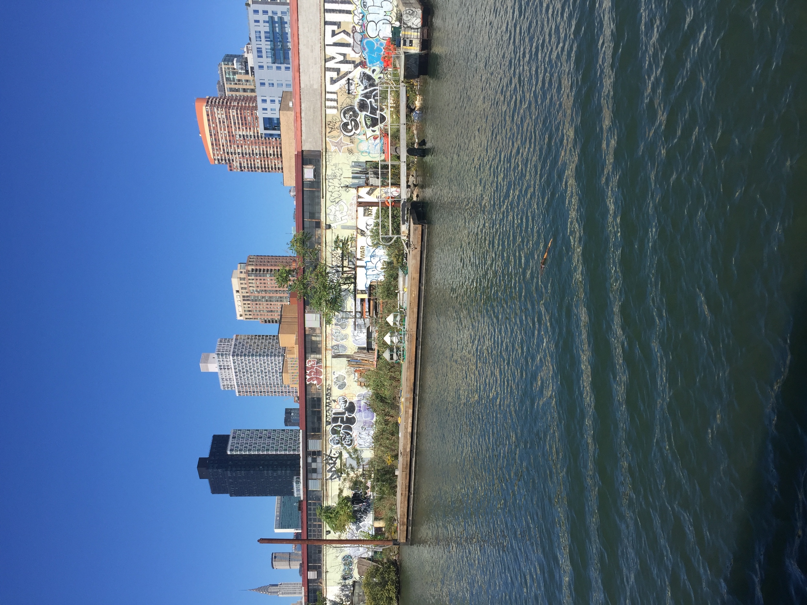

- The river is used by a variety of different boats. From large container ships, commercial touring boats and also private owned boats. However, on our trip I noticed mainly other tour ships and commercial boats (such as the one below)
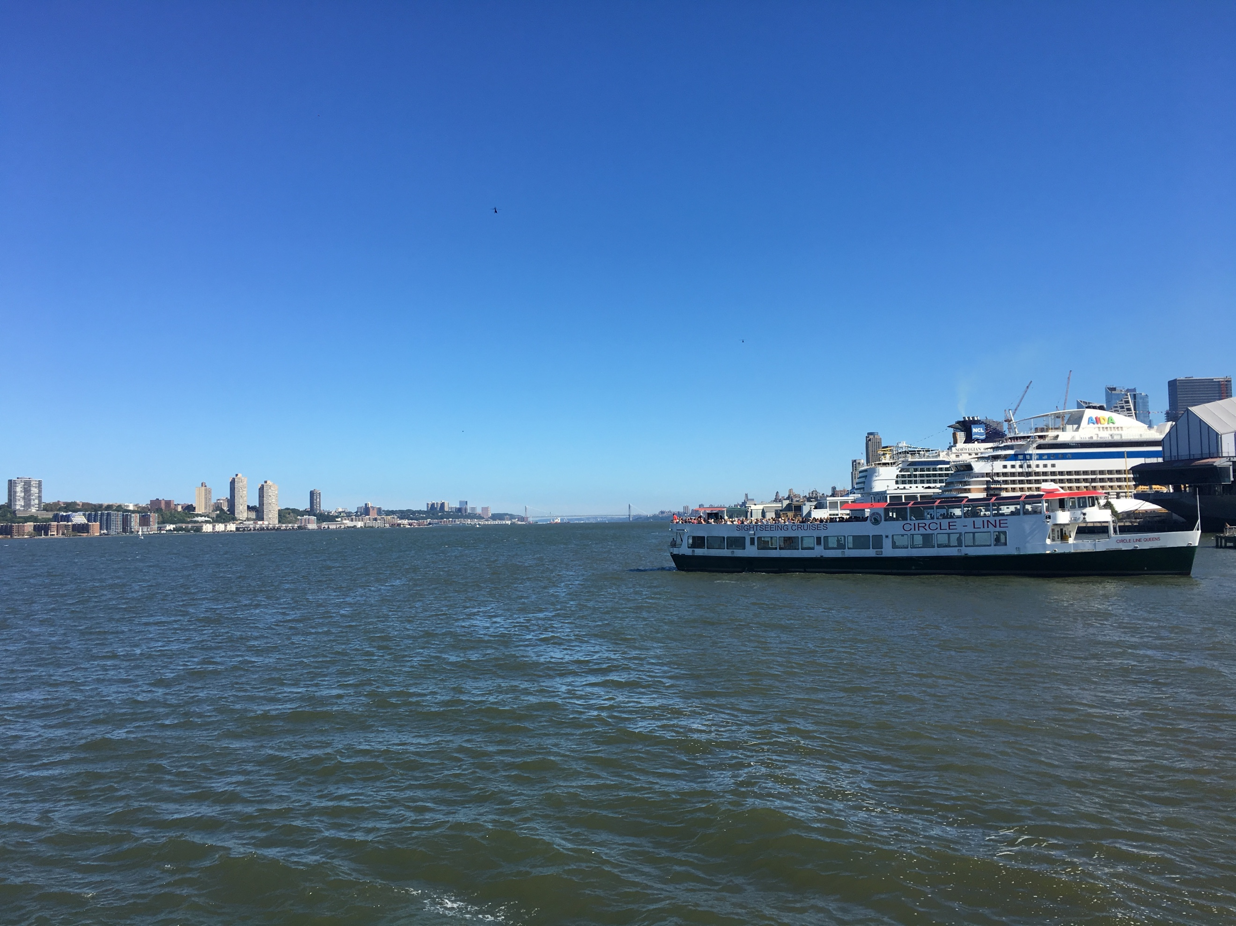
Anthropocene Journal #3: Postcard
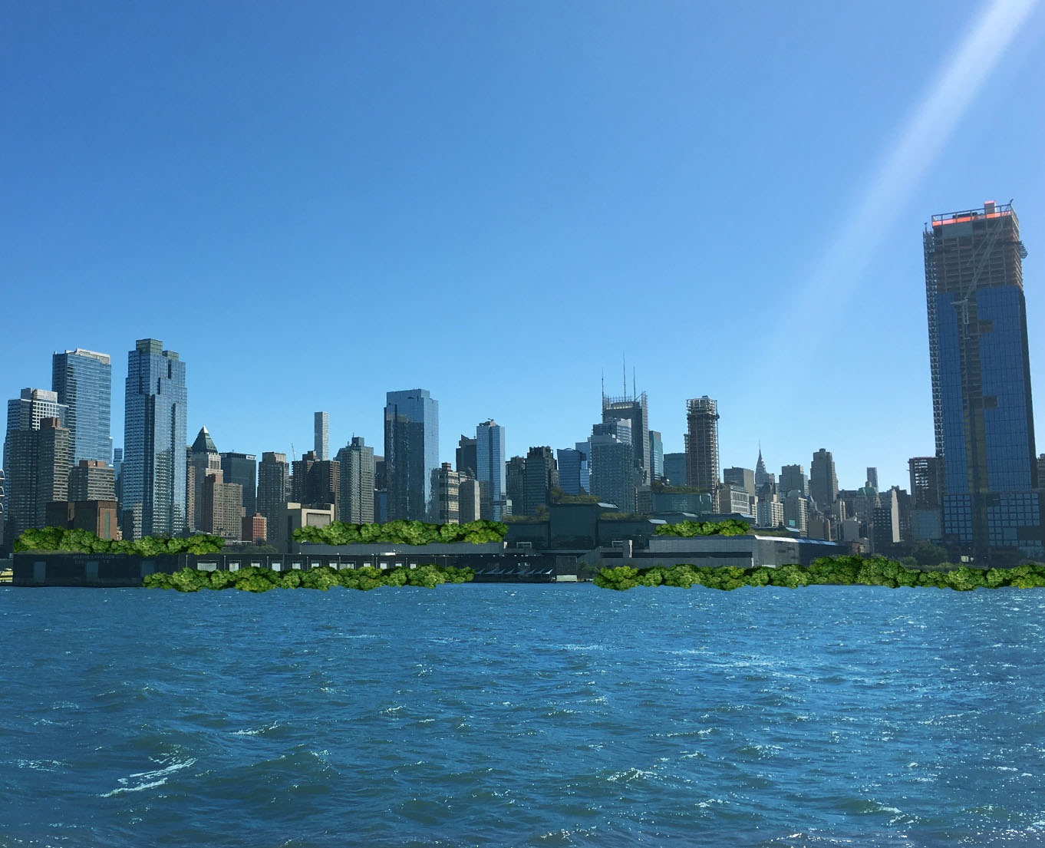

For my postcard, I decided to focus on the future shoreline of Manhattan. I decided to focus on the “imagined view of NYC” if there are constant efforts to contain and help shoreline resistance and global warming. In my imagined reality, the coast and shoreline would be covered in green spaces to help stop storm surges, and other effects of flooding and storms. There would be large areas of green spaces along the shore but also on the top of buildings. This would be done to help the effects of global warming and other side-effects of intense climate change and high levels of pollution.

Postcard Text

Dear --------- ,

I hope that you had a great experience on the City Line Tour. On the Tour, it was visibly explicit that there are many areas of New York’s coastline that is unprepared for major storms or its effects. The pollution is very obvious and the amount of impermeable ground and surfaces in and around New York City shows the lack of awareness and ignorance towards the possible effects of a changing climate, global warming and storms.

In my imagined reality, I have an optimistic outlook on how Manhattan can adapt and mitigate towards the changing climate in efforts to slow down the effects of global warming. I believe that with a joint effort, it is plausible that the citizens of New York City, will be able to help stop and adopt towards changing the current ominous view on the climate.

Hope you have a great weekend! I hope to hear from you and your opinion on this subject.

Best,
Marie. H

