THE HISTORY OF A LEATHER JACKET

PICTURE

Object: Black Lamb Skin Leather Jacket
Model: Isabelle Demeunynck

DRAWINGS/ SKETCHES

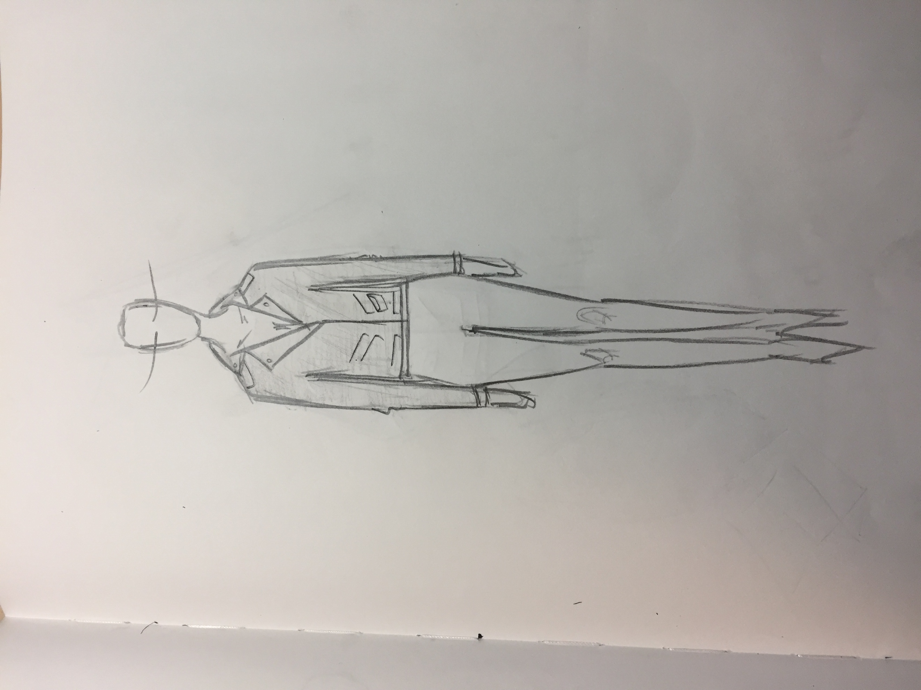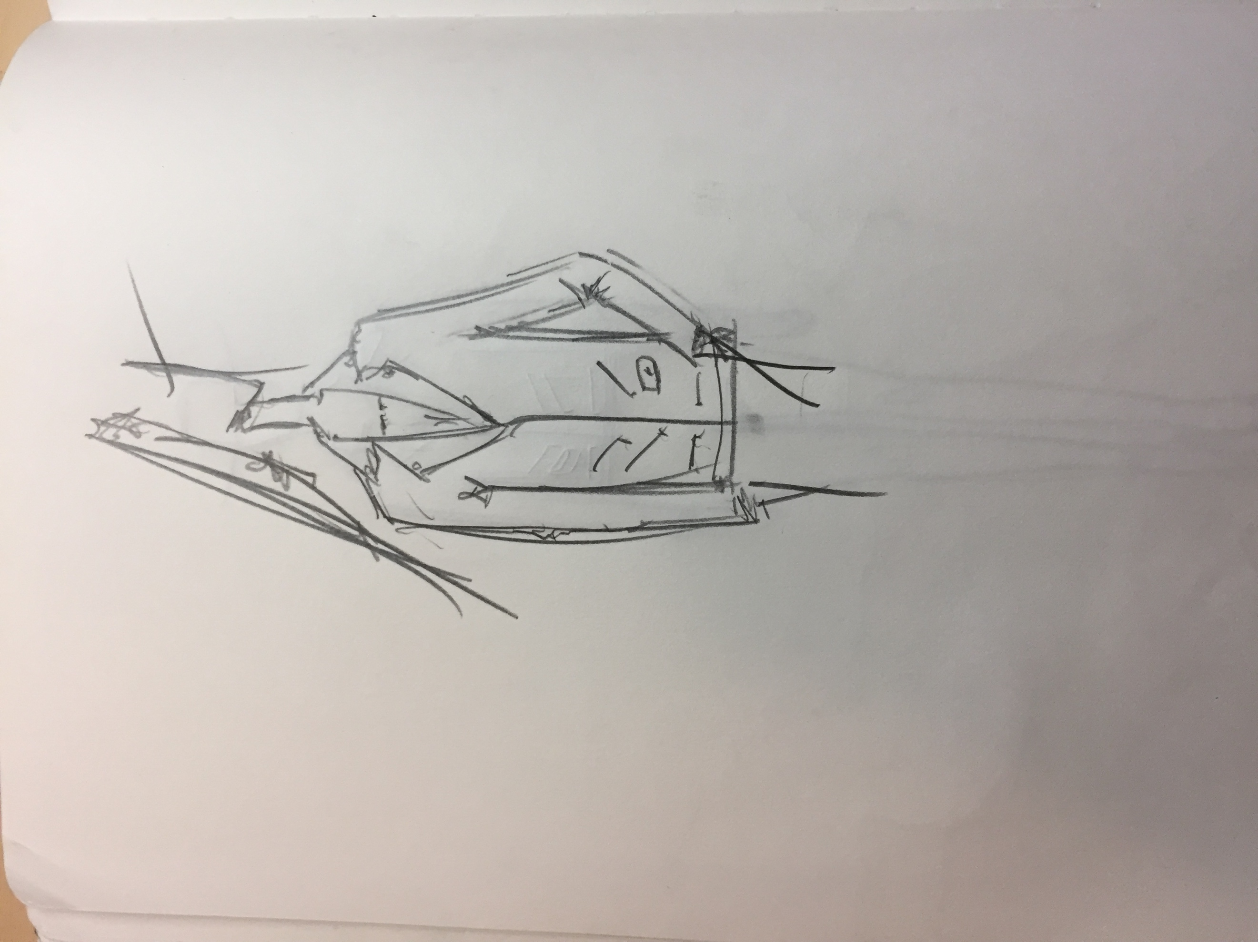
HISTORY

The life-cycle of a leather jacket is long and extensive due to its manufacturing and storing processes. The production and maintenance of leather is complicated and delicate and to produce a good quality jacket takes a lot of skill and correct materials.

Firstly, leather production starts with the cattle. The upkeep of cattle is extremely damaging to the environment due to the amount of water they consume and the methane they produce. The space needed for cattle usually entails having to burn down forests to make field space which adds to the CO2 levels in the atmosphere. Then there is the slaughter house which consists of the transportation of the animals, slaughter of animals, cleaning of the bodies, the carcass is then sold to butchers and the hides and skins are sold to tanneries.

To store and transport leather is also a strain on the environment as the hides must remain wet through rehydration. They are cured and are kept in a brine of sodium chloride. The hides are then transported to tanneries. The extensive use of water in the storing of leather and transportation of leather and the multitude of transport trips adds towards the effects on global warming and the deterioration of the atmosphere.

Hides are then treated with salt, re cleaned to remove any excess dirt and are soaked in a mixture of water lime and sodium sulfide. They are then re-tanned to change the texture and treated with dyes, synthetic oils and fat liquoring. The use of chemicals and dyes can result in water contamination and pollution.

Paper patterns must be cut to make the different parts of the jacket that are needed to be put together. This uses a lot of different papers and requires a lot of materials. A typical leather jacket depending on the animal can use up to 1-4 hides. For instance a lamb skin jacket can use up to 3 hides tripling the amount of energy needed to make the jacket.

Interlining and other fabrics are also used in the making of a leather garment, interlinings can range from being made of nylon to cotton. The shipping and packaging process must also be considered, including wrapping paper, plastic bags, cardboard cartons etc. Shipping and Transport depending on the type of transport ranging from local transport such as cars to international transport and shipping by boat or plane also add to the footprint and lifecycle of the jacket.

This specific leather jacket was made by a leather manufacturing company in China, based in Hong Kong. The factory is made up of 200 workers. They use sustainable dyes and do not contribute to water or air pollution due to environmentally friendly waste removal methods. The leather is naked lamb Nappa and is dyed black and hand stoned to create the supple soft texture. The accessories from the jacket are derived from Chinese factories and is sold in stores based in Europe.

This includes the production of the first initial leather hide, the dyeing, the transportation to the factory from the tanneries in France, the transportation to the offices in Hong Kong and then the garment transportation and storage in stores worldwide.

VISUAL WORK PT.1

VISUAL WORK PT. 2

THIS LEATHER JACKET

3 hides
10-12 accessories
Lining
Dyes
Transport from French tannery
Transport to China, Hong Kong, Europe
LEATHER
Cattle
Hide cleaning & storage
Transport

TRANSPORT
Air
Boat
Car

Fuel, Gas, Water, Manufacturing of Transport vehicles

TANNERY
Dyes
Synthetic oils
Chemical Brine

ACCESSORIES
Manufactured in China
Factory Waste
Shipping
Manufacturing
Transport

PACKAGING
Paper
Plastic bags
Cardboard shipping boxes

INTERLINING
Cotton/ Nylon
Dyes
Manufacturing
Shipping
Maintenance

DISPOSAL
Recycling
Decompose
Landfills

VISUAL WORK PT.3

INSPIRATION

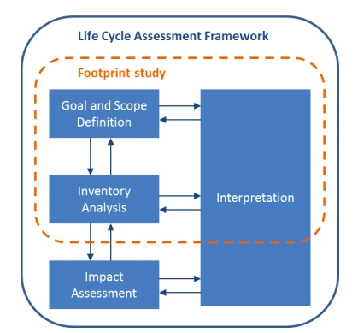

Footprint for a leather jacket

Average Range Leather Jacket weighs between 1.5Kg – 1.9 Kg
Total Average: 1.7 Kg

Processes | Materials | Footprint for 1 leather jacket
 |  | Resources |  | General Emissions
 |  | Energy (MJ) | Water (L) | CO2 (Kg) | N20 (Kg) | CH4 (Kg)
Textile Production | Fabric  & Interlining | 64.9 | 101.4 | 37.89 | 0.104 | 0.21
Lamb Leather Production | Leather | 2.21 | 14.28 | 0.21 | 4.386E-06 | 15.78E-08
Chemical Production | Chemical Dyes  Brine & Solvents | 0.83 | 2.84 | 4.52 | 9.061E-04 | 8.857E-05
Paper Production | Paper | 76.51 | 10.51 | 4.86 | 15.95E-05 | 0.002924
Transport (1KM) | Car, Boat, Plane | 3.06E-06 | 1.717E-05 | 8.62E-05 | 4.284E-09 | 8.98E-08
TOTAL |  | 144.45 | 129.03 | 42.48 | 0.11 | 9.21

