Hannah Swart
Discussion Week 14

Tokyo: Japan is well known for it’s avant-garde fashion, as men and women there like to combine different styles into one look in order to stand out on the streets. Famous fashion designers like Rei Kawakubo are from Japan, and her styles are very appreciated and sought after in Tokyo. This year, trends included “sporty sandals, puffy sleeves…[and] sheer pieces,” to name a few.
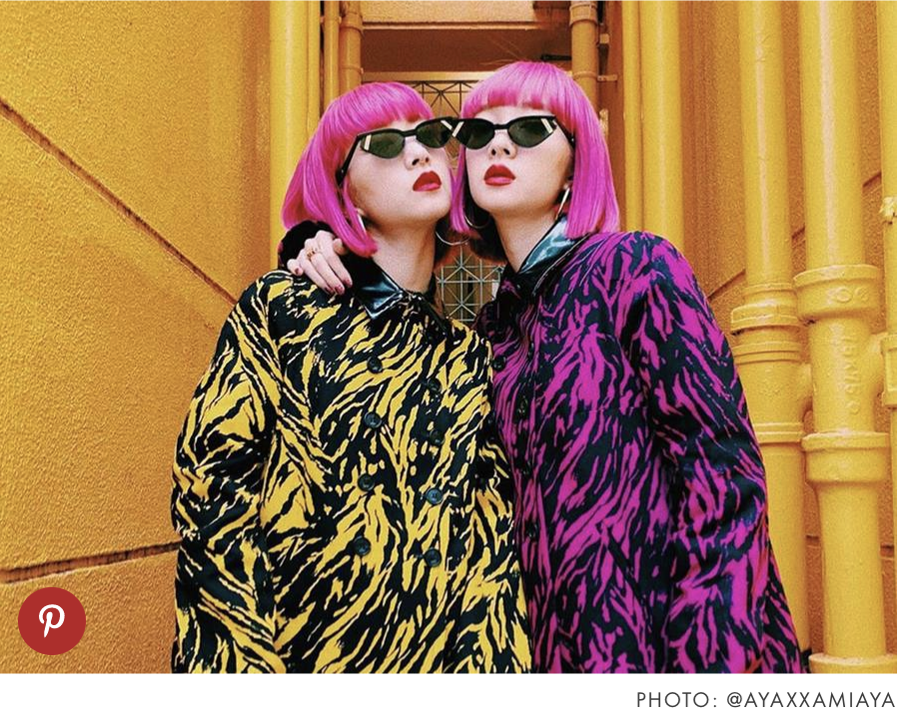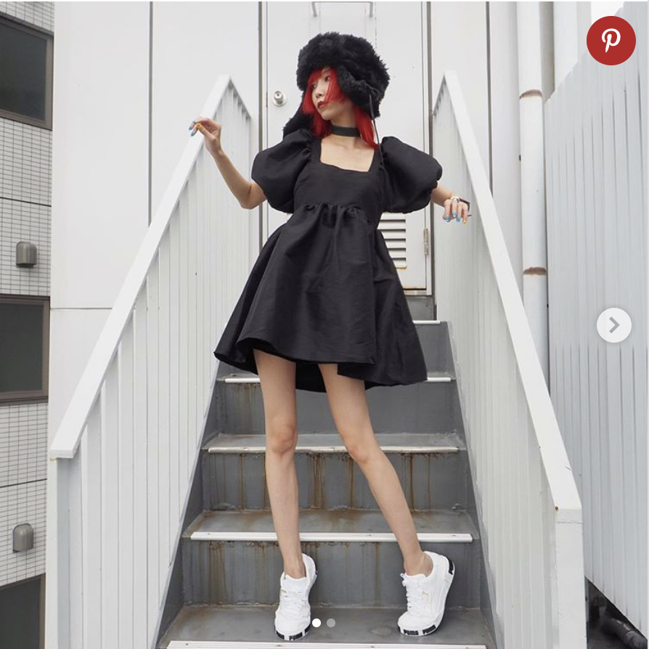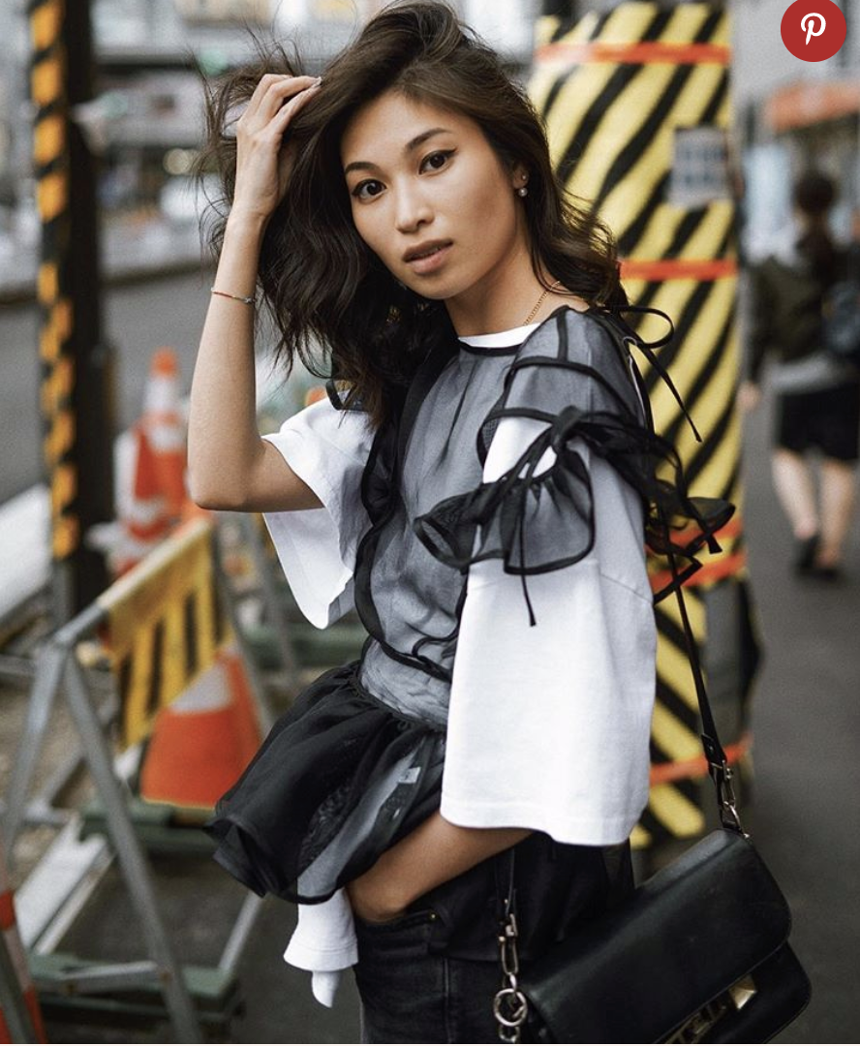
https://www.whowhatwear.com/tokyo-fashion/slide21

New Delhi: India is an emerging economy, and people in big cities like New Delhi are starting to shop more and experiment with popular styles, by adding their own twist. Colors play an important role in people’s outfits here, especially because they are such an integral part of the culture in India. Examples include bright oranges, different hues of blue, and deep purples. Jewelry and scarves are also very popular accessories, meant to complete one’s outfit. Men seem to wear the traditional clothes like the ones in the picture below, while western style clothing is also very popular.
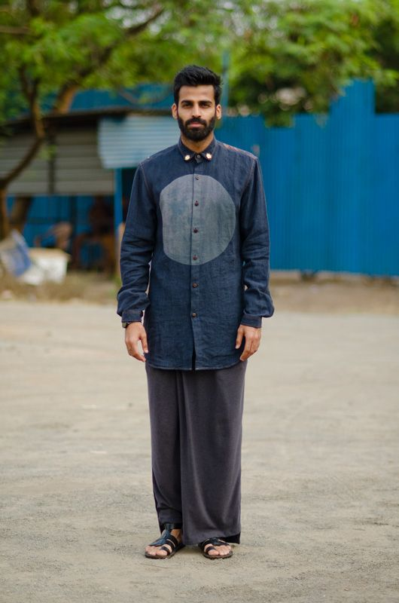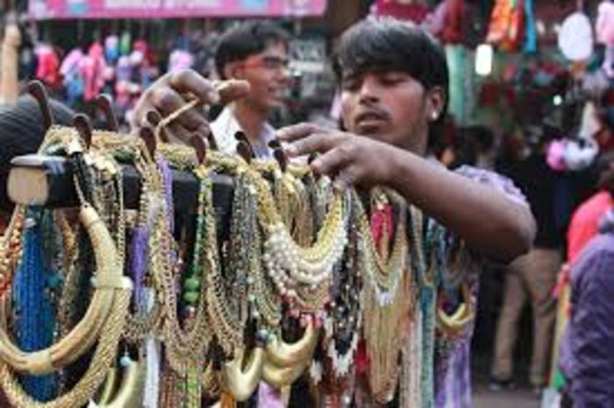
https://www.pinterest.com/ranjana81/delhi-street-style/

Madrid: Spain is another place known for its vibrant colors present in nature, food, and clothing. Summers are hot in Madrid, so women wear a lot of sun dresses, big hats, and strappy sandals to comply with the climate. On the other hand, in the winter, the women cover up a bit more with jackets, leather pants or jeans, and booties. Hats seem to be popular during all the seasons. Men tend to dress similarly to those in the United States, wearing jeans and a white tee or a button down and a pair of sneakers or loafers.
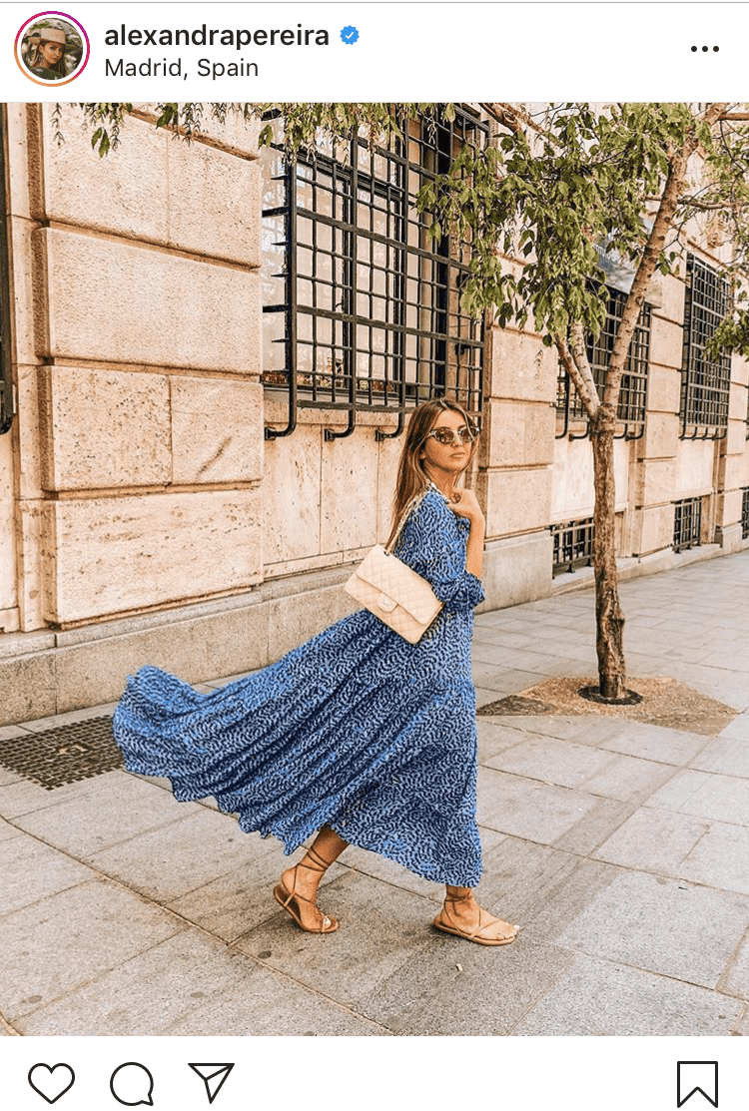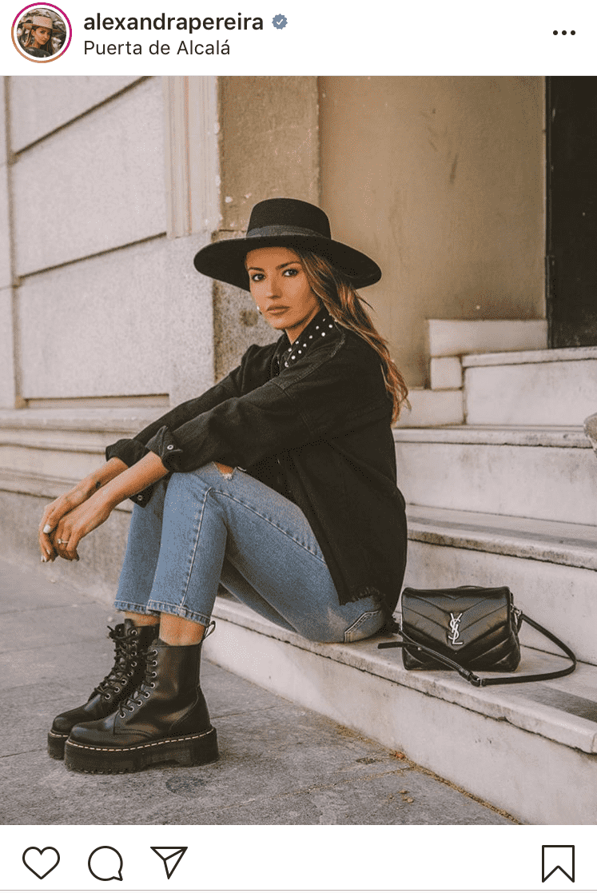
https://blog.pimsleur.com/2019/07/24/fashion-in-spain-today-how-to-not-look-like-a-tourist/

Paris: Paris is undoubtedly one of the most fashion forward cities. During Paris Fashion Week Spring 2020, we saw lots of florals, transparent clothing, leather, lace, and geometric shapes, to name a few. These will likely influence how people around the world dress in the near future. Parisienne women tend to dress very cool and casual, wearing high waisted jeans, flats or wedges, wrap tops and tees, and accessorizing with stylish bags and scarves. 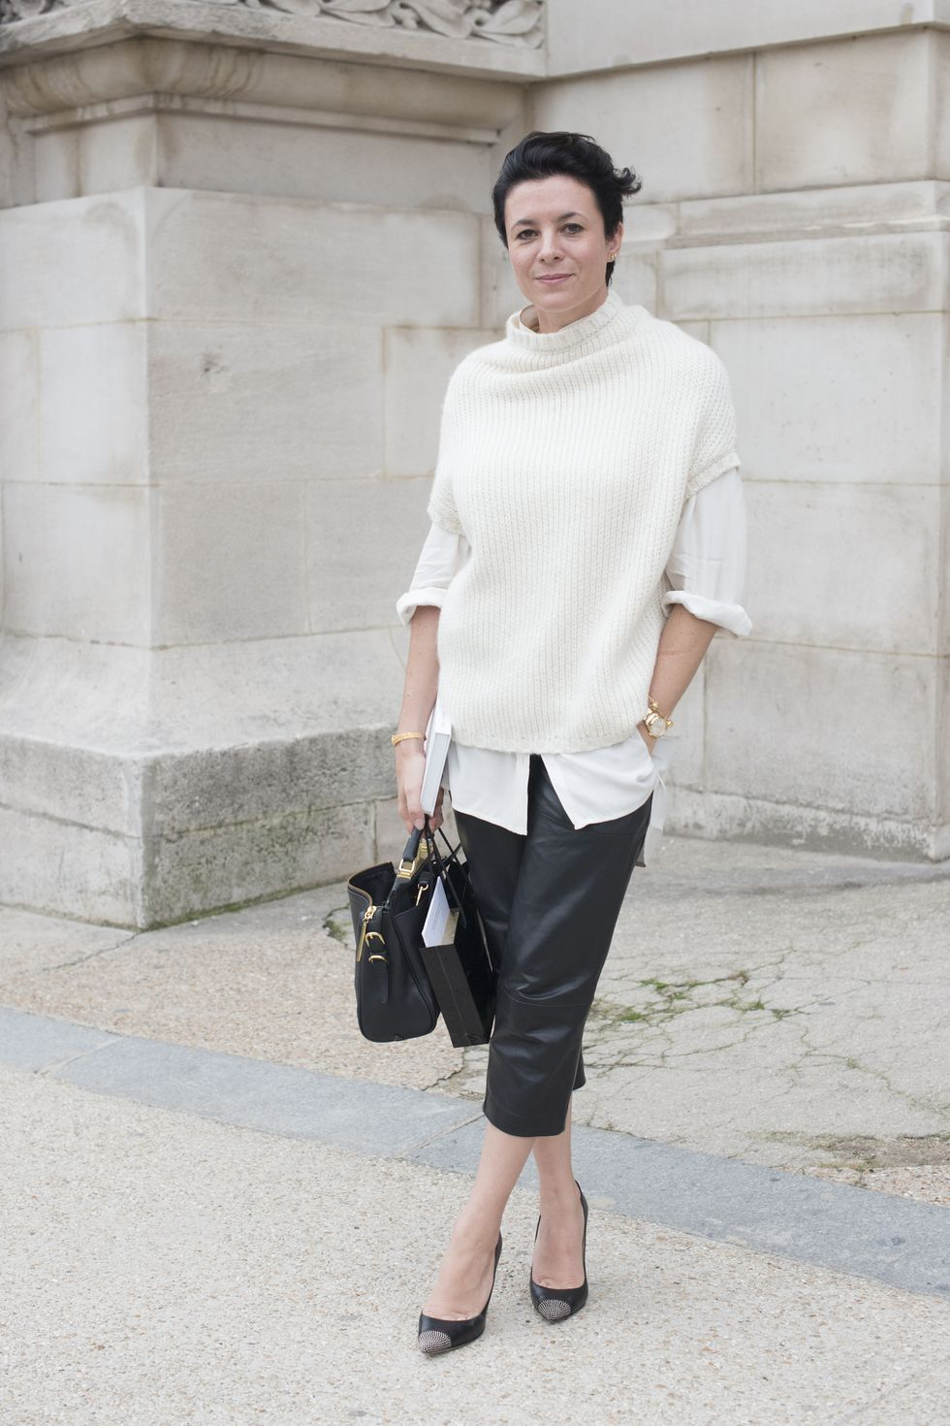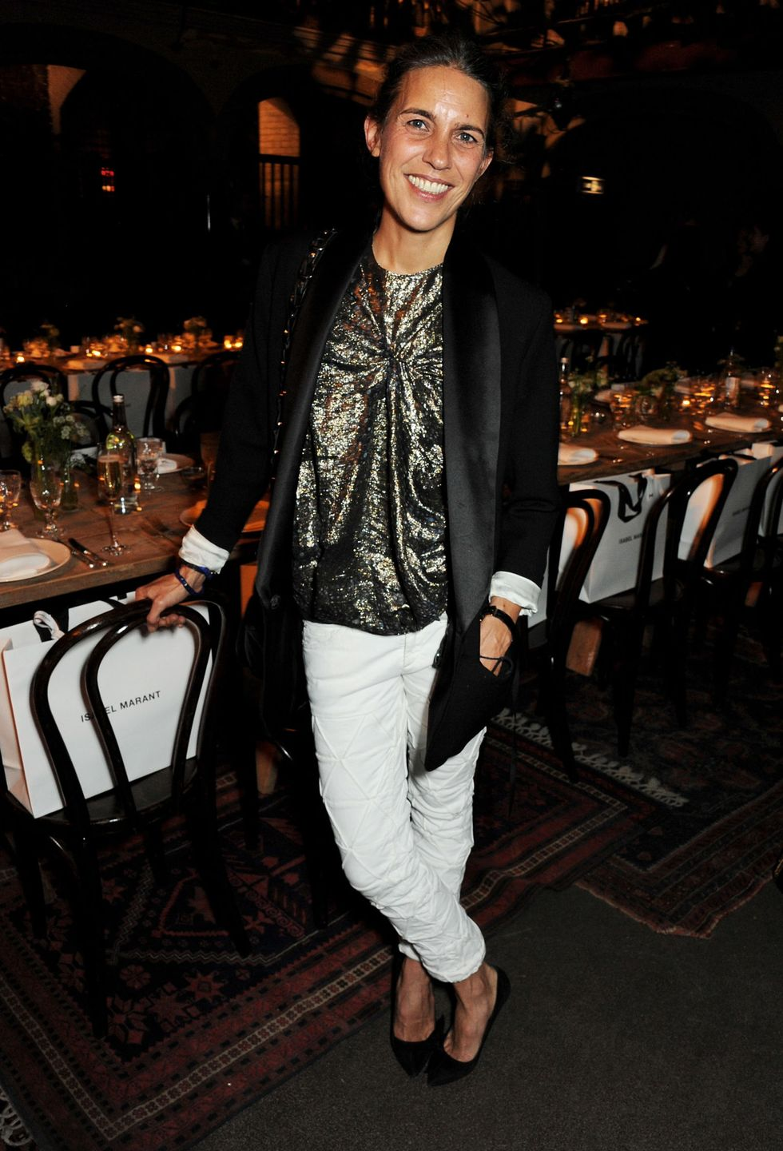
https://fashionista.com/2019/10/paris-fashion-week-spring-2020-trends
https://www.elle.com/fashion/personal-style/tips/g27203/how-french-women-define-french-style/

London: London is often very rainy, so women and men have to be sure to wear sturdy shoes and always bring a jacket or umbrella with them. People in London often tend to dress either very grungy, or very proper, and then everything in between. Camel and trench coats are a staple in many women’s wardrobes. This season, some popular trends include flowy dresses, Doc Martens, silk skirts, and chunky sneakers.
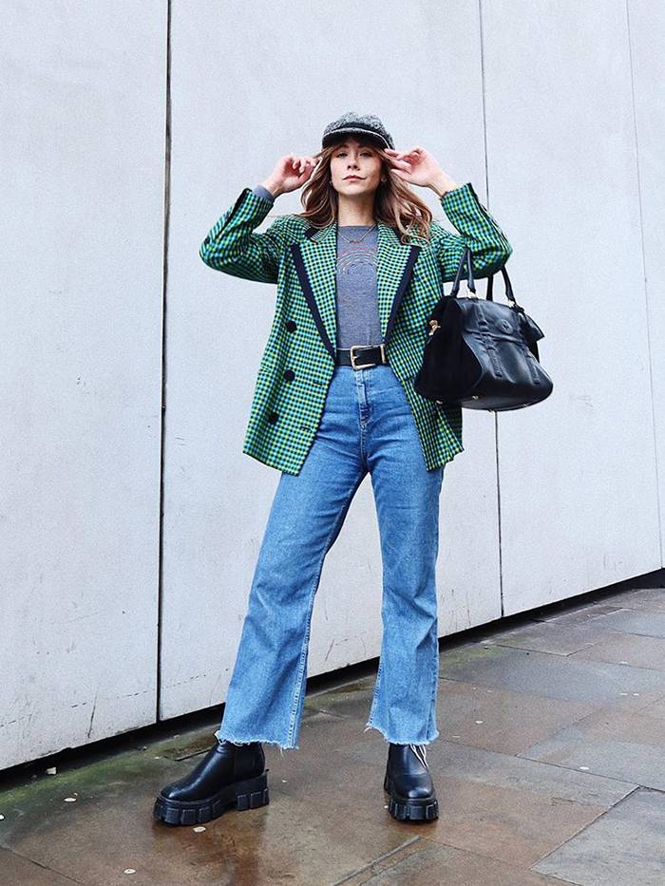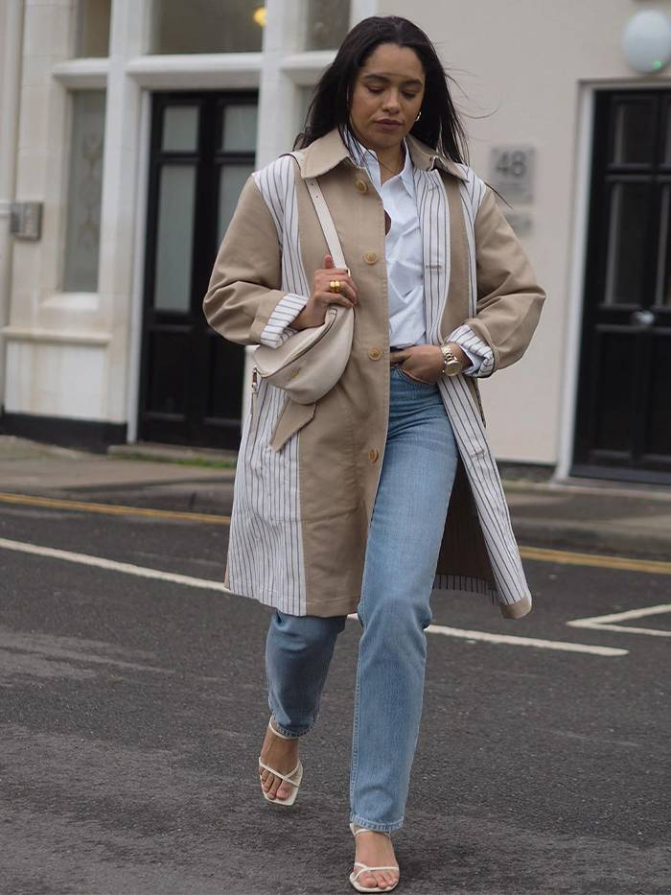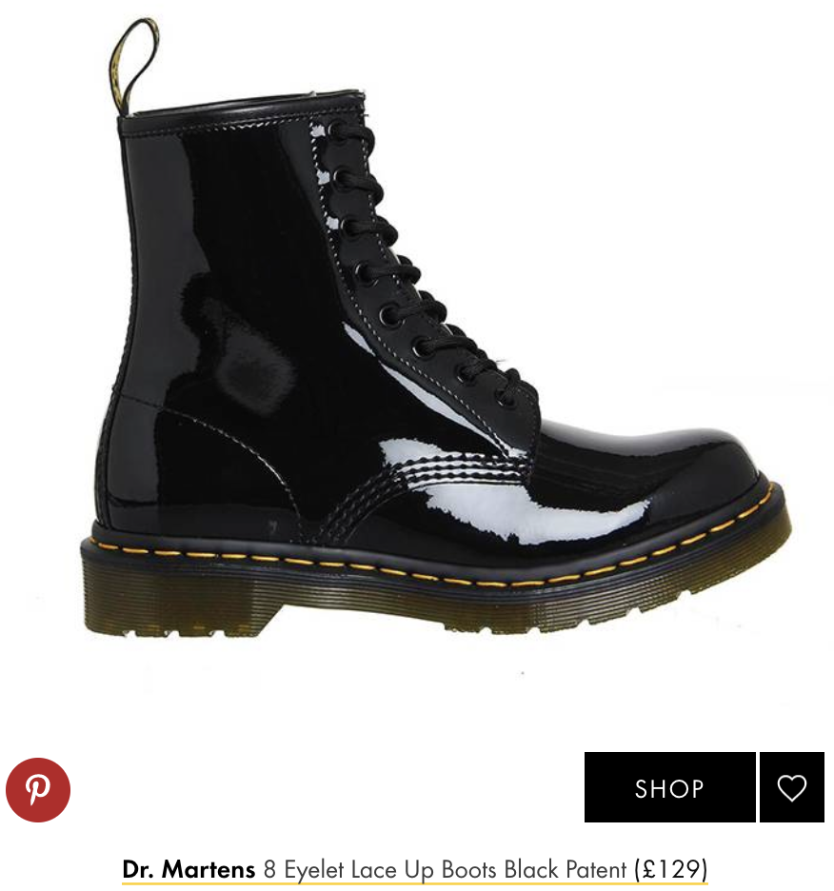
https://www.whowhatwear.com/london-fashion-trends/slide33

Mexico City: Mexico is a place with many traditions, and there is a strong emphasis on craft and the use of raw materials. For example, embroidery and weavings are quite popular. Vibrant colors and prints in the clothing represent nature, from flowers to wild animals. It is quite hot there year round, which means that people tend to dress in lighter fabrics. 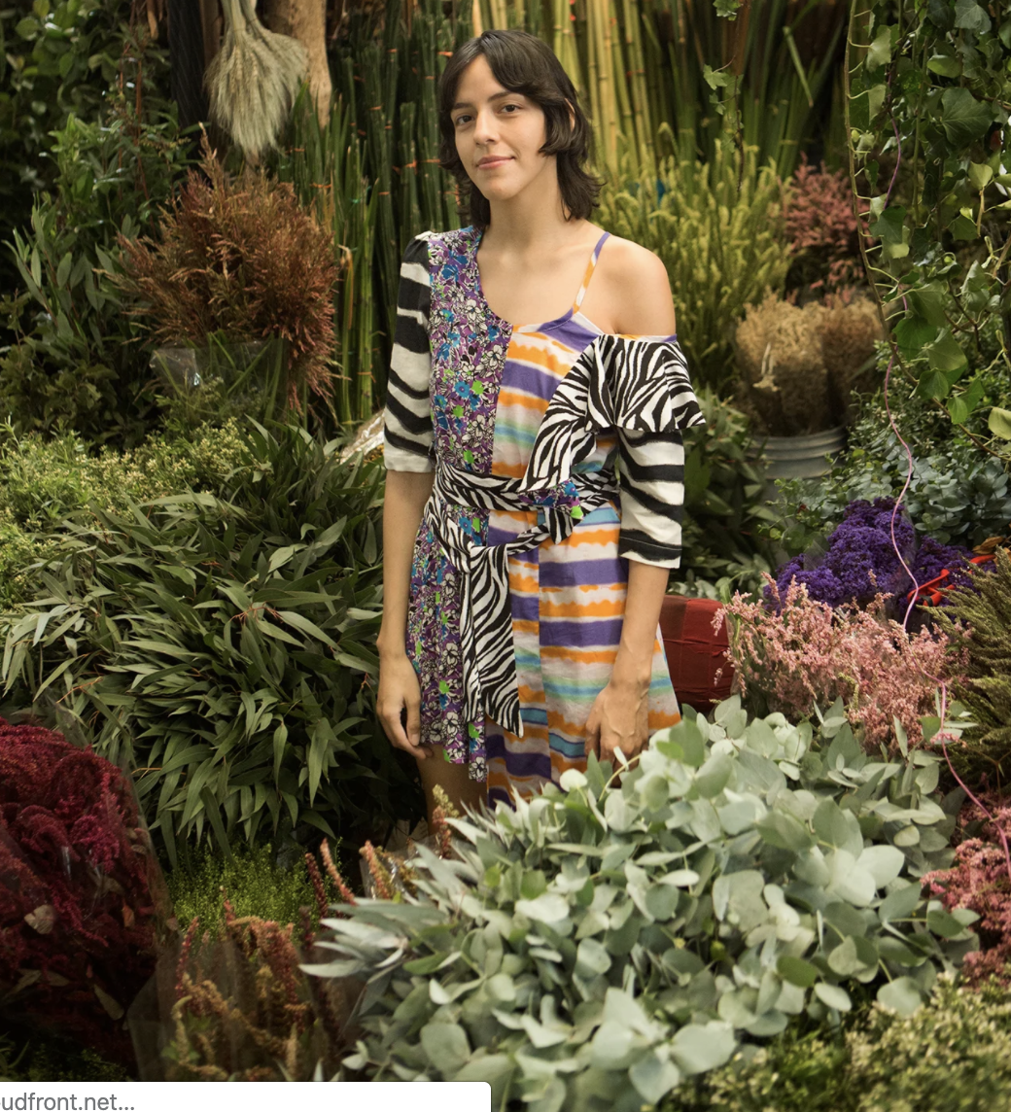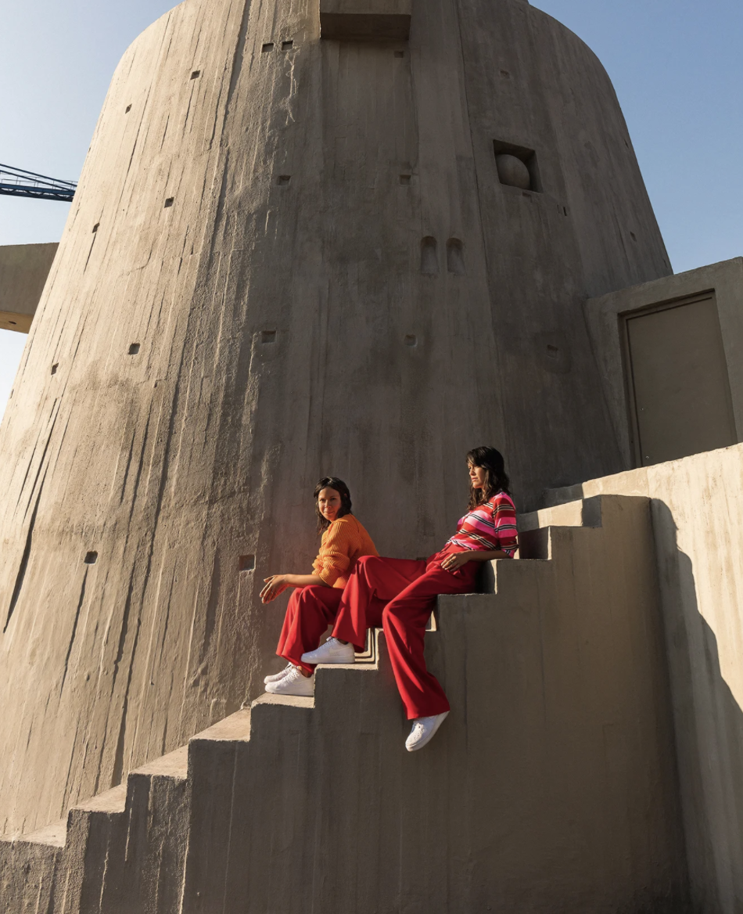
https://www.vogue.com/article/the-latina-cool-girls-guide-to-mexico-city

New York: New York is a melting pot of people coming from different places and cultures. Women in New York usually tend to be very busy, either running around doing their job or going to school. Since most people who live here walk most places, comfortable shoes are a must. Layering pieces are also very popular, since the weather is sometimes unpredictable. Soho is a place to see all of the newest fashion trends in action. Popular styles this season included, oversized blazers, asymmetrical dresses and skirts, and kitten heels, to name a few. The most stylish women tend to be very confident and comfortable walking around in the latest trends mixed with their own personal style. Men also work hard, and are often required to wear somewhat formal clothes to work; while on the weekends jeans and button downs are some go-tos.
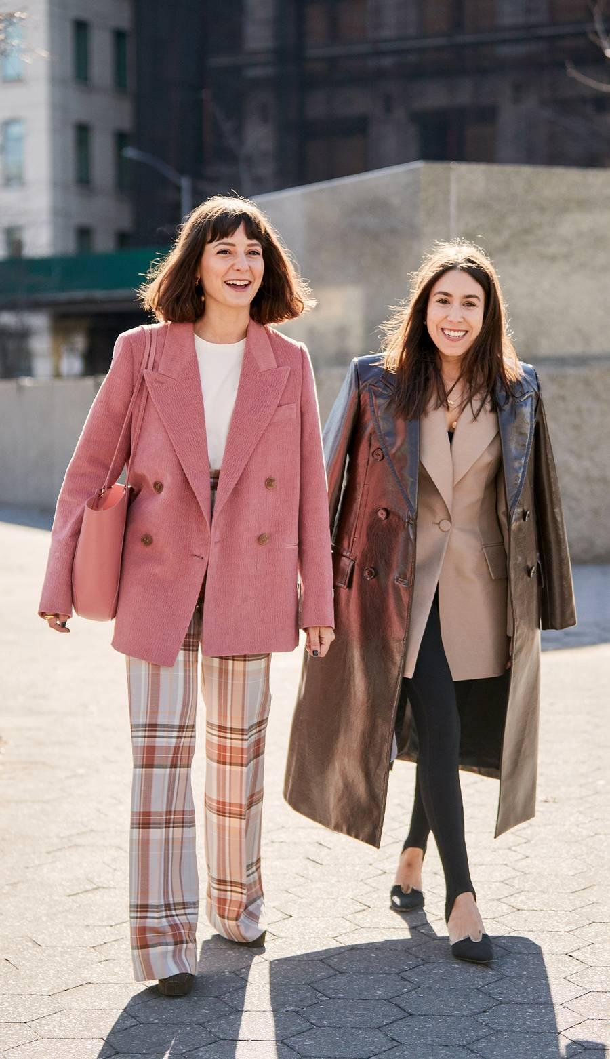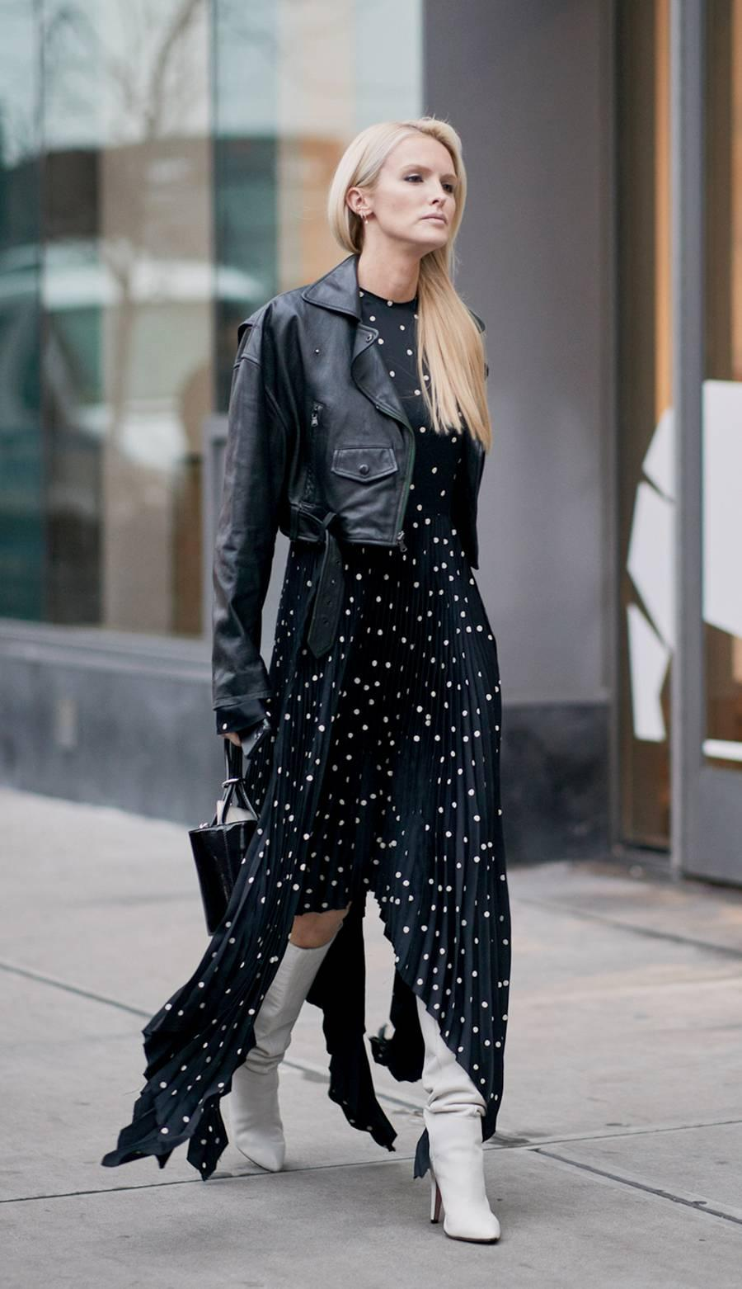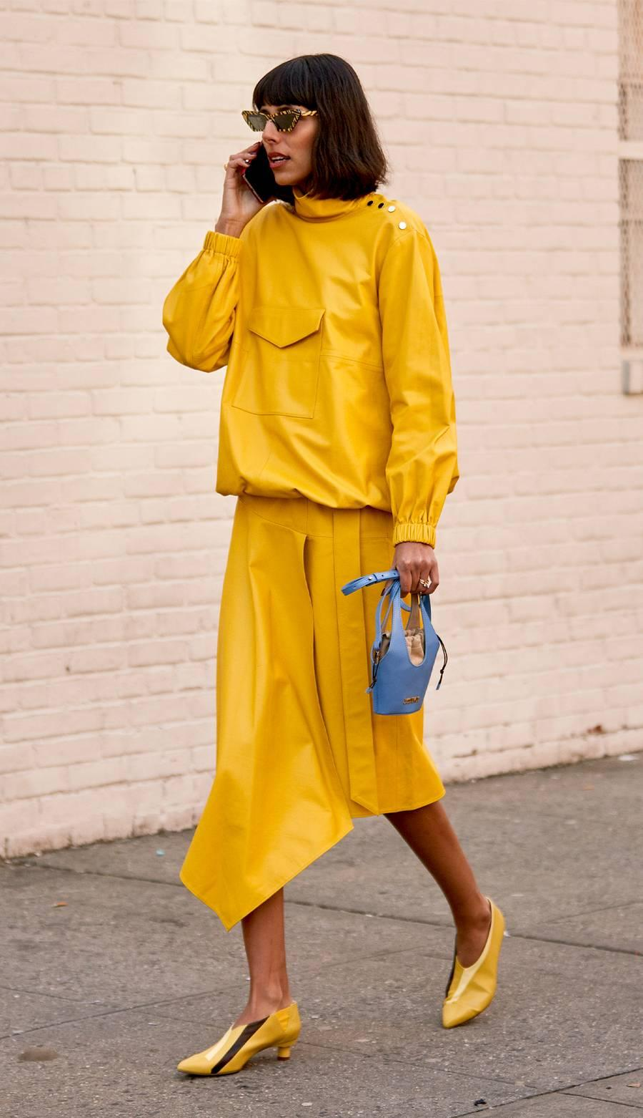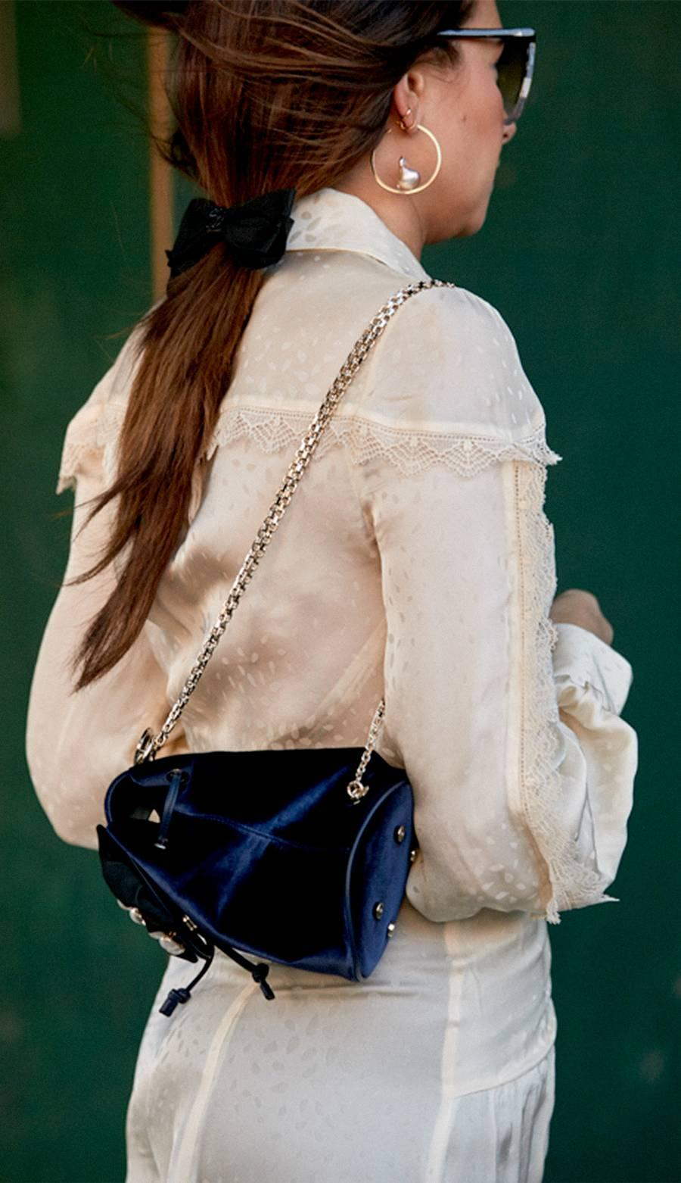
https://www.whowhatwear.com/easy-fashion-trends-2020/slide24

A common similarity about many of these cities is that the fashion trends tend to involve bright and vibrant colors. Jewelry also seems to be popular in almost every city. Otherwise, these cities mentioned above have their own unique style trends that correspond to the culture, history and weather in each place.

I would have to say that my favorite of all these trends and styles are those present in Paris. I love how the Parisienne women dress very comfortably, yet stylish and ultimately to look so seemingly effortless. I also appreciate how they emphasize the importance of quality pertaining to clothing and accessories. Their style is similar to what I would like my own personal style to be.

