Bridge 3 Proposal

My intervention is to install a number of single stall booths at the South East of Union Square in an attempt to recreate the “slave market”. The decrease in human traffic will reducing crimes like assault and pick pocketing.
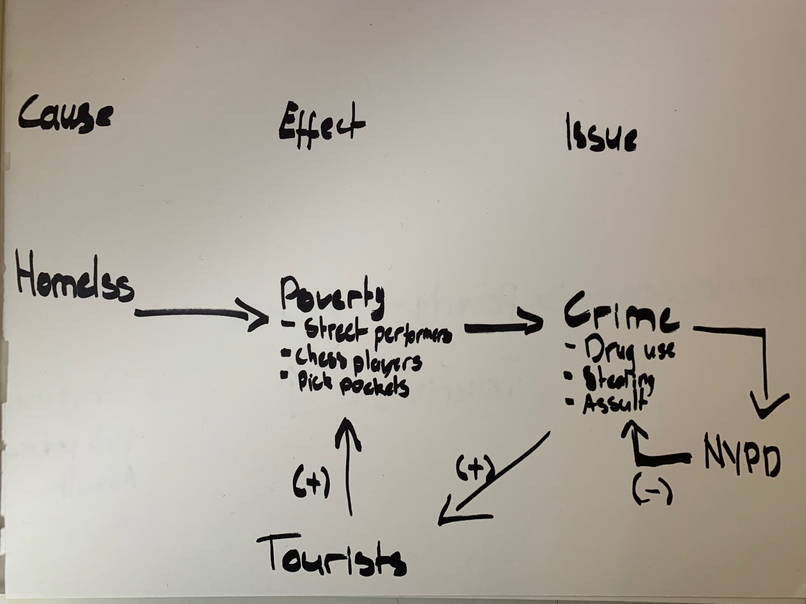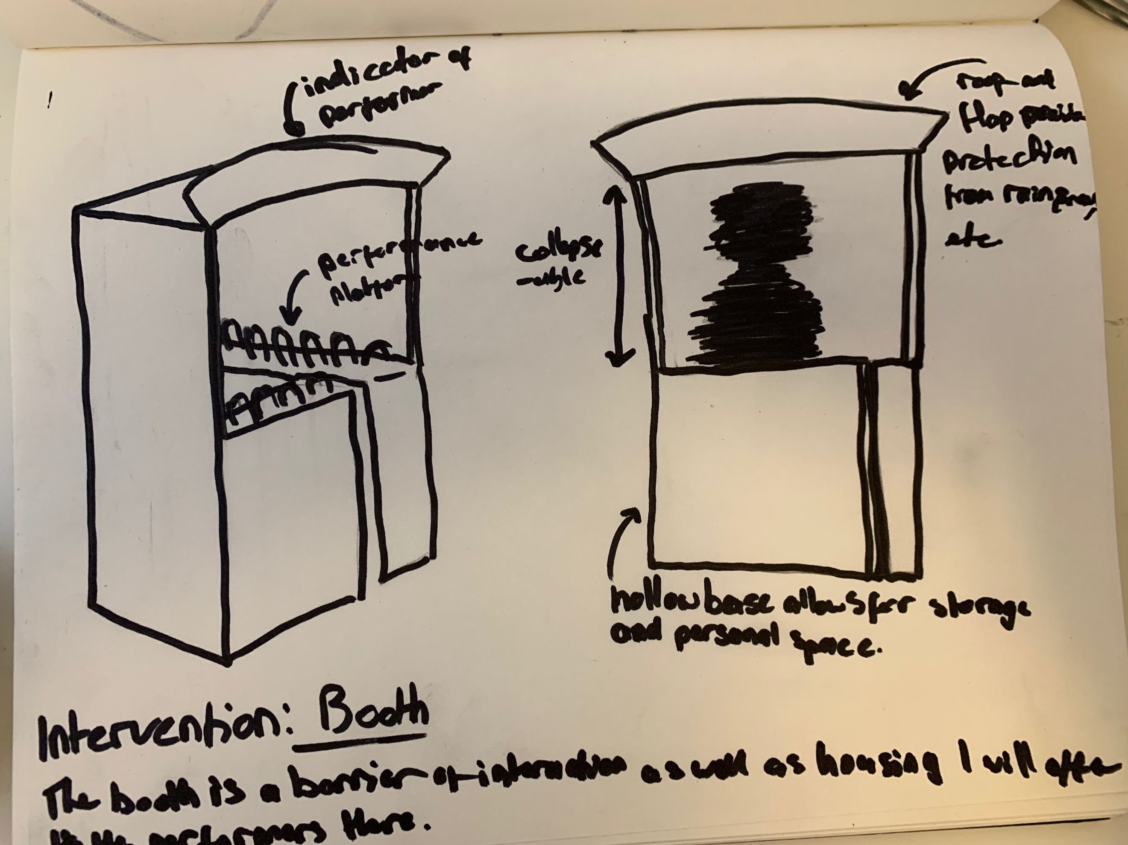

- My project is an intervention to the system of poverty in Union Square regulated by police presence. The cause of the system is homelessness, homelessness as a cause is a result of factors outside of Union Square such as unemployment. The effect into the system is poverty as street performers, chess players, etc. The system is sustained by the tourists who are not familiar with the local mode of interaction allowing pickpockets to work among the performers and the resulting issue is crime. The issue of crime brings drug use, stealing and assault into the system which responds by increasing the dispatch of police officers to the area. The NYPD act to reduce crime which increases the number of tourists and feeding back into the loop at poverty.
- The goals of my project are to either reverse the loop to reduce the human traffic at Union Square, and/ or remove tourists as a feeding factor of the loop. To reverse the loop, I would have to find a way for my intervention to independently reduce tourists, by legal means not to increase police activity. By reducing the number of tourists, the factors affecting poverty resulting in crime would suffer meaning that NYPD would reduce numbers and lighten foot traffic. The booths would also act as short-term solutions until I can direct the project in a way to solve the problem all together.
- The target audience for my work includes the street performers and the tourists. The booths are designed for the street performers, to their basic comfort needs and mostly as a point of honest interaction with the tourists. The tourists interact with the intervention less frequently and less intimately however they are the most user centered design for the intervention. The street performers belong to a wide range demographic; the ages range from mid twenties to sixty, ethnic range predominantly African American includes few other minorities, from immediate observation the genders identities appear to be mostly cis-males, and the closer details of background require deeper investigation. My tourist demographic includes all races, all ages, all genders identities inclusively as Union Square is a point of interest at one of the most popular tourist destinations in the world.
- The research process would be a close observation to the reactions to the environment and how they affect the street performers directly; how it affects their business, how it affects they’re comfort, how it affects their interactions with people. The aim is for the final design of the booth to support the interaction between both parties so that the performers are unable to pick pocket their customers and still perform for pay. This assumes that the results of my research find that the street performers are willing to sacrifice how much they make from stealing.

Redeem
The theme used to help me choose a topic for research is redeem.

Site
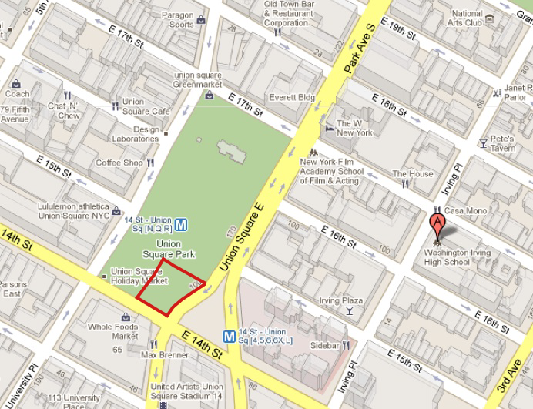

References

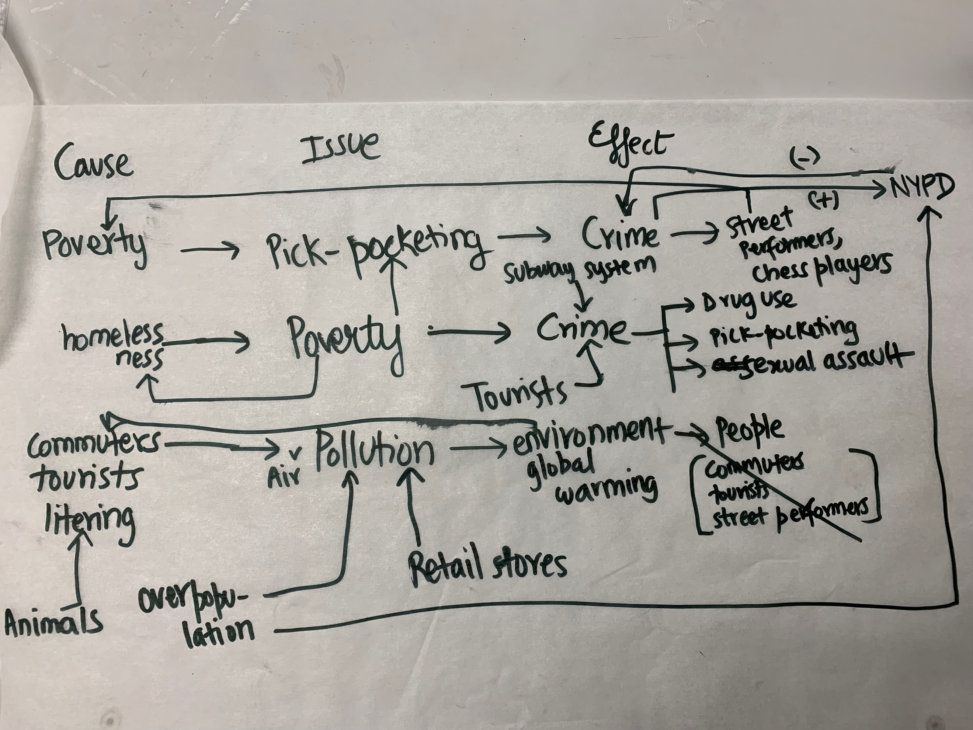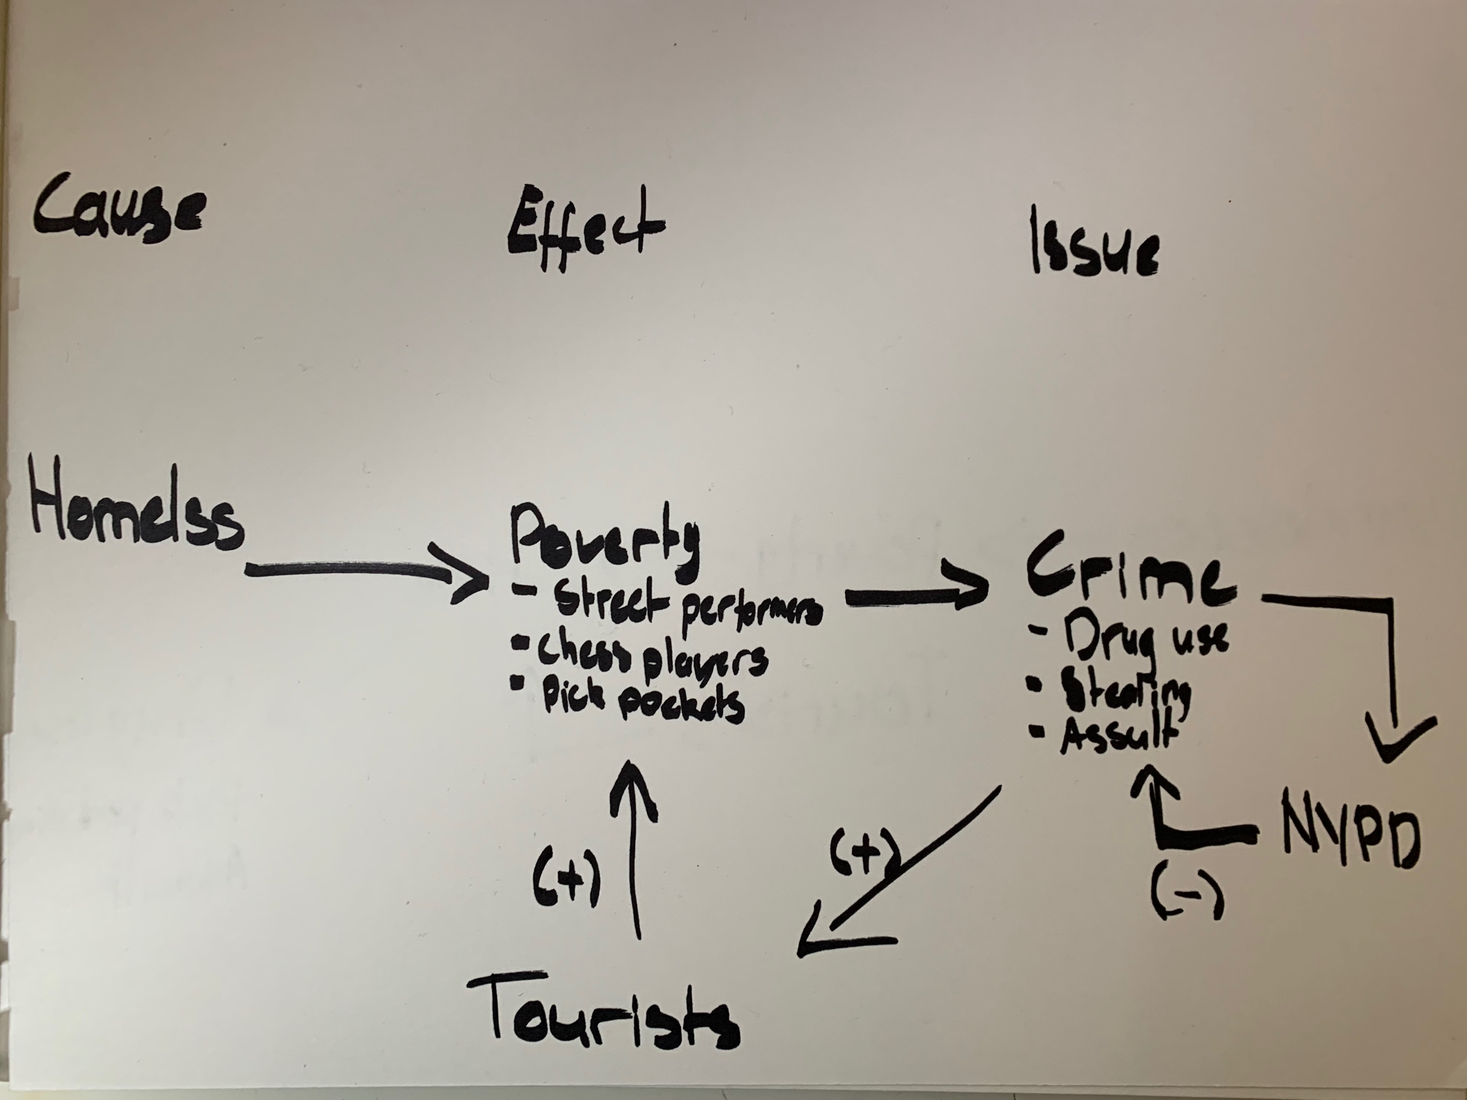
In class discussion.

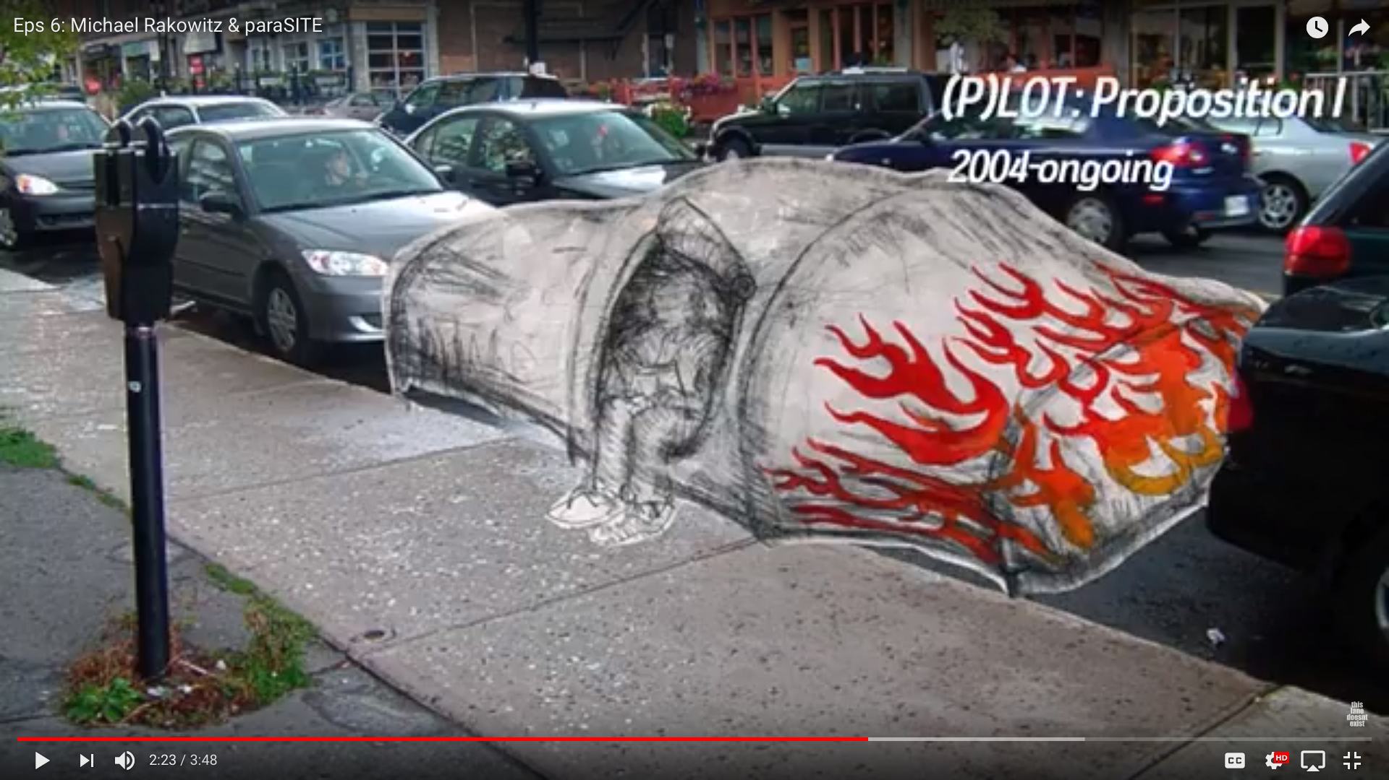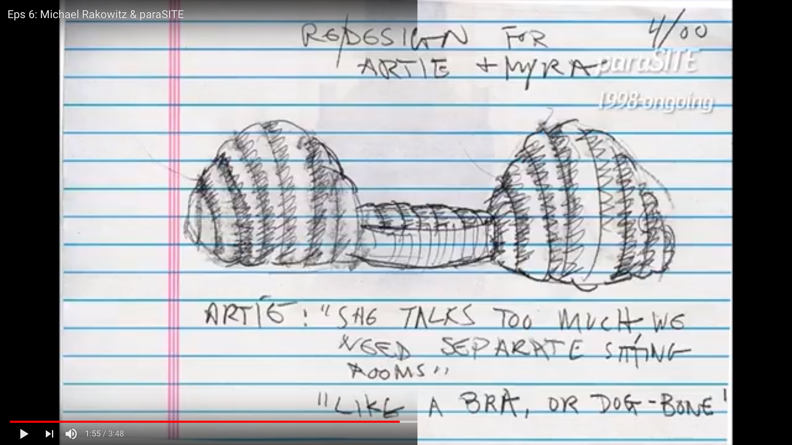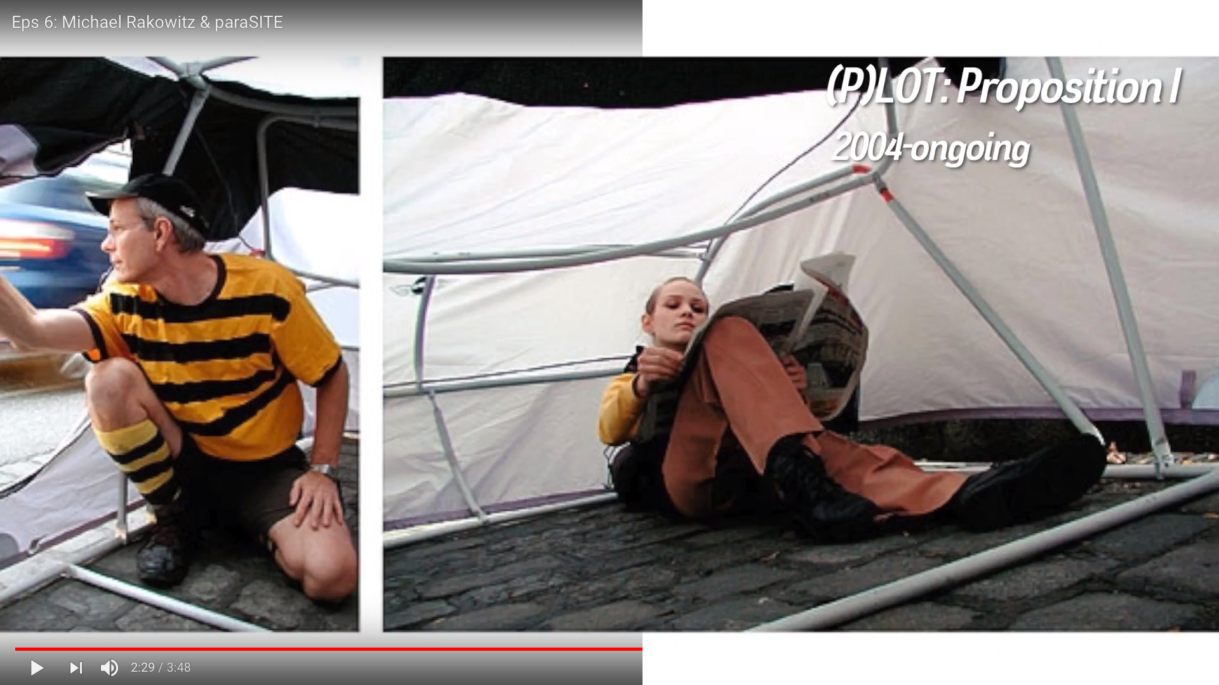
Michael Krakowitz
http://www.michaelrakowitz.com/

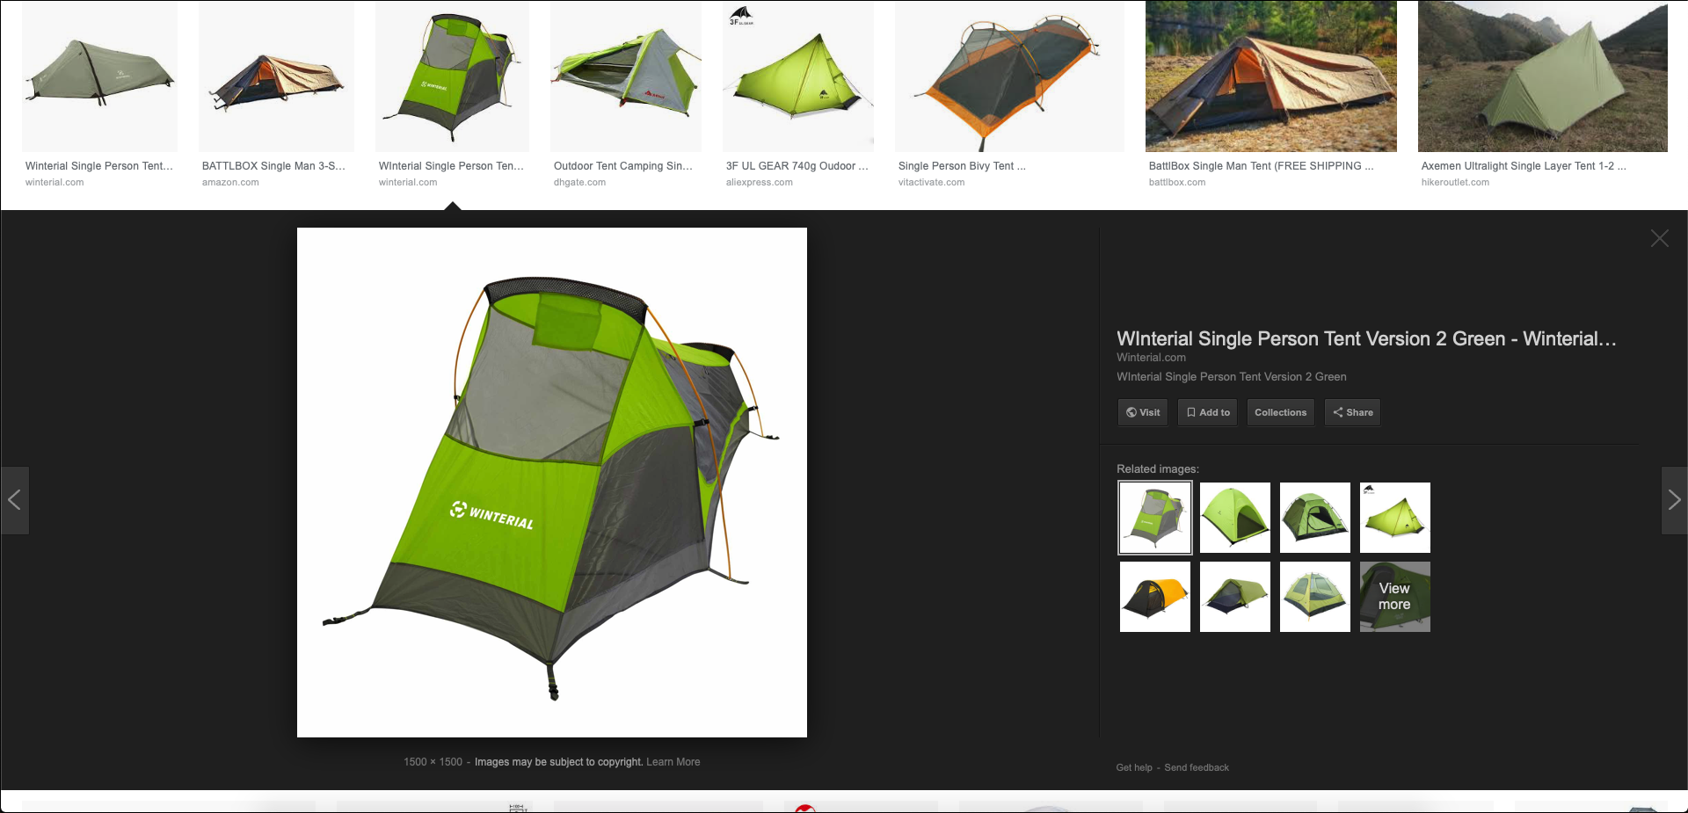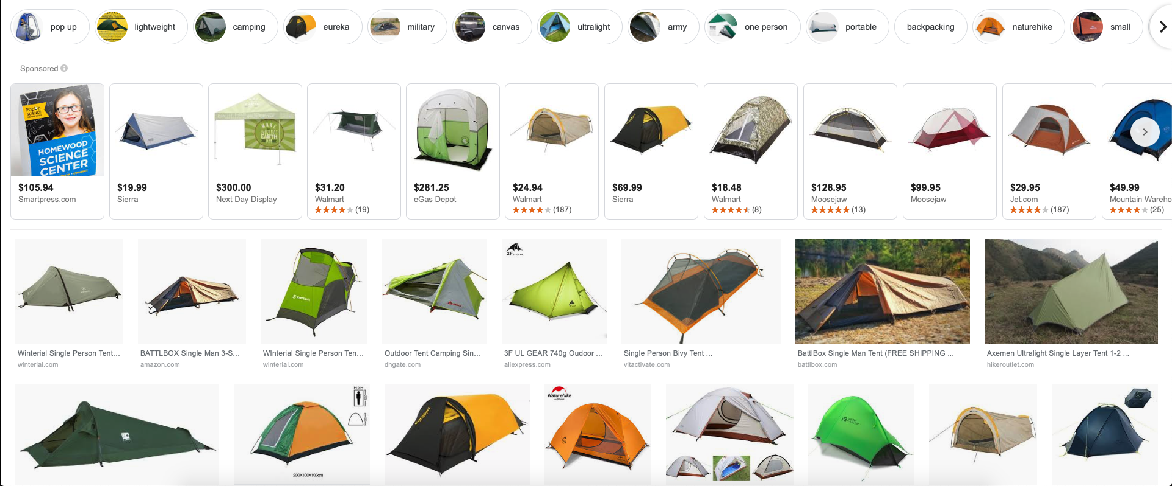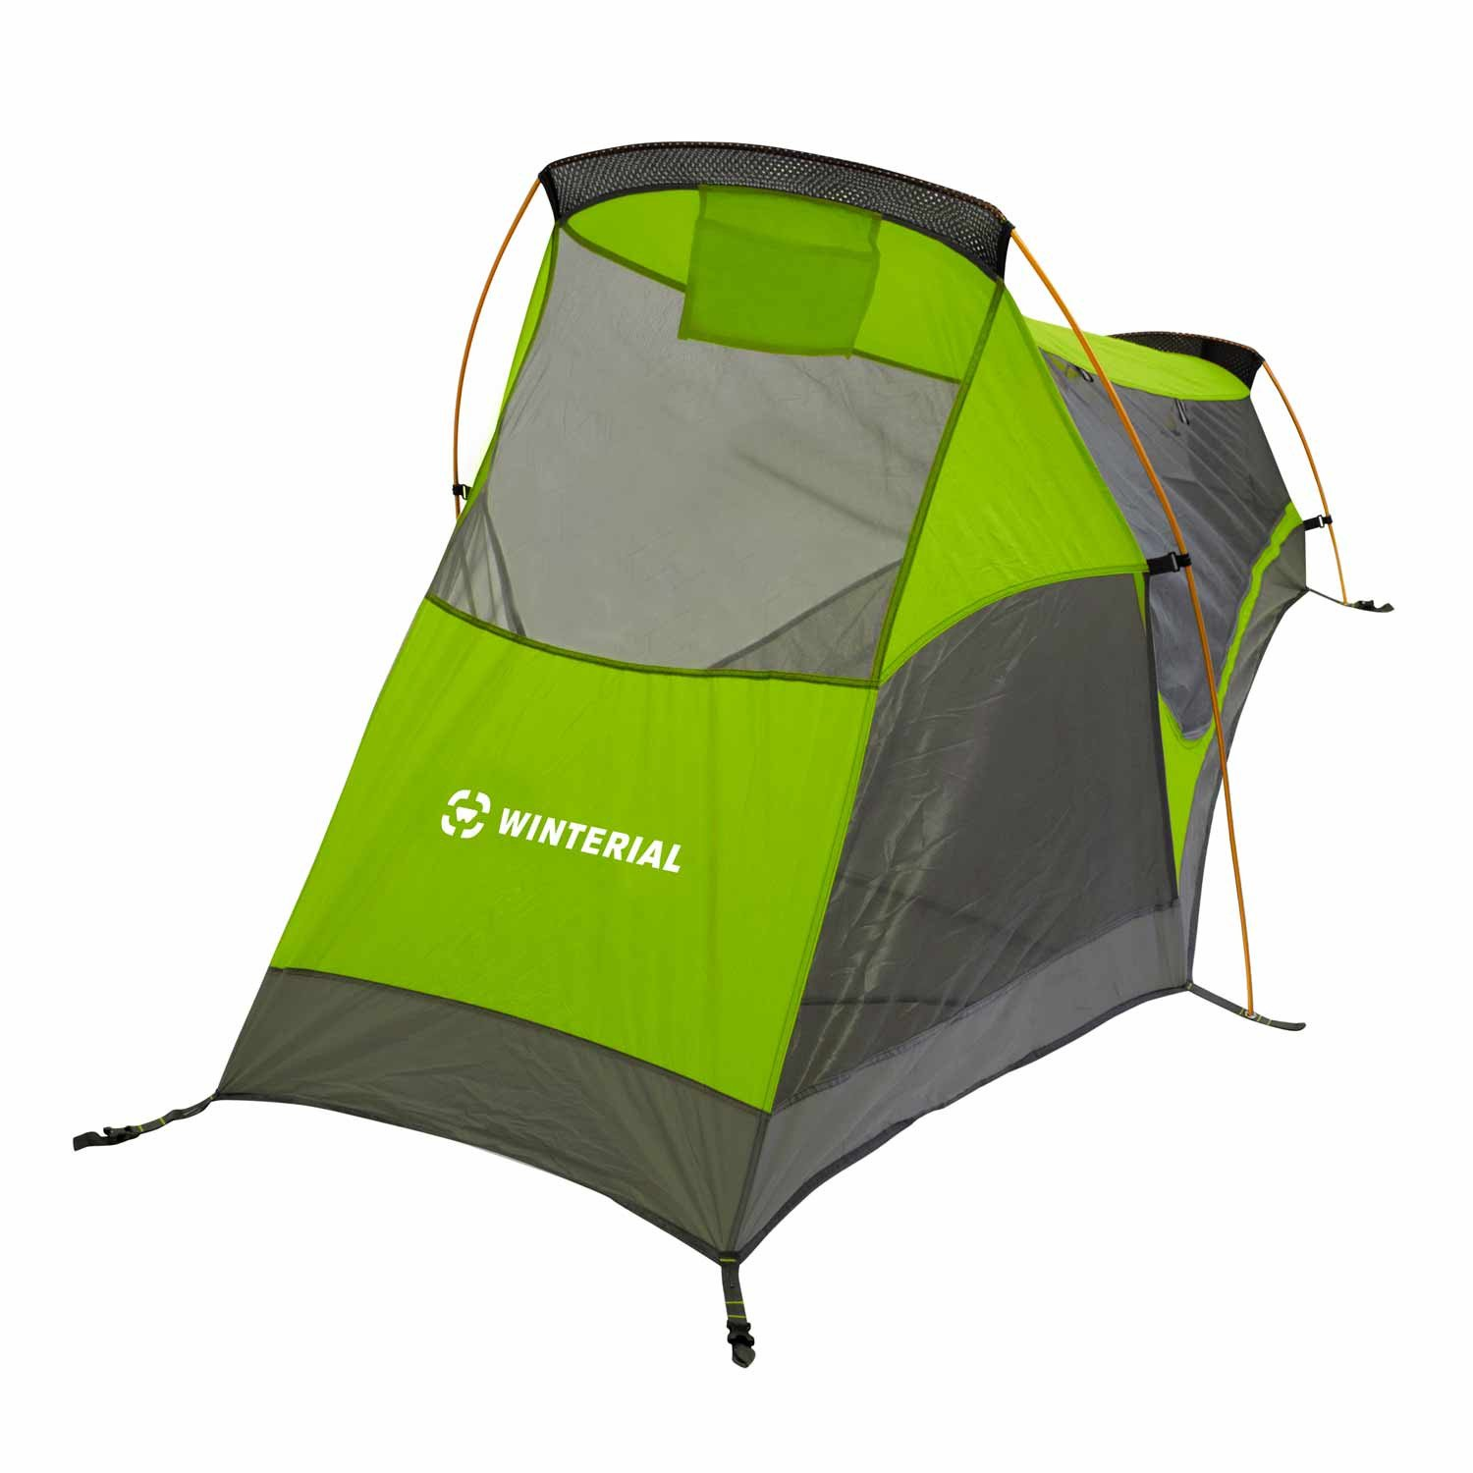
Google Images

