Relevance between human development and climate change
Yeong Jin (Marc) CHOI
1/25/17

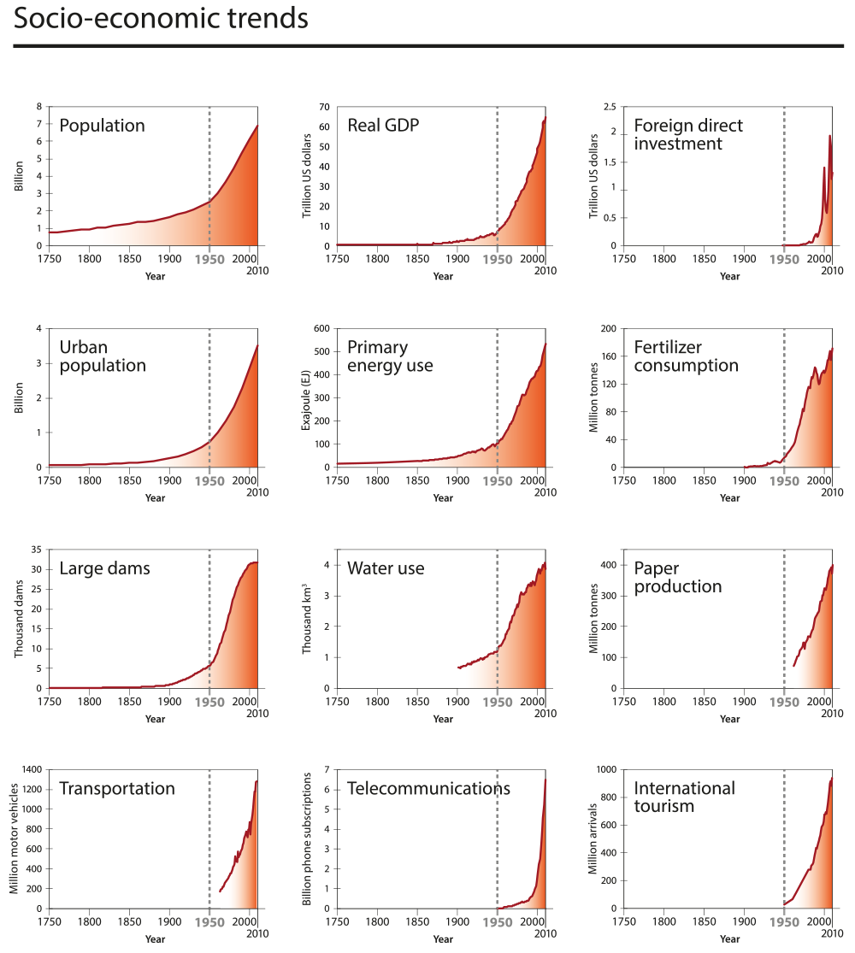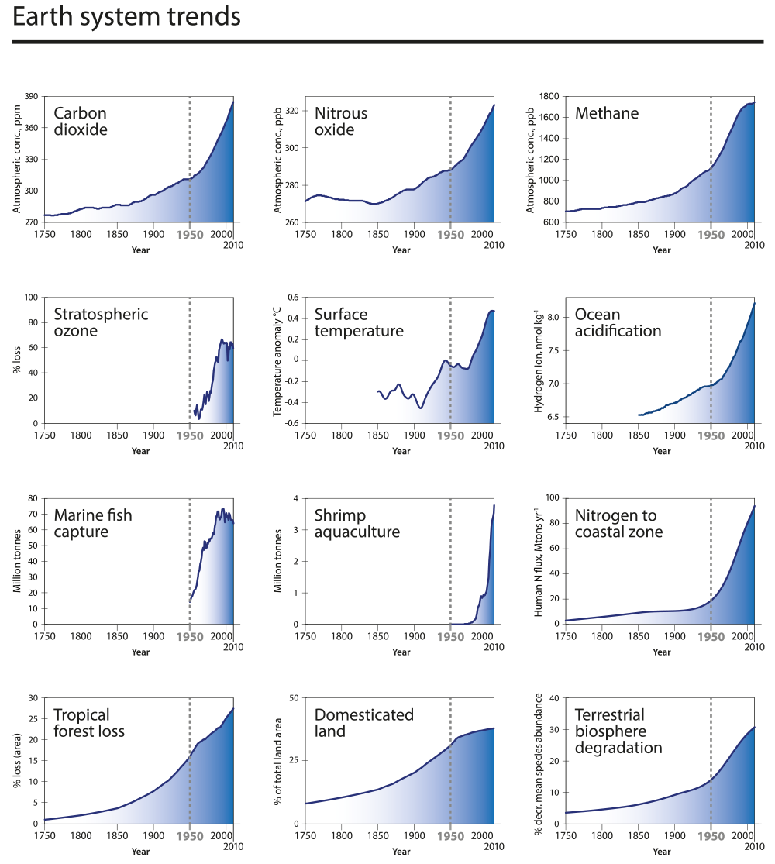
Image Credit: International Geosphere-Biosphere Programme

- As shown in graphs above factors which are believed to give bad influence to the Earth’s climate or/and bare responsibility of global warming issue.

- As population increased rapidly, due to lengthened life expectancy, growth of food production and other factors, content of Carbon Dioxide went up as well.

- As population increased more energy is needed to accommodate increased population.
- Increased population can also mean increase consumption and increase labors; which resulted mass production.
- Mass production could not solely rely on human labor so use machinery increased. Use of machinery consumes energy which majorly relies on fossil fuel. Which the use of it creates carbon dioxide.

- As GDP goes up, primary energy goes up as well, showing similar curve.

- United States of America has largest GDP as of 2016. But United States of America is rarely blamed for climate change. In this term GDP and primary energy use seem not related to each other.
- Walmart, biggest company of U.S., has imported 795,900 shipping containers in 2016. Other than the food and grocery, majority of products it buys are made in foreign countries, majorly from China.
- P&G also makes majority of its products in China, as well as HP, Apple ect. Those companies are exempted from the blame because the actual productions are done in a form of out sourcing, which is to be blamed for not only climate change but also other issues like workers’ condition and child labor.
- Other than manufacturer, U.S. has oil companies, like Exxon M., Chevron, for its biggest company. They are to blame for carbon footprints all over this glove, not only because the fact that they are producer of fossil fuel but also for the carbon footprints they make with shipping, refining and others.
- Another major business of U.S. is investment firm, or bank, which plays huge role in foreign developed countries’ capital to go to relatively less-developed countries to produce in the most hazardous condition, both to climate and humanity. (See the relevance between global investments and other climate change factors)

As a conclusion, we cannot blame one specific country for climate change as it has countless factors which affect it. We need to step away from globalists’ point of view and should focus more on a community. Mega companies like Shell, VW AG, HP and others are to be blamed for the climate change and it is their obligation to invest more on to clean energy and sustainable production.

Also as a person who is passionate in fashion, I blame fast fashion and ready-to-wear clothing, which has much shorter history than fashion itself, for being responsible for carbon footprints they cause. Duration of clothes has been shortened due to decrease of production cost of fashion. Also globalism has allowed and provided a bigger market which also allowed smaller margins and it also destroyed smaller brands by large scale marketing. Different cultures or communities used to have their own distinctive fashion, but now we all wear alike. People does not spend less, if not more, on clothing and many of that money is spent on marketing, not on manufacturing. Clothes manufacturing has been bringing conflicts recently. It uses cheaper, artificial fabrics and materials to keep the cost low and absolute majority of them are made from fossil fuel and takes very long time to self-decompose and as their production is more focused on design and low price, quality of each products are unscrupulous. Thus it makes much easier, and even necessary up to certain point, for people to trash their clothes which they bought couple years ago. I feel deep aggression to this custom, because fashion is an art form which people use to express themselves on everyday basis.

