Rachel Chang
Fashion Seminar
BP #5
My Freshman Year

My name is Rachel Chang and I am a fashion design major at Parsons. I have always been interested in fashion, and how to make clothes and design them as well. I have never worked with a sewing machine until I started teaching myself through the class of Space and Materiality. This class introduced me to the new electronic sewing machines, rather than the old industrial ones. By learning these skills, I was able to use these new found skills to create my final garment in my Studio Fashion class.
A constantly appearing theme that comes up within my artwork is the 90s era. I noticed that by two favorite pieces are both related to the 90s in a way, and by expanding on this thought I realized I have a fascination for the 90s era. In result, this inspiration shows up frequently in my art projects.
My two highlights throughout my entire freshman experience at Parsons has got to be my Mickey Mouse hand that I hand-sewed together for my final in Space and Materiality, and the wind-breaker that I sewed together for my Fashion Studio final.
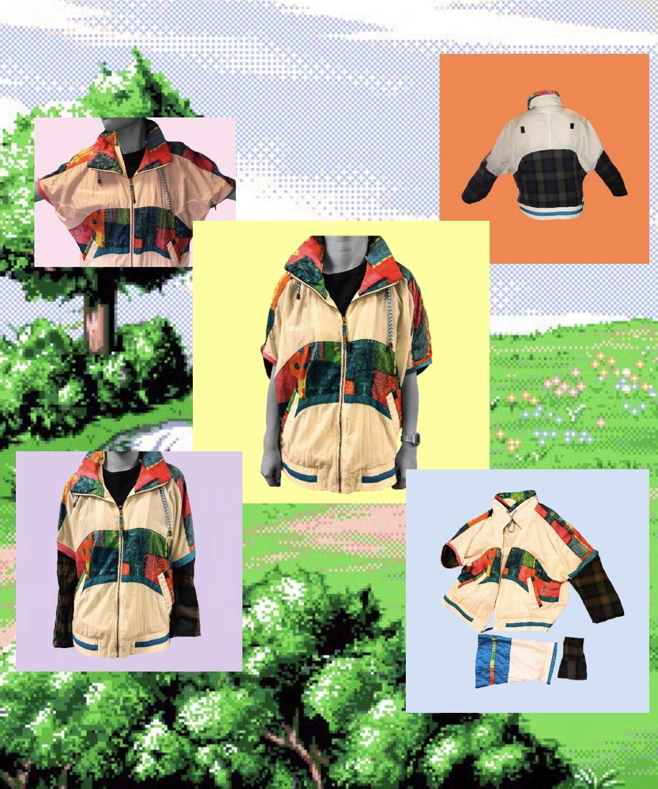
This is the wind-breaker that I created for my final in my Fashion Studio class. I am very proud of this piece because everything you see here is thrifted or free in some way. Therefore, it is a sustainable way to create something new out of some pieces of old clothing. I really connected with this piece because this was the first garment I have ever created all on my own and it was very exciting to see myself creating something out of nothing. In addition, my theme around this was the 90s era. So, I focused my garment on wind-breakers and flannels because those two styles were very prominent during this time era. I had problems with sewing on the different types of sleeves due to not having much experience with changing and resewing on different sleeves. Other than that I was very happy with the outcome.

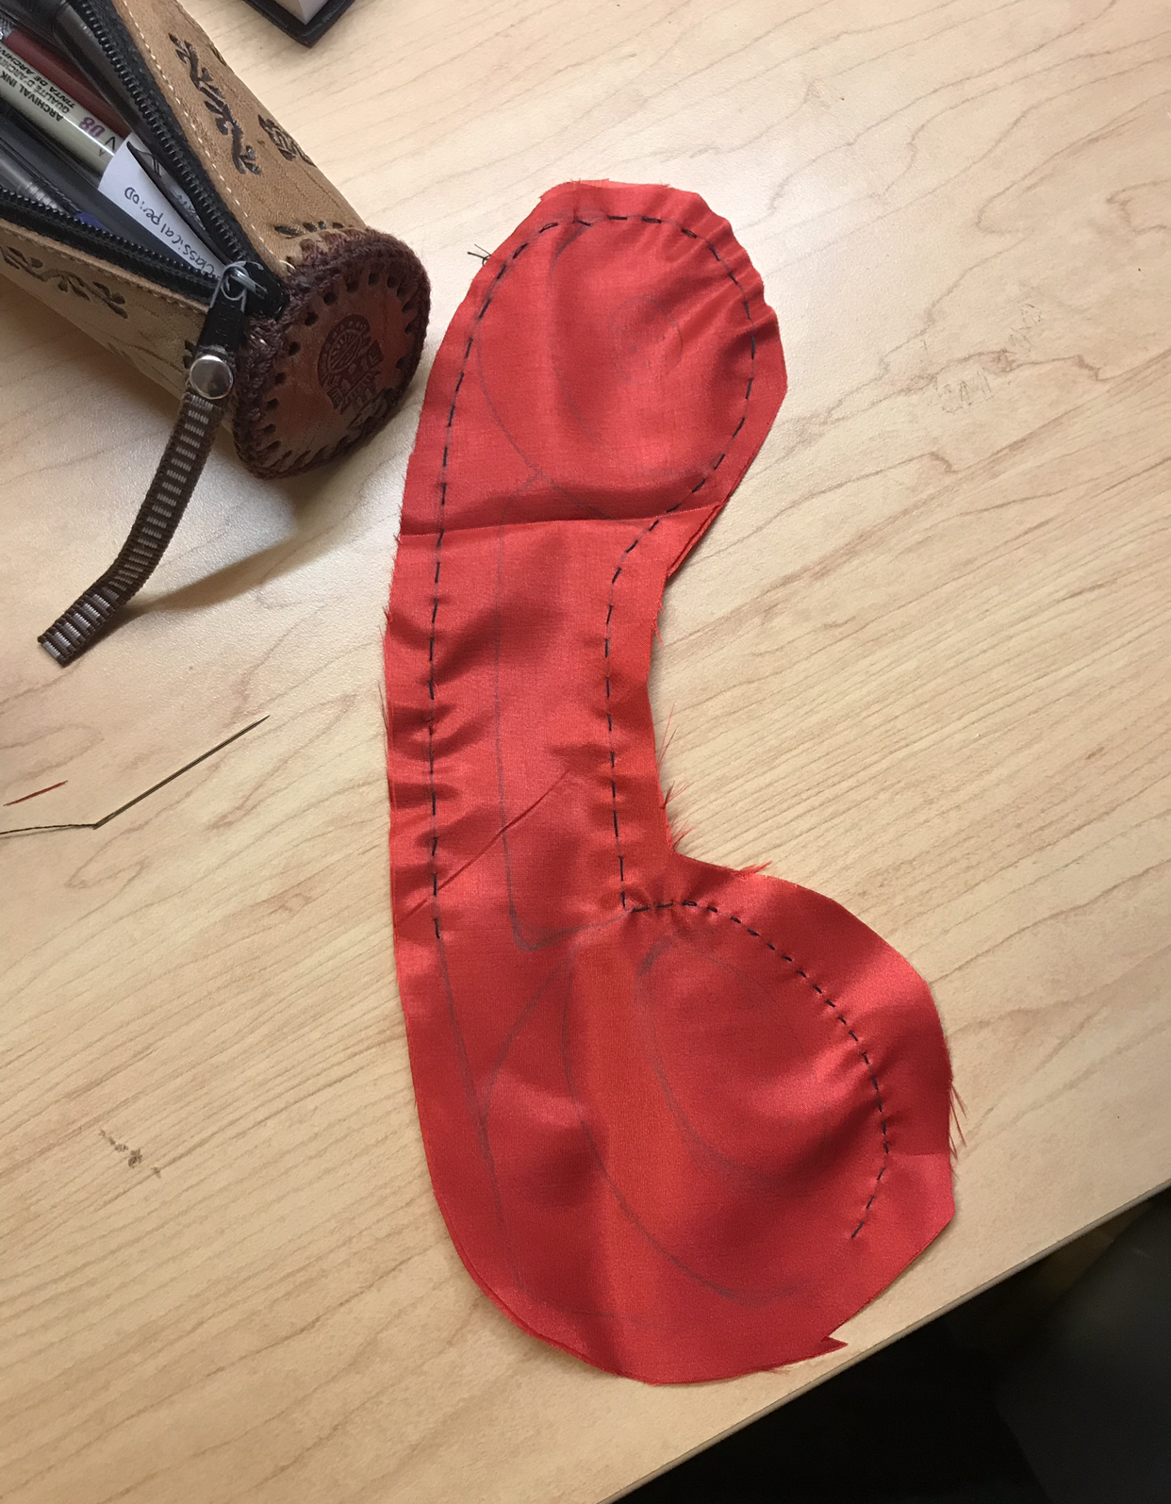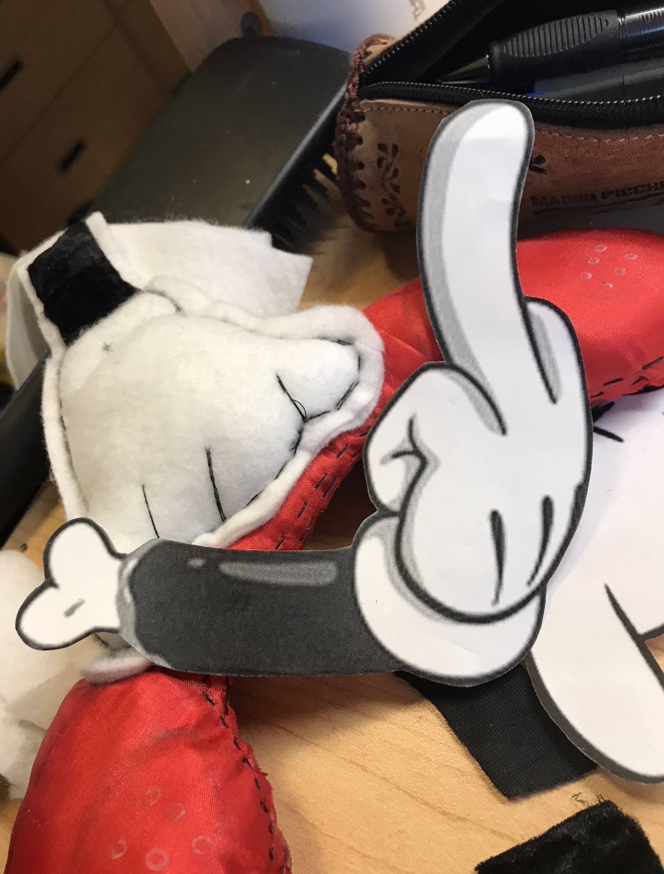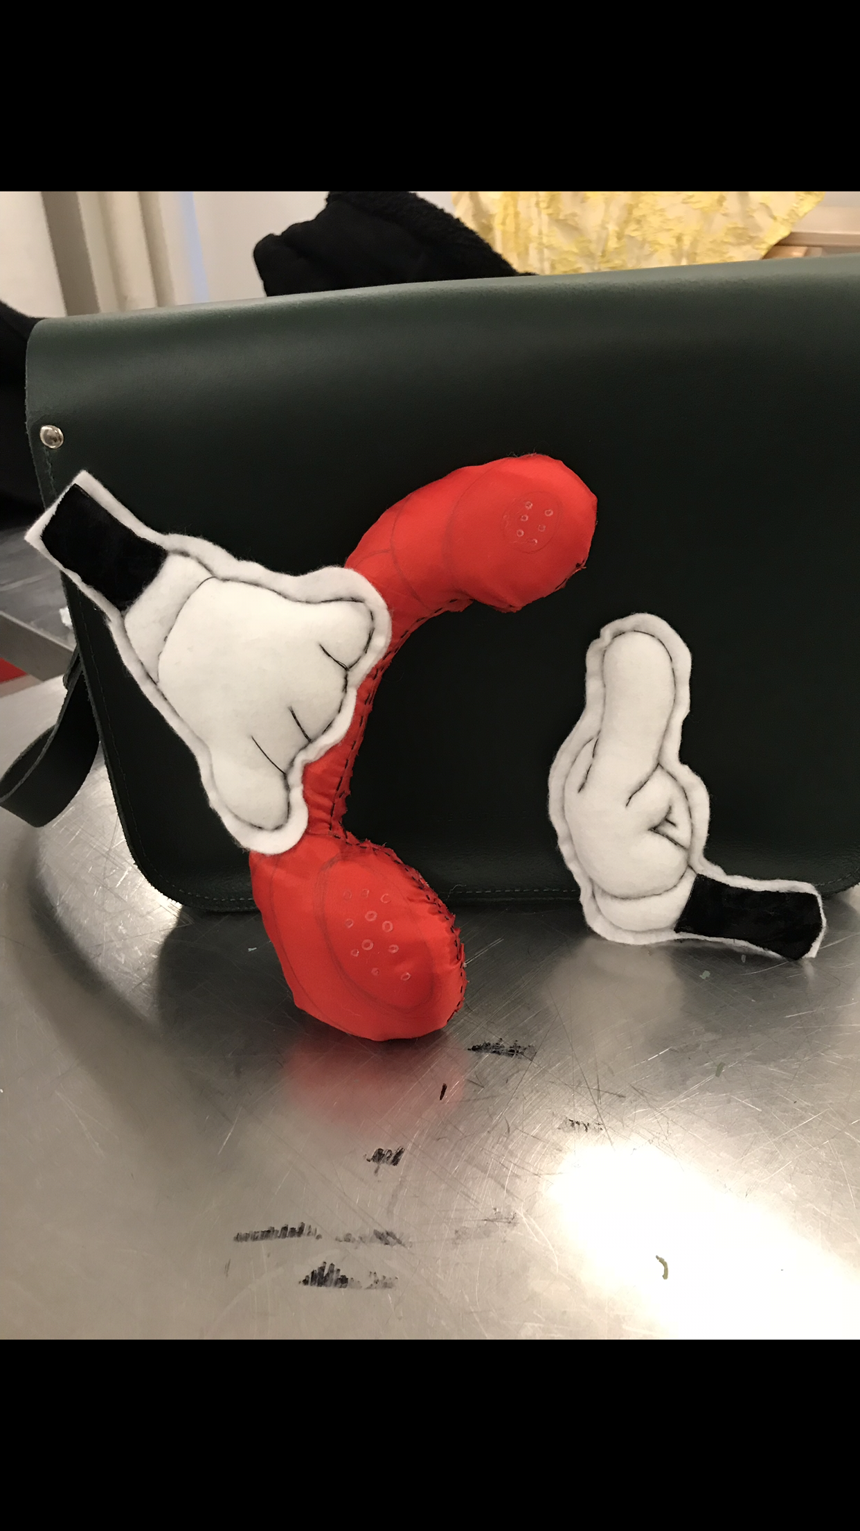

Here is my second highlight which is a Mickey mouse hand holding a telephone and flicking the other hand off. The reasoning behind this piece was to show a sense of rebellion but also have a 90s cartoon vibe to it. I had a lot of problems putting this together because at this time, I was not able to check out a sewing machine. Therefore, I had to hand-sew the entire toy. In the end, I was very happy with the results and how it turned out. If I could redo this project, I would use my personal sewing machine to put these pieces together because it would turn out so much cleaner and crisp.
These two highlights represent me because I really resonate with the 90s era and 90s fashion and I love how it is all coming back into society today. I also discovered that the pieces that I make that are related to my major are usually the ones I end up being the most attached to. I enjoyed reflecting back on my year and relearning the new found techniques that I have acquired while attending Parsons. The new topics that I wish to explore in the future is how I can combine being sustainable with looking fabulous. I want to research more on different fibers on fabrics and how different kinds react and what kind of outcomes will occur. I want to practice sewing more over the summer to gain more knowledge and skill about the sewing machine itself so I can have leverage for when I actually start my major in Sophomore year. All in all, I enjoyed learning throughout this year and finding out all these new topics about fashion that I was unaware of before. I plan on researching more and learning more to expand my skill sets for the future years ahead of me.

