Rachel Chang
Fashion Seminar
BP #5
My Freshman Year

My name is Rachel Chang and I am an aspiring fashion designer studying at Parsons. I am from Atlanta, Georgia but have always felt like New York City was the place for me because of the heavy fashion influence that resonates throughout the city and campus itself. I have always been interested in fashion and how to make clothes and design them as well. To be more specific, I want to create innovative clothing and shoe wear. In addition, I also want to incorporate sustainable business tactics when it comes to my clothing and the brands that I invest in.
Sustainability has came up numerous times throughout my college first year. For example, in my fashion seminar class we discussed about fast fashion and how to eliminate some of the negative effects that it causes. I saw a connection to my fashion studio class when it came to this topic due to having two projects that related within the same topic: innovative sustainable fashion.
In my fashion seminar class I did a research paper on clothing lines that are aiming to becoming more sustainable when it comes to their business tactics and resources. The brand I researched on was the Adidas and Parley collaboration.

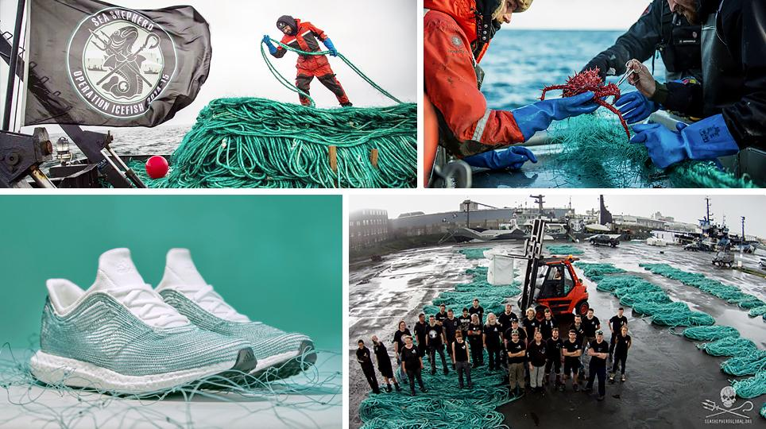
Adidas and Parley made a collaboration where they took plastic from the ocean and incorporated it into their new boost design. This inspired me to explore more ways to become sustainable and how to eliminate the problem of fast fashion as a whole. I started off my research by thinking about what interests me in fashion and obviously I came to the conclusion of focusing on shoes. Unfortunately, I did not have the proper skills to make a full on shoe prototype. Therefore, my next highlight would be my final project that I did for my fashion studio class about Innovative fashion.

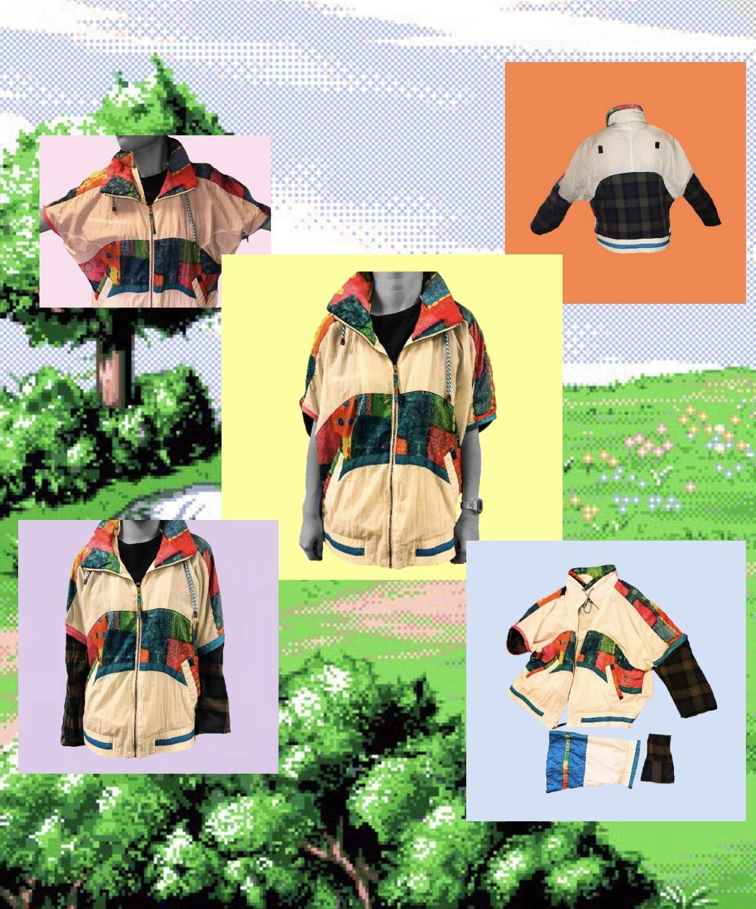

This is the wind-breaker that I created for my final in my Fashion Studio class. I am very proud of this piece because everything you see here is thrifted or free in some way. Therefore, it is a sustainable way to create something new out of some pieces of old clothing. I really connected with this piece because this was the first garment I have ever created all on my own and it was very exciting to see myself creating something out of nothing. In addition, my theme around this was the 90s era. So, I focused my garment on wind-breakers and flannels because those two styles were very prominent during this time era. I had problems with sewing on the different types of sleeves due to not having much experience with changing and resewing on different sleeves. All in all, I was very happy with the outcome.
In conclusion, while studying at Parsons I discovered within myself what kind of clothing aesthetic I want to aim for in my fashion designing career. By exploring more about the topic of being sustainable and how to create new garments out of old ones, I learned that fashion has endless possibilities to solving everyday problems such as pollution and a lack of fabrics and materials. The new topics that I wish to explore in the future is how I can combine being sustainable with looking fabulous. I want to research more on different fibers on fabrics and how different kinds react and what kind of outcomes will occur. I want to practice sewing more over the summer to gain more knowledge and skill about the sewing machine itself so I can have leverage for when I actually start my major in Sophomore year. All in all, I enjoyed learning throughout this year and finding out all these new topics about fashion that I was unaware of before. I plan on researching more and learning more to expand my skill sets for the future years ahead of me.

