Met Museum as Archive Report
To Be Typed Up and Uploaded to Canvas by Friday, Feb. 8 at Midnight

1. State the maker, title, date, and material (or process) of your chosen 2D work and include an image of the work if possible.
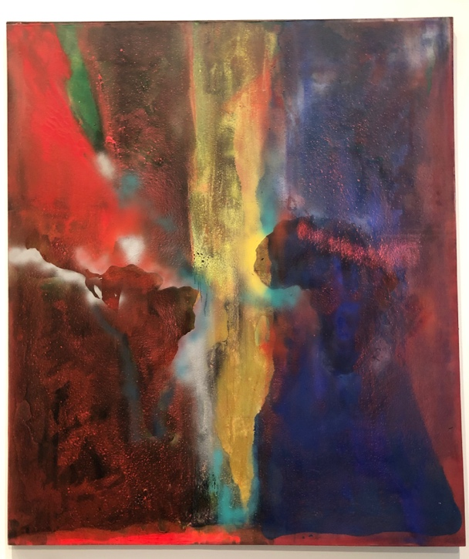
This was a work of art located in the abstract expressionism display gallery at the MET. This work is by Frank Bowling- titled Night Journey and was done in 1969-70 in Acrylic on canvas.

2. Spend 3 minutes sketching your chosen work here:
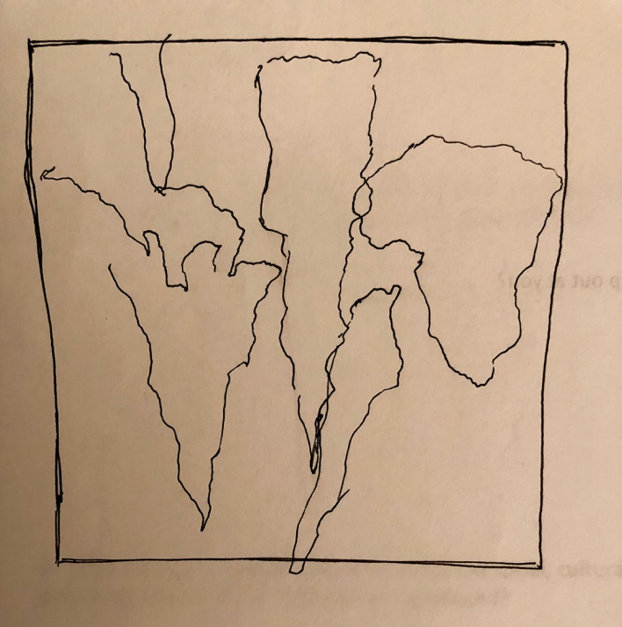

3. Describe your chosen work as if you were speaking to a friend who had never seen it. Don’t interpret the work, just describe it. This description will be used both for seminar and studio so please be sure to include the following elements in your description: subject matter, pose, color, line, texture, composition, medium, and size.
The work of art shows a section of the world map- specifically depicting the continents of Australia, South America and Africa. There is a lot of color present in the work, an intense mix of warm and cool colors. Amongst the strong layers of colors that make up this piece there is a luminous white shadow like form that outlines the continents which creates a distinct definition of their presence among the background. The wide array of colors creates a lot of texture within the work. At 84 x 72 inches the piece is fairly large and is very pleasing to look at. I was very drawn to this work.

4. What aspects of the work jump out at you?
I was particularly struck when I realized that the painting depicted a super imposed section of the world map. I was initially very drawn to the use of colors in this work and I always find that I get even more drawn to a work if I notice something new after viewing the work.

5. What is it about your chosen work that excites or interests you?
As I am looking at exploring Singaporean images of “home” either in art and ads, it was interesting to see how this artist used sections of the map against the wide array of colors and textures prevalent within the piece. It made me think about finding distinctive ways in which I could use that point to particular ideas in culture of the history of the nation I grew up in, Singapore.

6. When you look at your chosen work, what assumptions from your own experience are you bringing to it? These assumptions can be of any sort. For example, they might be about who owned it, or why and how it was made, or its use.
I am amazed at the use of color in the piece, all the colors run so well against one another and they each complement the colors that they fade into or are paired up by each other. I was also drawn to the use of medium of painting that was used to create this painting, it is acrylic on canvas which in my opinion is a very difficult medium to use to get the type of effects that we see in the art work.

7. What other works are in the room with the one you have chosen? What qualities of your object/artwork do those other works emphasize or minimize?
The other works in the room were all similar in the way that they were abstract however as they were part of the abstract expressionism period, they were all done between 1940-1950s which dates a good 20 years before this piece. I found that this brings more emphasis on the similarity in the style of the work that were in this space.

8. What are your immediate thoughts about the social, cultural, or political aspects of the period and place in which the work was produced?
The barely discernible shapes of South America create some questions on what this work is trying to represent. I wonder what the implications of this piece were in comparison to the date and time it was created.

9. What information might help you understand and interpret your object better?
I wanted to do some research into how the work was created and why the artist chose to outline some sections of the map and left others unclear. I had some questions with regard to why he chose to make the decision to change some parts of it and leave others.

10. Create at least 5 questions you have about your work. They can be very general or very specific. You can answer them with your own hypotheses below but you can also leave your questions open.
a. What emotions were Bowling trying to convey within this piece?

b. How did he come up with the concept of the piece?
c. Where did Rowling gain inspiration when creating this piece?

d. Did Abstract expressionism play a part in creating this piece?

e. What were the stylistic choices made to create this work?

