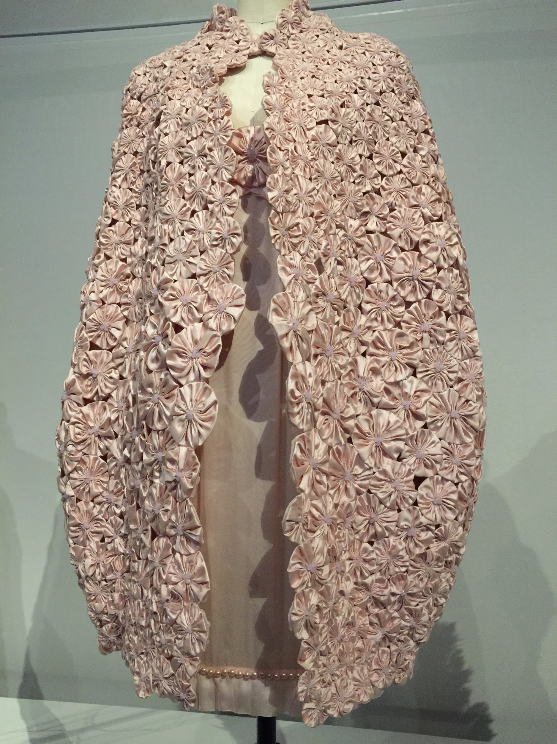
The maker, Karl Lagerfeld (born in Hamburg, 1938) made a dress made up of pink silk chiffon and charmeuse, that had hand-embroidered with pink silk satin flowers, pearls, and pink frosted crystals. The cape was hand-finished, which has 1,300 hand-piece pink silk satin flowers by Lenmarie with pink frosted crystals. It was assembled during spring/summer 2010, as haute couture. This piece captured my interest because of the color and composition of the piece. The jacket is very textured, with many different satin flowers of different sizes, which would either be larger or smaller in size. It almost feels as if the larger the satin flowers, the closer the fabric/area of the clothing appears, and the more attention it gives as it brings me in towards the middle of the clothes, which is the simple dress underneath. It uses one color, but yet has its own completion by making a balance between a complicated-looking form of a jacket, and a simple dress underneath.

Please copy one quote from the exhibitions:
Write what is interesting to you about this quote

Raf Simons once said, “The whole idea about juxtaposing something so specifically from that time with something so specifically from this time is, for me, already modernity in itself.” This relates to a lot to me and I feel, life as well, personally. I usually take experiences from the past and use it in the future to generate the actions I make that result in different conclusions. I always improvise and change my thoughts along the way of a plan or of a constructed idea. I believe that using past ideas and memories to create something for the future leads to a new idea, which makes it present, and “modern”. I believe in constantly in believing in the future and modern times, but as well appreciate the past times that led me up to where I am now.

