Scavenger Hunt

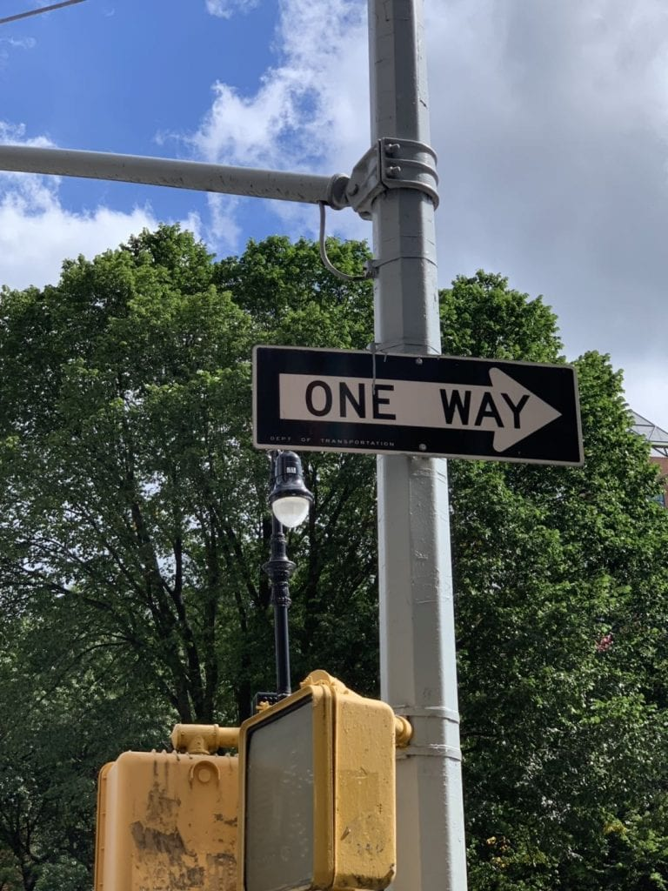
Geeweon believes that the one-way road is a stereotype of New York.
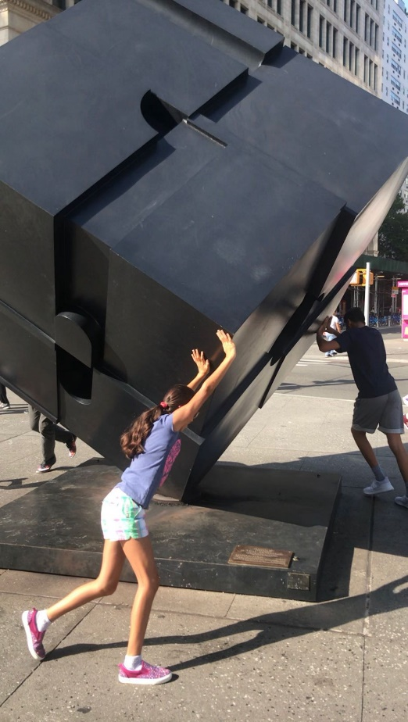
Geeweon feels very busy right now, so the spinning cube represents her a lot.
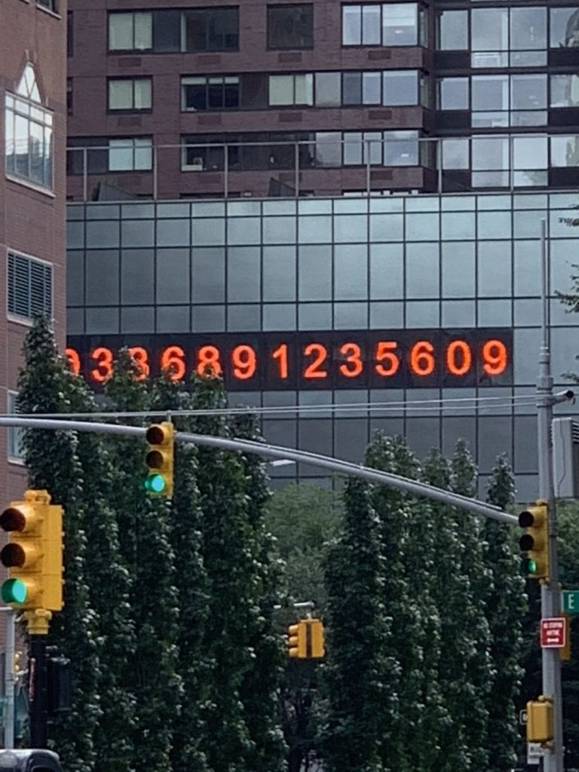
The passing time symbolize who Geeweon used to be.
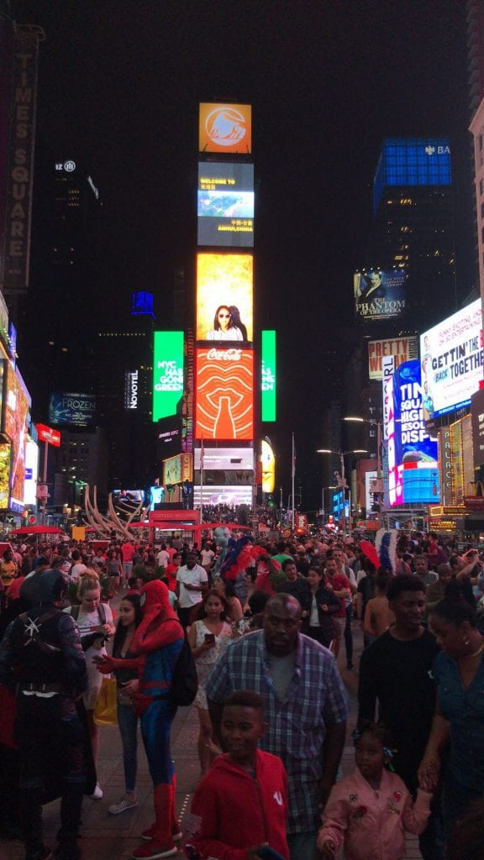
Geeweon gets excited about the Time Square and all the activities that associate with it.
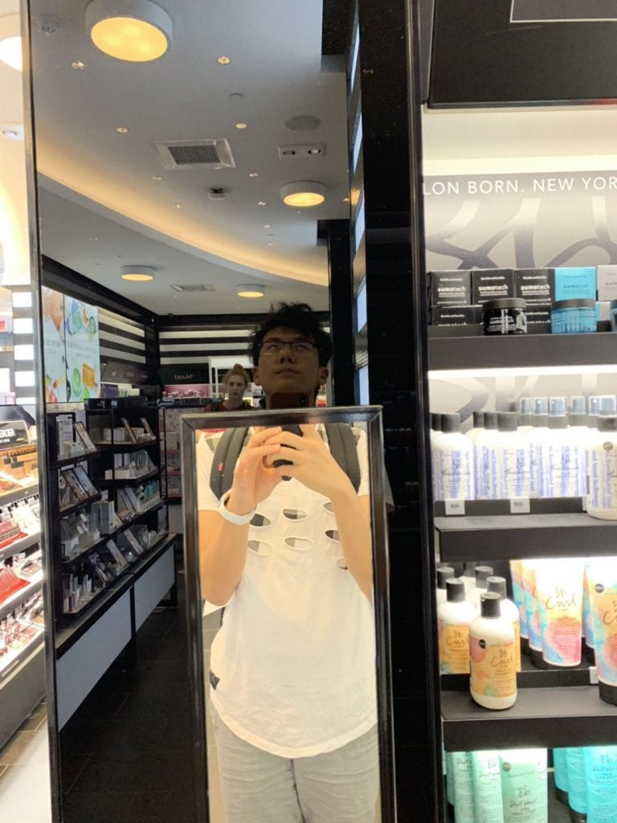
“This mirror is too short for Alex, but it works for me~” This is something relate with her body.

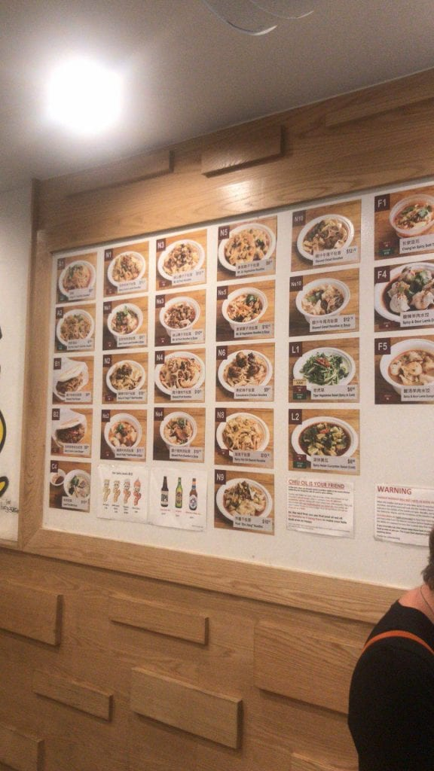
Geeweon loves noodles. Dining in Xi’an Famous food reminds her as home.

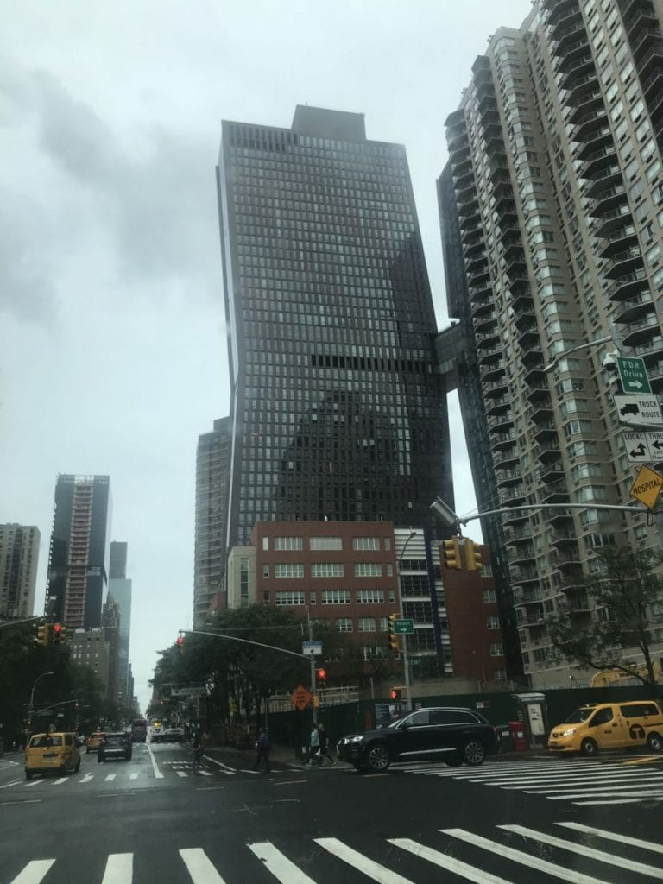
Geeweon is very approachable, so she makes lots of friends. She believes that other people see her as a building that can connect with other buildings.
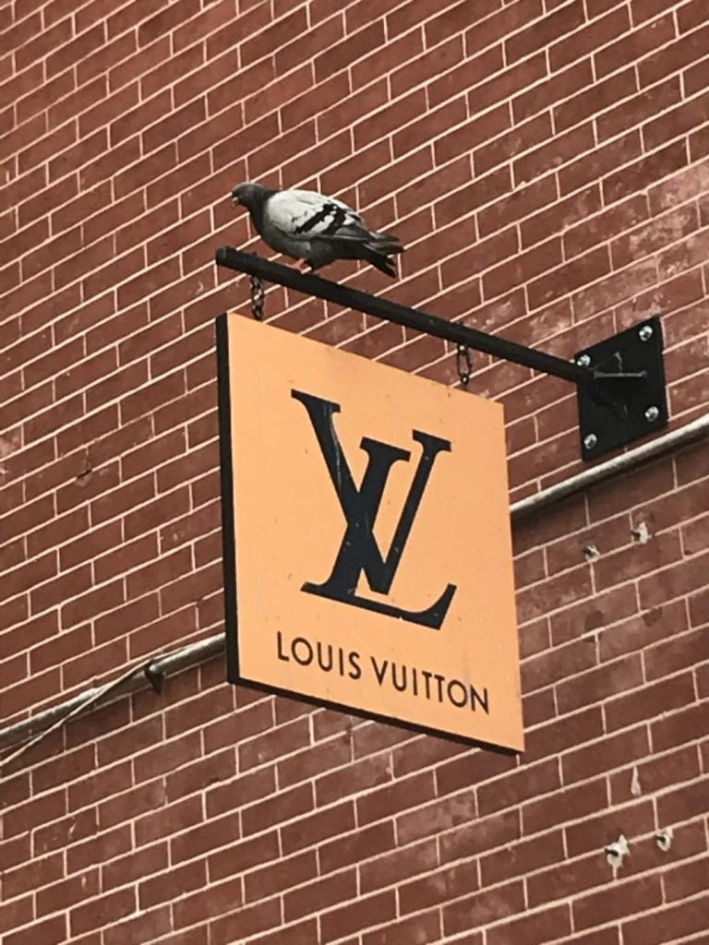
She loves fashion brands, so this is a place that she definitely feels seen.
She does not like constructions because they create noise.
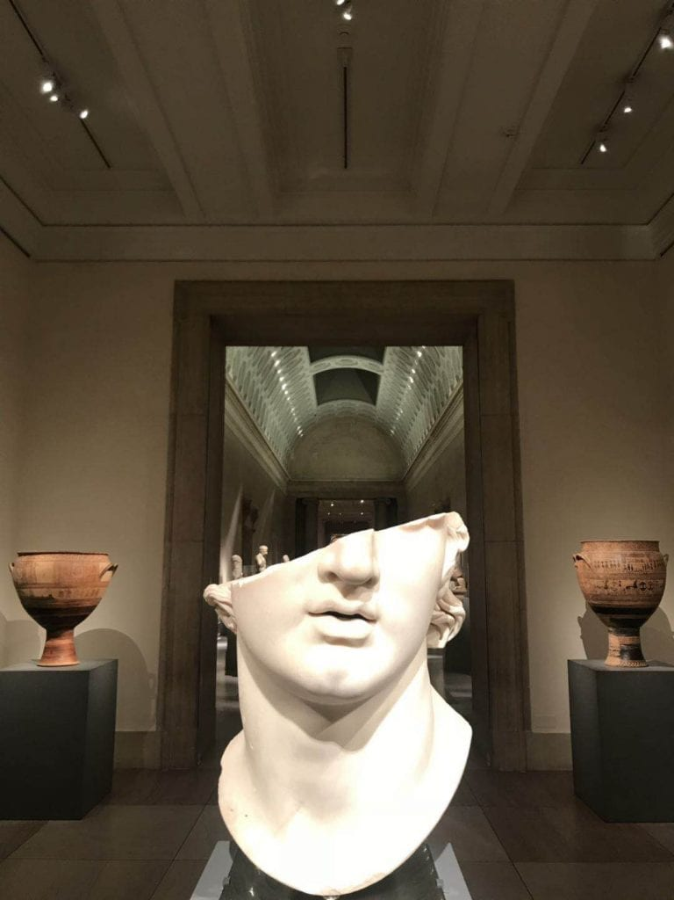
This is how Geeweon sees herself – a half completed sculpture. She always believes that there is a lot of potential inside her, and she wants to find the other half of herself.

